UNITED STATES
SECURITIES AND EXCHANGE COMMISSION
Washington, D.C. 20549
FORM 8-K

CURRENT REPORT
Pursuant to Section 13 or 15(d) of The Securities Exchange Act of 1934

Date of Report (Date of earliest event reported): September 16, 2026

AH REALTY TRUST, INC.
(Exact name of registrant as specified in its charter)

Maryland |  |  |  |  |  | 001-35908 |  |  |  |  |  | 46-1214914
(State or other jurisdiction of incorporation) |  |  |  |  |  | (Commission File Number) |  |  |  |  |  | (IRS Employer Identification No.)

4605 Columbus St. |  |  |  |  |  | ,
Virginia Beach |  |  | , |  |  | Virginia |  |  |  |  |  |  |  |  | 23462
(Address of principal executive offices) |  |  |  |  |  |  |  |  |  |  |  |  |  |  | (Zip Code)

Registrant’s telephone number, including area code: (757) 366-4000
Not Applicable
(Former name or former address, if changed since last report)

Check the appropriate box below if the Form 8-K filing is intended to simultaneously satisfy the filing obligation of the registrant under any of the following provisions:

☐ Written communications pursuant to Rule 425 under the Securities Act (17 CFR 230.425)

☐ Soliciting material pursuant to Rule 14a-12 under the Exchange Act (17 CFR 240.14a-12)

☐ Pre-commencement communications pursuant to Rule 14d-2(b) under the Exchange Act (17 CFR 240.14d-2(b))

☐ Pre-commencement communications pursuant to Rule 13e-4(c) under the Exchange Act (17 CFR 240.13e-4(c))

Securities registered pursuant to Section 12(b) of the Act:
Title of each class |  |  |  |  |  | Trading Symbol(s) |  |  |  |  |  | Name of each exchange on which registered
Common Stock, $0.01 par value per share |  |  |  |  |  | AHRT |  |  |  |  |  | New York Stock Exchange
6.75% Series A Cumulative Redeemable Perpetual Preferred Stock, $0.01 par value per share |  |  |  |  |  | AHRTPrA |  |  |  |  |  | New York Stock Exchange

Indicate by check mark whether the registrant is an emerging growth company as defined in Rule 405 of the Securities Act of 1933 (§230.405 of this chapter) or Rule 12b-2 of the Securities Exchange Act of 1934 (§240.12b-2 of this chapter).

Emerging growth company ☐

If an emerging growth company, indicate by check mark if the registrant has elected not to use the extended transition period for complying with any new or revised financial accounting standards provided pursuant to Section 13(a) of the Exchange Act. ☐

Item 7.01 Regulation FD Disclosure.

Beginning on September 16, 2026, Shawn J. Tibbetts, the President and Chief Executive Officer of AH Realty Trust, Inc. (the “Company”), and Matthew T. Barnes-Smith, the Chief Financial Officer and Treasurer of the Company, will use the presentation materials that are included as Exhibit 99.1 to this Current Report on Form 8-K in meetings with investors. A copy of the presentation materials also will be available on the Company’s website, ir.ahrealtytrust.com.

The information contained in Item 7.01 of this Current Report on Form 8-K (including Exhibit 99.1 attached hereto) shall not be deemed “filed” for purposes of Section 18 of the Securities Exchange Act of 1934, as amended (the “Exchange Act”), or otherwise subject to the liabilities of that section, nor shall it be deemed incorporated by reference in any filing under the Securities Act of 1933, as amended, or the Exchange Act, except as expressly provided by specific reference in such a filing.

Item 9.01 Financial Statements and Exhibits.

(d) Exhibits.

Exhibit  No. |  |  |  |  |  | Description
99.1 |  |  |  |  |  | Investor Presentation
104 |  |  |  |  |  | Cover Page Interactive Data File - the cover page XBRL tags are embedded within the Inline XBRL document

SIGNATURES

Pursuant to the requirements of the Securities Exchange Act of 1934, the Registrant has duly caused this report to be signed on its behalf by the undersigned hereunto duly authorized.

 |  |  | AH REALTY TRUST, INC.
Date: September 16, 2026 |  |  | By: |  |  | /s/ Matthew Barnes-Smith
 |  |  |  |  |  | Matthew Barnes-Smith
 |  |  |  |  |  | Chief Financial Officer and Treasurer

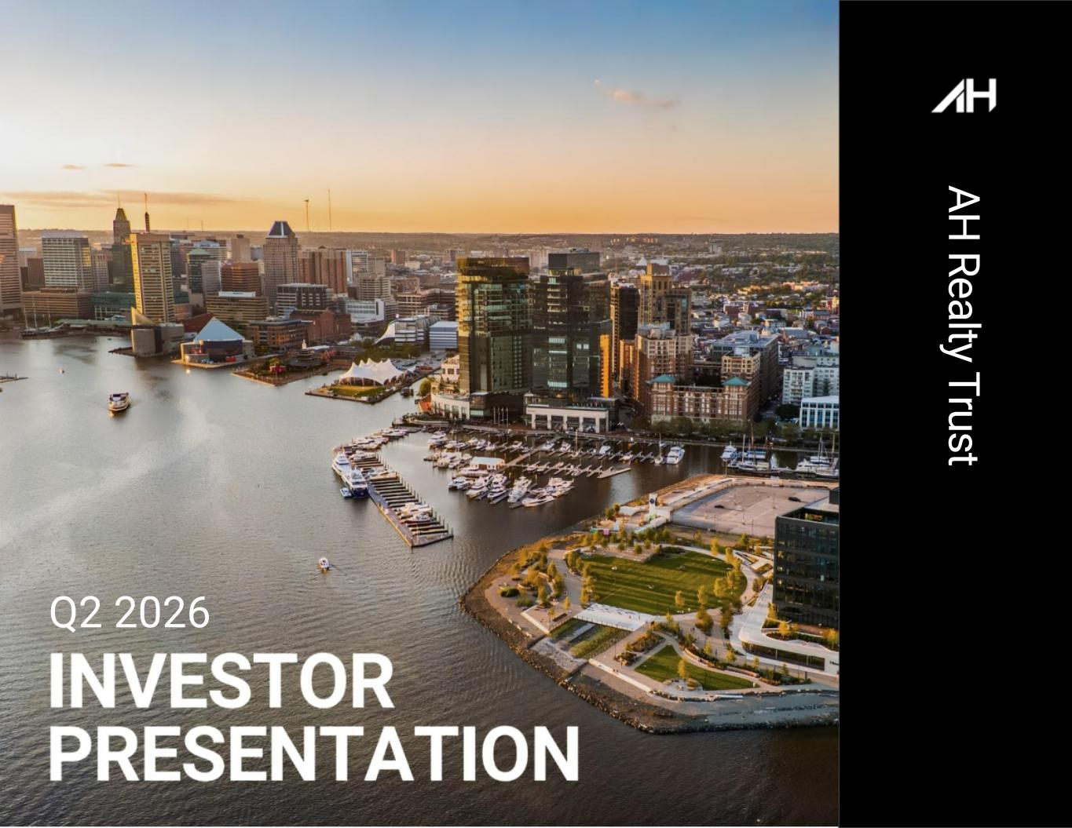

1 Q2 2026 A H R e a lty T ru st

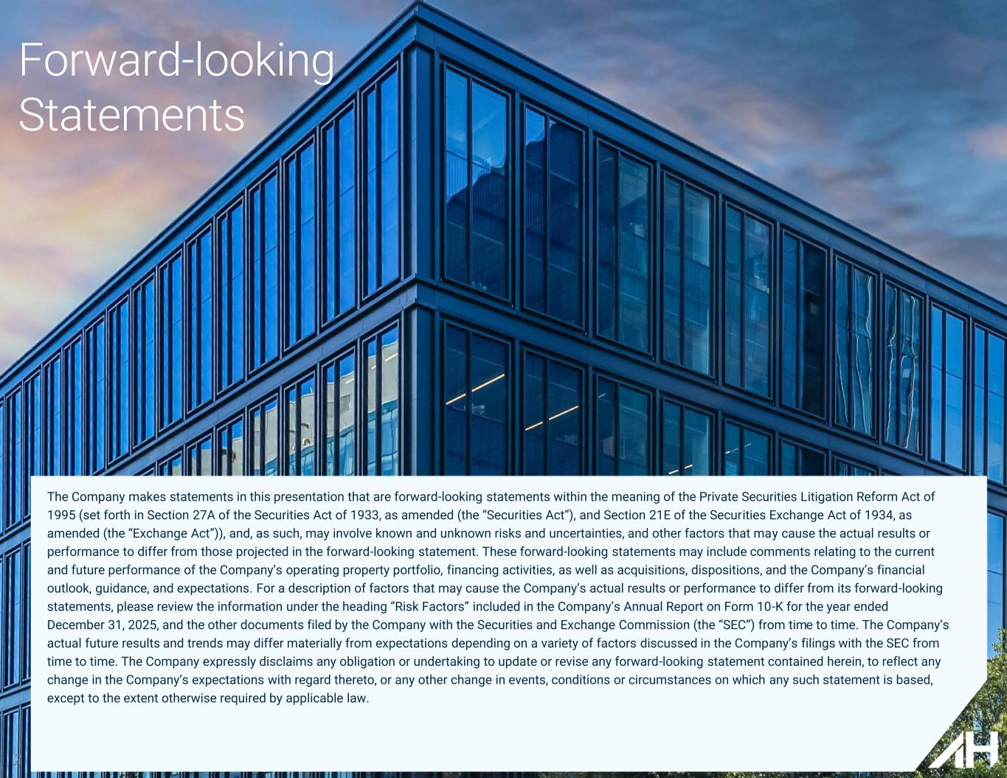
2 Forward-looking Statements The Company makes statements in this presentation that are forward-looking statements within the meaning of the Private Securities Litigation Reform Act of 1995 (set forth in Section 27A of the Securities Act of 1933, as amended (the “Securities Act”), and Section 21E of the Securities Exchange Act of 1934, as amended (the “Exchange Act”)), and, as such, may involve known and unknown risks and uncertainties, and other factors that may cause the actual results or performance to differ from those projected in the forward-looking statement. These forward-looking statements may include comments relating to the current and future performance of the Company’s operating property portfolio, financing activities, as well as acquisitions, dispositions, and the Company’s financial outlook, guidance, and expectations. For a description of factors that may cause the Company’s actual results or performance to differ from its forward-looking statements, please review the information under the heading “Risk Factors” included in the Company’s Annual Report on Form 10-K for the year ended December 31, 2025, and the other documents filed by the Company with the Securities and Exchange Commission (the “SEC”) from time to time. The Company’s actual future results and trends may differ materially from expectations depending on a variety of factors discussed in the Company’s filings with the SEC from time to time. The Company expressly disclaims any obligation or undertaking to update or revise any forward-looking statement contained herein, to reflect any change in the Company’s expectations with regard thereto, or any other change in events, conditions or circumstances on which any such statement is based, except to the extent otherwise required by applicable law.

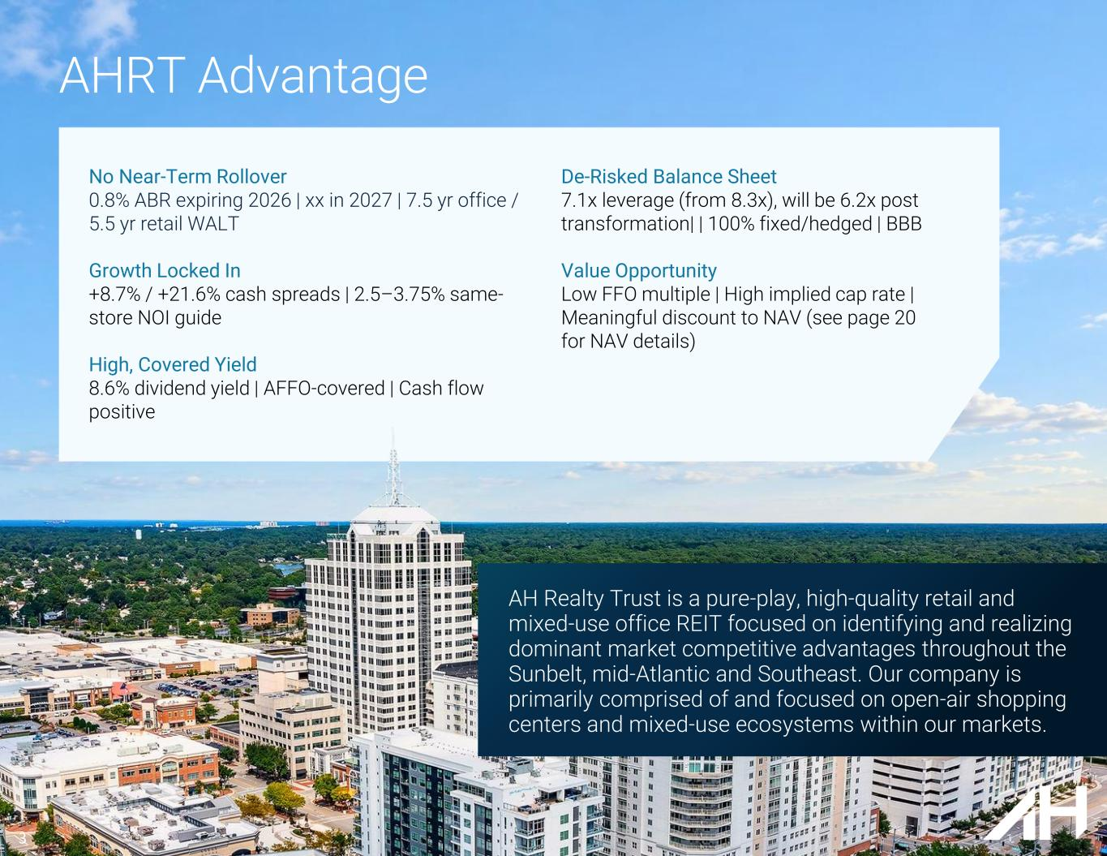
No Near-Term Rollover 0.8% ABR expiring 2026 | xx in 2027 | 7.5 yr office / 5.5 yr retail WALT Growth Locked In +8.7% / +21.6% cash spreads | 2.5–3.75% same- store NOI guide High, Covered Yield 8.6% dividend yield | AFFO-covered | Cash flow positive De-Risked Balance Sheet 7.1x leverage (from 8.3x), will be 6.2x post transformation| | 100% fixed/hedged | BBB Value Opportunity Low FFO multiple | High implied cap rate | Meaningful discount to NAV (see page 20 for NAV details) AHRT Advantage AH Realty Trust is a pure-play, high-quality retail and mixed-use office REIT focused on identifying and realizing dominant market competitive advantages throughout the Sunbelt, mid-Atlantic and Southeast. Our company is primarily comprised of and focused on open-air shopping centers and mixed-use ecosystems within our markets.​ 3

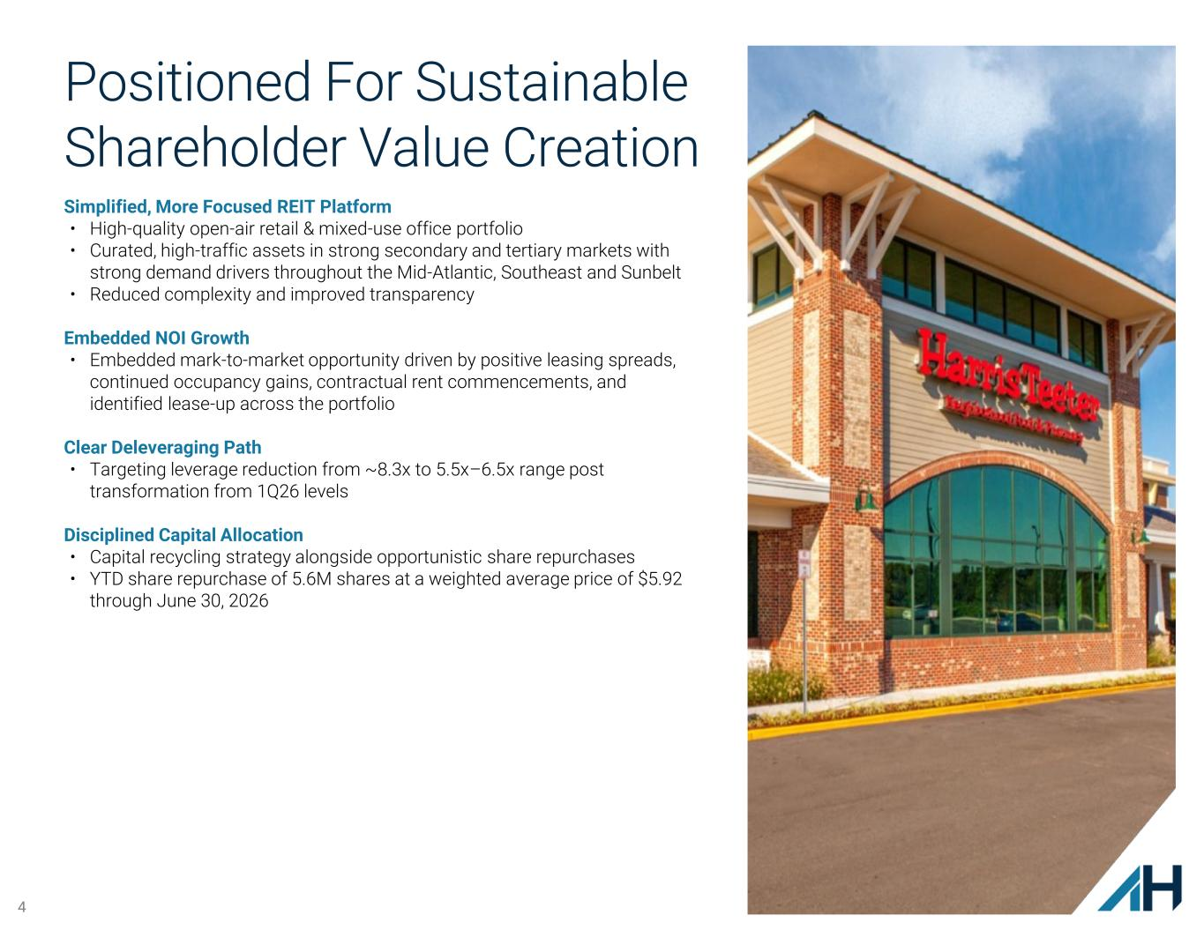
4 Positioned For Sustainable Shareholder Value Creation Simplified, More Focused REIT Platform • High-quality open-air retail & mixed-use office portfolio • Curated, high-traffic assets in strong secondary and tertiary markets with strong demand drivers throughout the Mid-Atlantic, Southeast and Sunbelt • Reduced complexity and improved transparency Embedded NOI Growth • Embedded mark-to-market opportunity driven by positive leasing spreads, continued occupancy gains, contractual rent commencements, and identified lease-up across the portfolio Clear Deleveraging Path • Targeting leverage reduction from ~8.3x to 5.5x–6.5x range post transformation from 1Q26 levels Disciplined Capital Allocation • Capital recycling strategy alongside opportunistic share repurchases • YTD share repurchase of 5.6M shares at a weighted average price of $5.92 through June 30, 2026

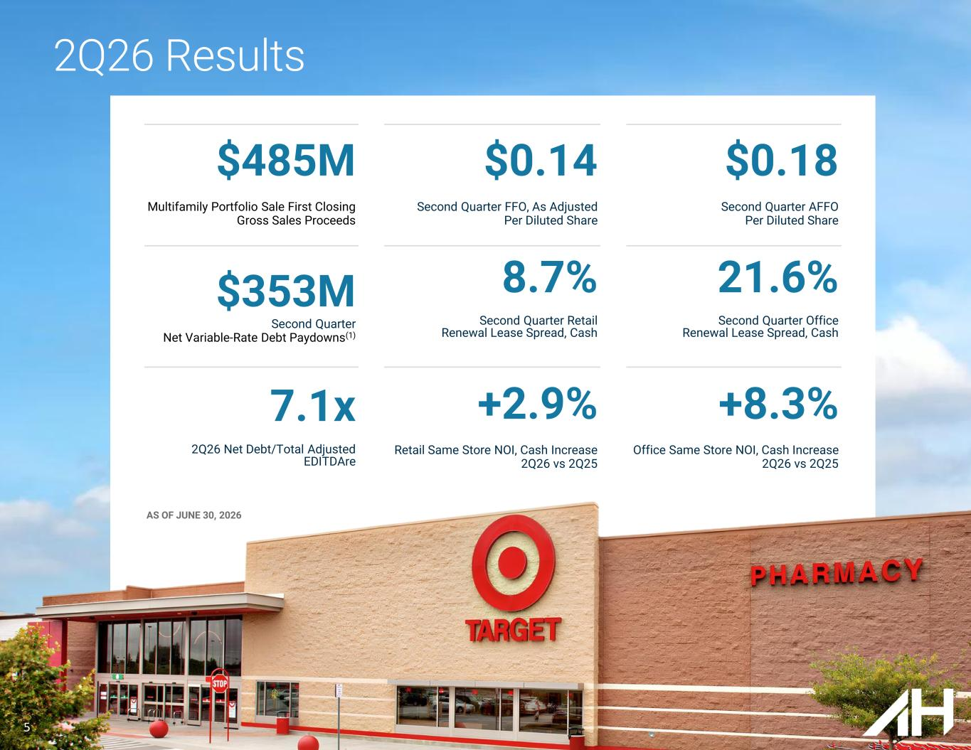
$485M Multifamily Portfolio Sale First Closing Gross Sales Proceeds $0.14 Second Quarter FFO, As Adjusted Per Diluted Share $0.18 Second Quarter AFFO Per Diluted Share $353M Second Quarter Net Variable-Rate Debt Paydowns(1) 8.7% Second Quarter Retail Renewal Lease Spread, Cash 21.6% Second Quarter Office Renewal Lease Spread, Cash 7.1x 2Q26 Net Debt/Total Adjusted EDITDAre +2.9% Retail Same Store NOI, Cash Increase 2Q26 vs 2Q25 +8.3% Office Same Store NOI, Cash Increase 2Q26 vs 2Q25 AS OF JUNE 30, 2026 2Q26 Results 5

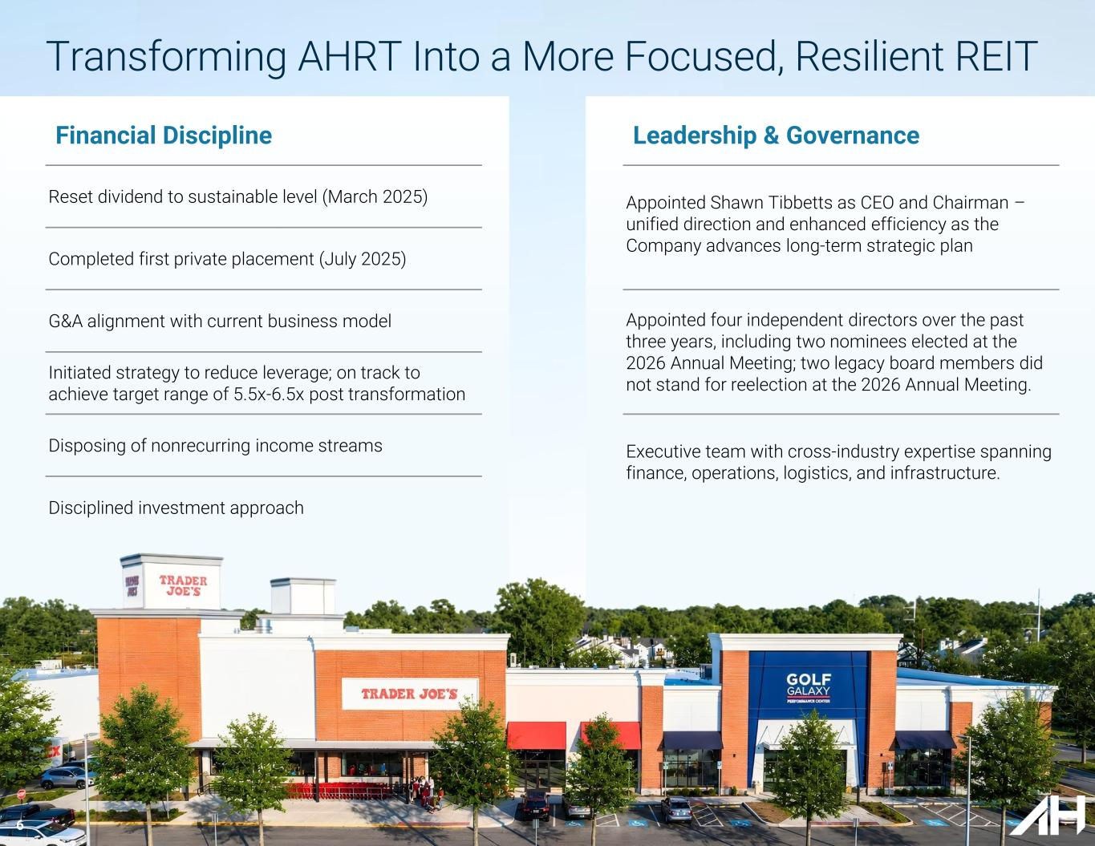
6 Financial Discipline Reset dividend to sustainable level (March 2025) Completed first private placement (July 2025) G&A alignment with current business model Initiated strategy to reduce leverage; on track to achieve target range of 5.5x-6.5x post transformation Disposing of nonrecurring income streams Disciplined investment approach Appointed Shawn Tibbetts as CEO and Chairman – unified direction and enhanced efficiency as the Company advances long-term strategic plan Appointed four independent directors over the past three years, including two nominees elected at the 2026 Annual Meeting; two legacy board members did not stand for reelection at the 2026 Annual Meeting. Executive team with cross-industry expertise spanning finance, operations, logistics, and infrastructure. Leadership & Governance Transforming AHRT Into a More Focused, Resilient REIT

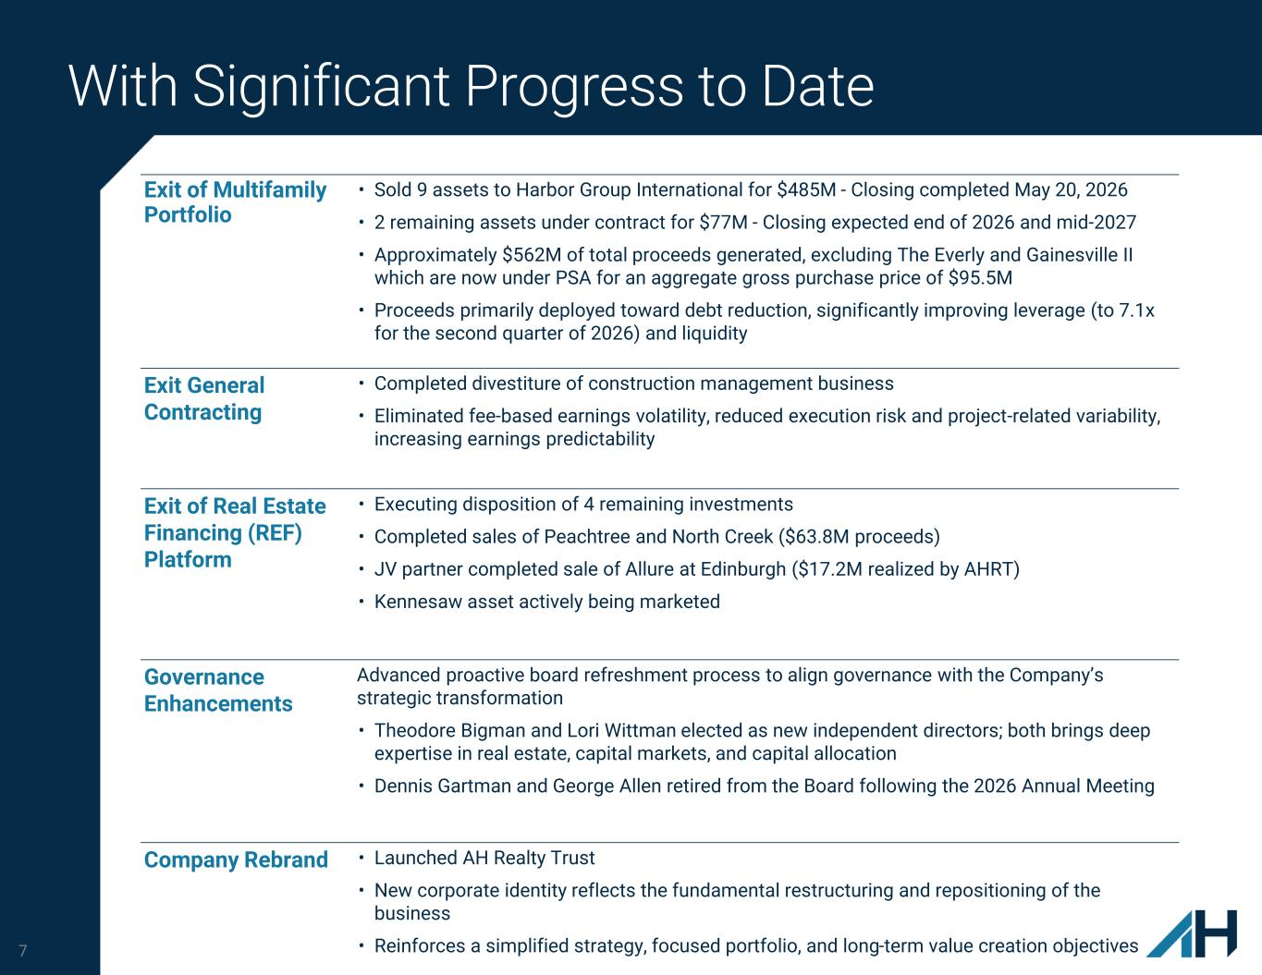
7 With Significant Progress to Date Exit of Multifamily Portfolio • Sold 9 assets to Harbor Group International for $485M - Closing completed May 20, 2026 • 2 remaining assets under contract for $77M - Closing expected end of 2026 and mid-2027 • Approximately $562M of total proceeds generated, excluding The Everly and Gainesville II which are now under PSA for an aggregate gross purchase price of $95.5M • Proceeds primarily deployed toward debt reduction, significantly improving leverage (to 7.1x for the second quarter of 2026) and liquidity Exit General Contracting • Completed divestiture of construction management business • Eliminated fee-based earnings volatility, reduced execution risk and project-related variability, increasing earnings predictability Exit of Real Estate Financing (REF) Platform • Executing disposition of 4 remaining investments • Completed sales of Peachtree and North Creek ($63.8M proceeds) • JV partner completed sale of Allure at Edinburgh ($17.2M realized by AHRT) • Kennesaw asset actively being marketed Governance Enhancements Advanced proactive board refreshment process to align governance with the Company’s strategic transformation • Theodore Bigman and Lori Wittman elected as new independent directors; both brings deep expertise in real estate, capital markets, and capital allocation • Dennis Gartman and George Allen retired from the Board following the 2026 Annual Meeting Company Rebrand • Launched AH Realty Trust • New corporate identity reflects the fundamental restructuring and repositioning of the business • Reinforces a simplified strategy, focused portfolio, and long-term value creation objectives

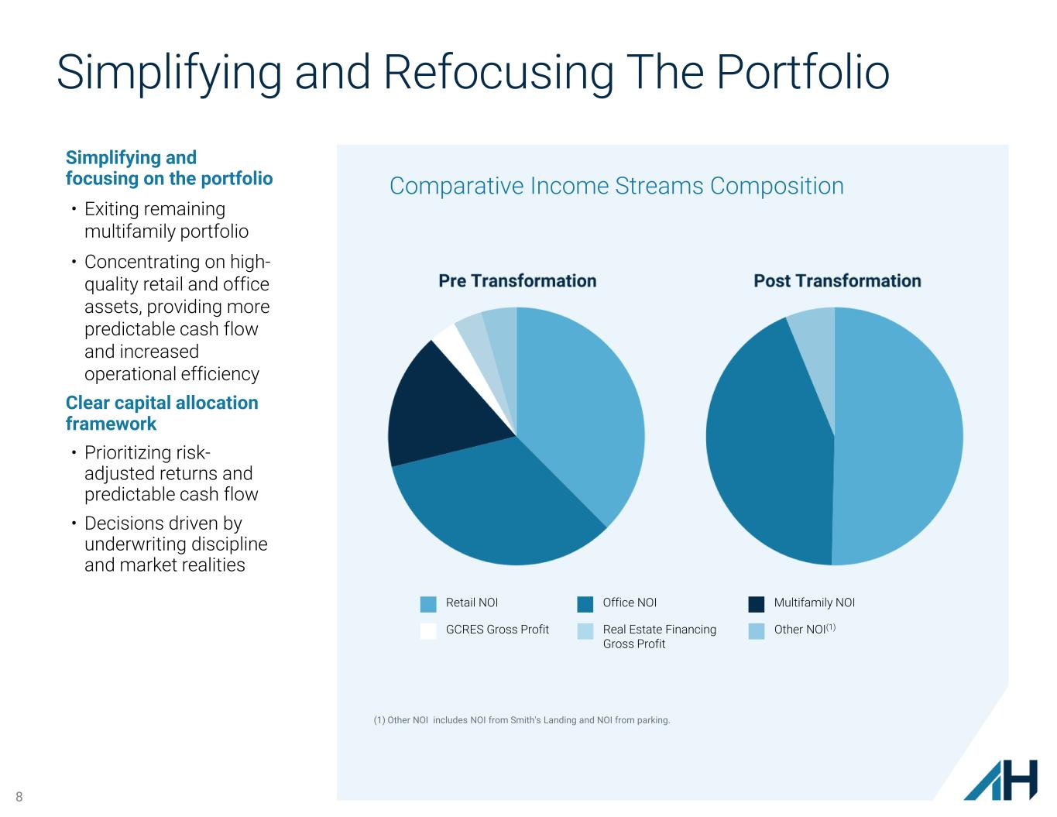
8 Simplifying and Refocusing The Portfolio Simplifying and focusing on the portfolio • Exiting remaining multifamily portfolio​ • Concentrating on high- quality retail and office assets, providing more predictable cash flow and increased operational efficiency ​ Clear capital allocation framework • Prioritizing risk- adjusted returns and predictable cash flow • Decisions driven by underwriting discipline and market realities Comparative Income Streams Composition Retail NOI Office NOI Multifamily NOI GCRES Gross Profit Real Estate Financing Gross Profit Other NOI(1) (1) Other NOI includes NOI from Smith's Landing and NOI from parking.

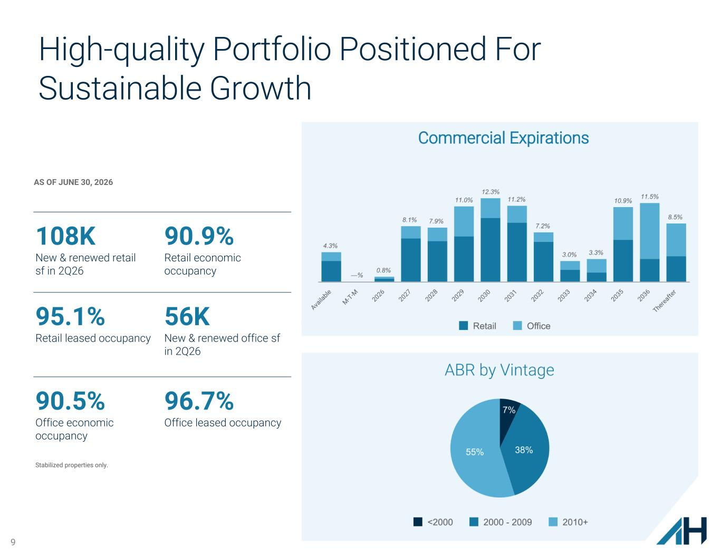
9 High-quality Portfolio Positioned For Sustainable Growth AS OF JUNE 30, 2026 108K New & renewed retail sf in 2Q26 90.9% Retail economic occupancy 95.1% Retail leased occupancy 56K New & renewed office sf in 2Q26 90.5% Office economic occupancy 96.7% Office leased occupancy Stabilized properties only.

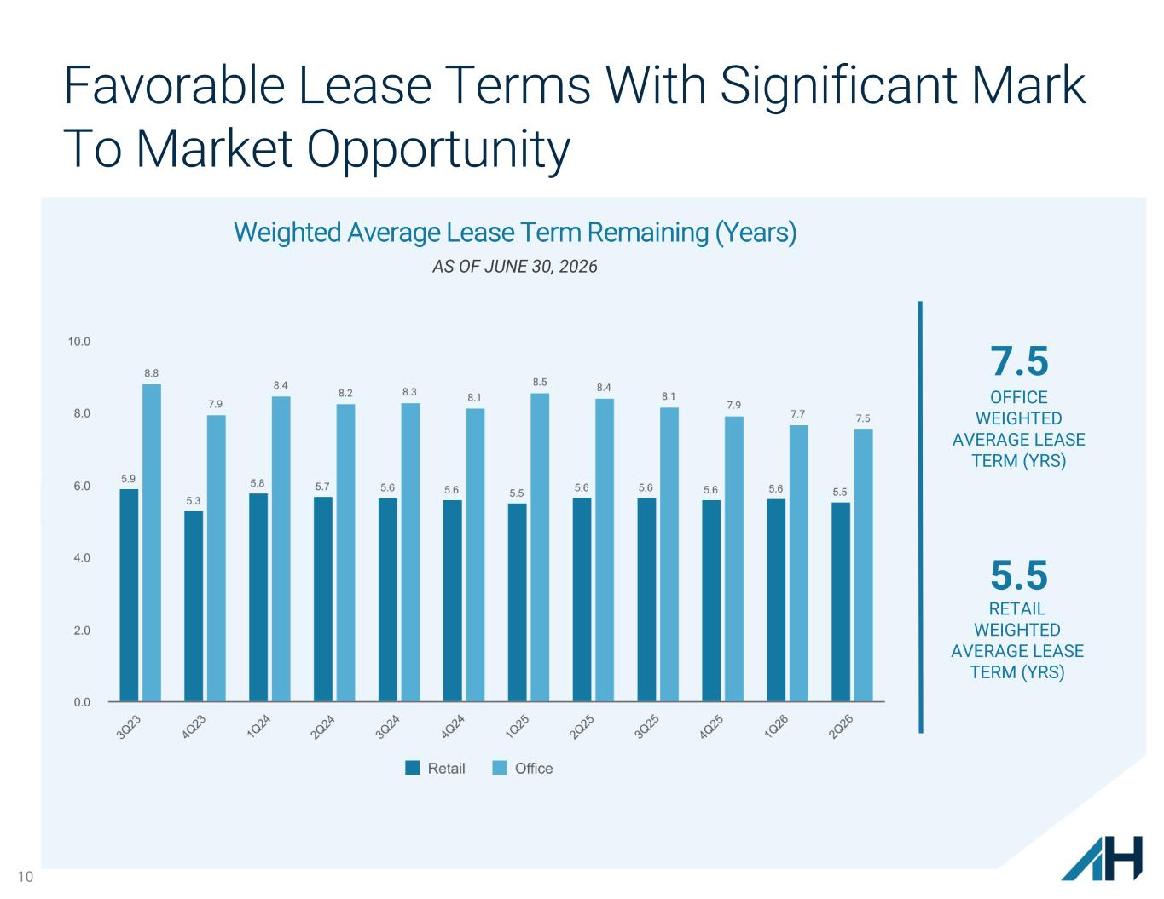
10 Favorable Lease Terms With Significant Mark To Market Opportunity AS OF JUNE 30, 2026 7.5 OFFICE WEIGHTED AVERAGE LEASE TERM (YRS) RETAIL WEIGHTED AVERAGE LEASE TERM (YRS) 5.5 Weighted Average Lease Term Remaining (Years)

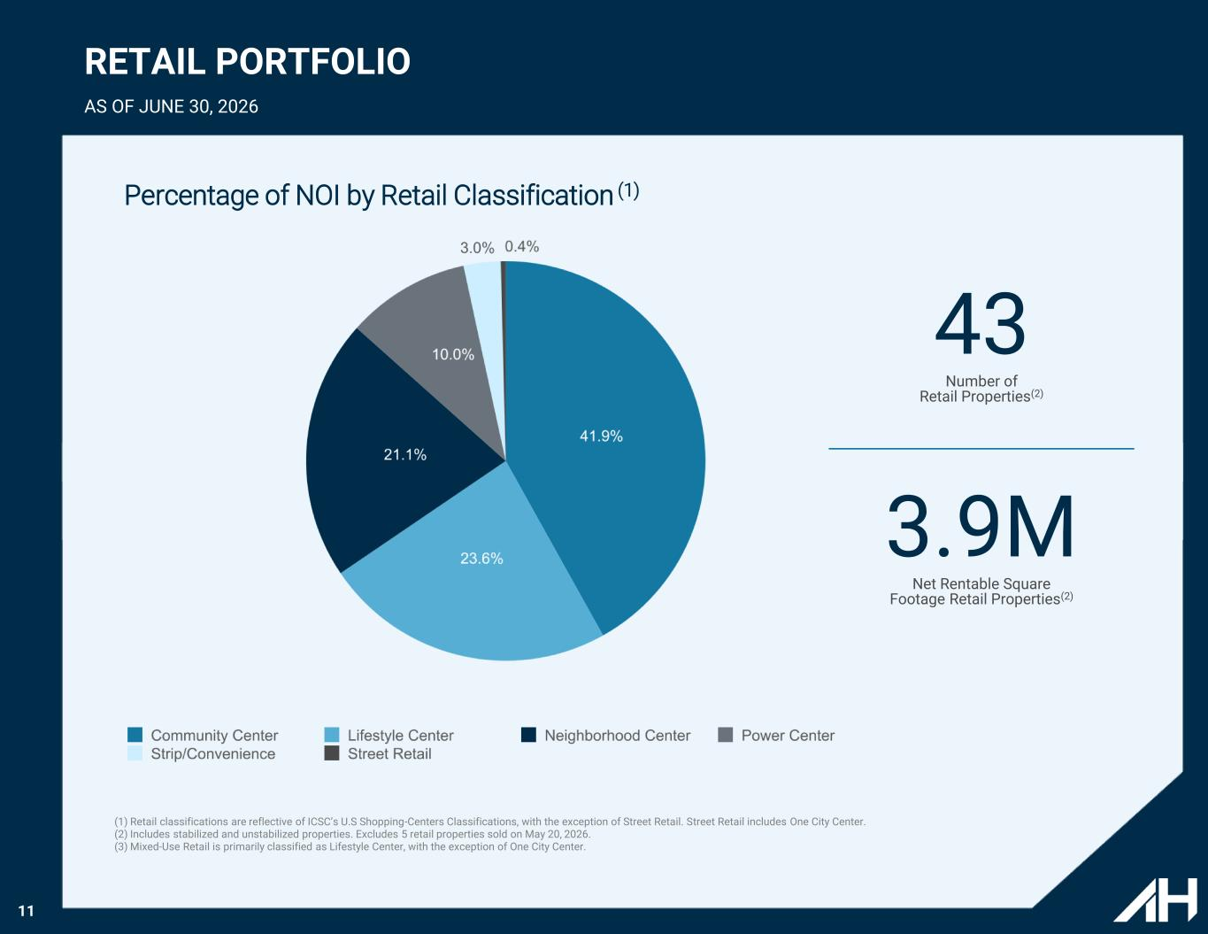
11 43 Number of Retail Properties(2) 3.9M Net Rentable Square Footage Retail Properties(2) RETAIL PORTFOLIO AS OF JUNE 30, 2026 (1) Retail classifications are reflective of ICSC’s U.S Shopping-Centers Classifications, with the exception of Street Retail. Street Retail includes One City Center. (2) Includes stabilized and unstabilized properties. Excludes 5 retail properties sold on May 20, 2026. (3) Mixed-Use Retail is primarily classified as Lifestyle Center, with the exception of One City Center. Percentage of NOI by Retail Classification (1)

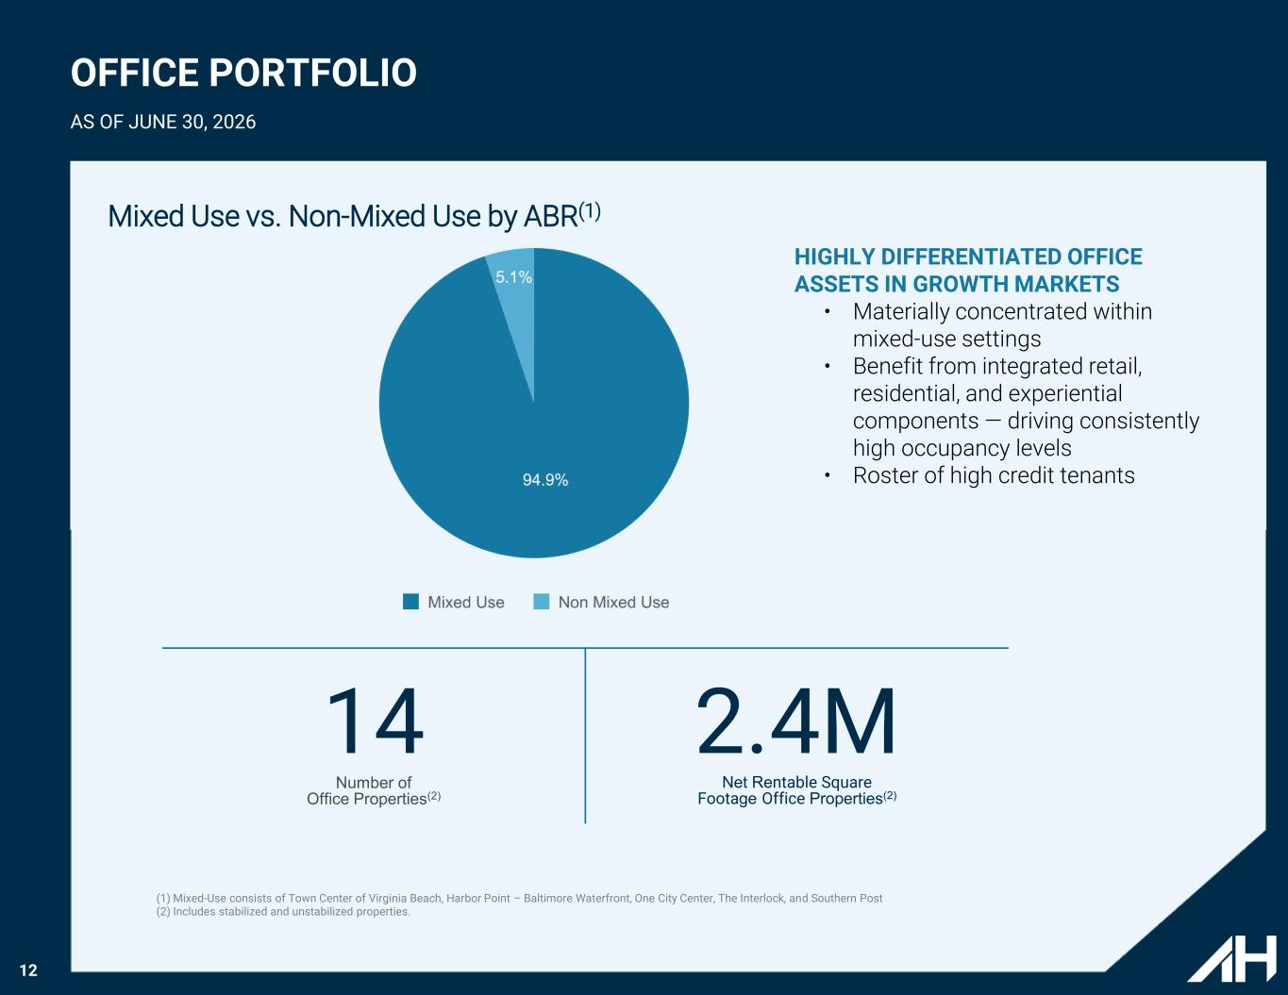
12 OFFICE PORTFOLIO AS OF JUNE 30, 2026 14 Number of Office Properties(2) 2.4M Net Rentable Square Footage Office Properties(2) Mixed Use vs. Non-Mixed Use by ABR(1) HIGHLY DIFFERENTIATED OFFICE ASSETS IN GROWTH MARKETS • Materially concentrated within mixed-use settings • Benefit from integrated retail, residential, and experiential components — driving consistently high occupancy levels • Roster of high credit tenants (1) Mixed-Use consists of Town Center of Virginia Beach, Harbor Point – Baltimore Waterfront, One City Center, The Interlock, and Southern Post (2) Includes stabilized and unstabilized properties.

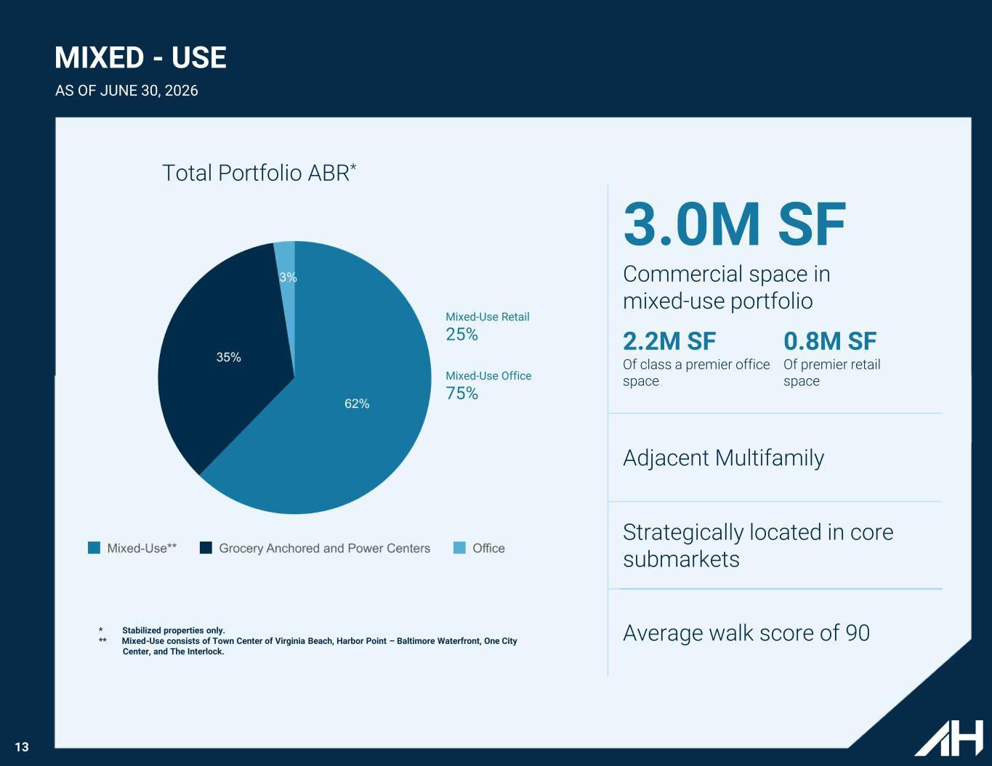
13 Total Portfolio ABR* 3.0M SF Commercial space in mixed-use portfolio 2.2M SF Of class a premier office space 0.8M SF Of premier retail space Adjacent Multifamily Strategically located in core submarkets Average walk score of 90 Mixed-Use Retail 25% Mixed-Use Office 75% * Stabilized properties only. ** Mixed-Use consists of Town Center of Virginia Beach, Harbor Point – Baltimore Waterfront, One City Center, and The Interlock. MIXED - USE AS OF JUNE 30, 2026

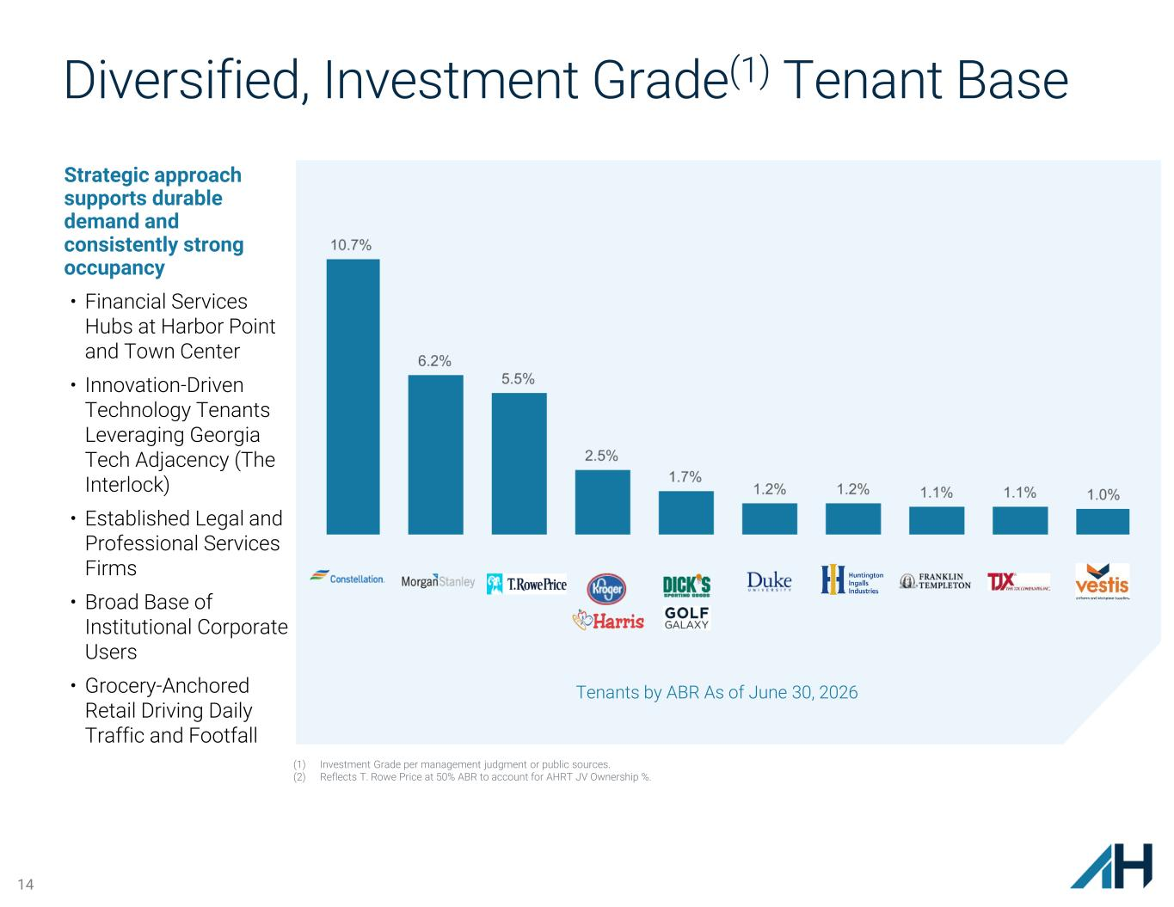
14 Diversified, Investment Grade(1) Tenant Base Strategic approach supports durable demand and consistently strong occupancy • Financial Services Hubs at Harbor Point and Town Center • Innovation-Driven Technology Tenants Leveraging Georgia Tech Adjacency (The Interlock) • Established Legal and Professional Services Firms • Broad Base of Institutional Corporate Users • Grocery-Anchored Retail Driving Daily Traffic and Footfall Tenants by ABR As of June 30, 2026 (1) Investment Grade per management judgment or public sources. (2) Reflects T. Rowe Price at 50% ABR to account for AHRT JV Ownership %.

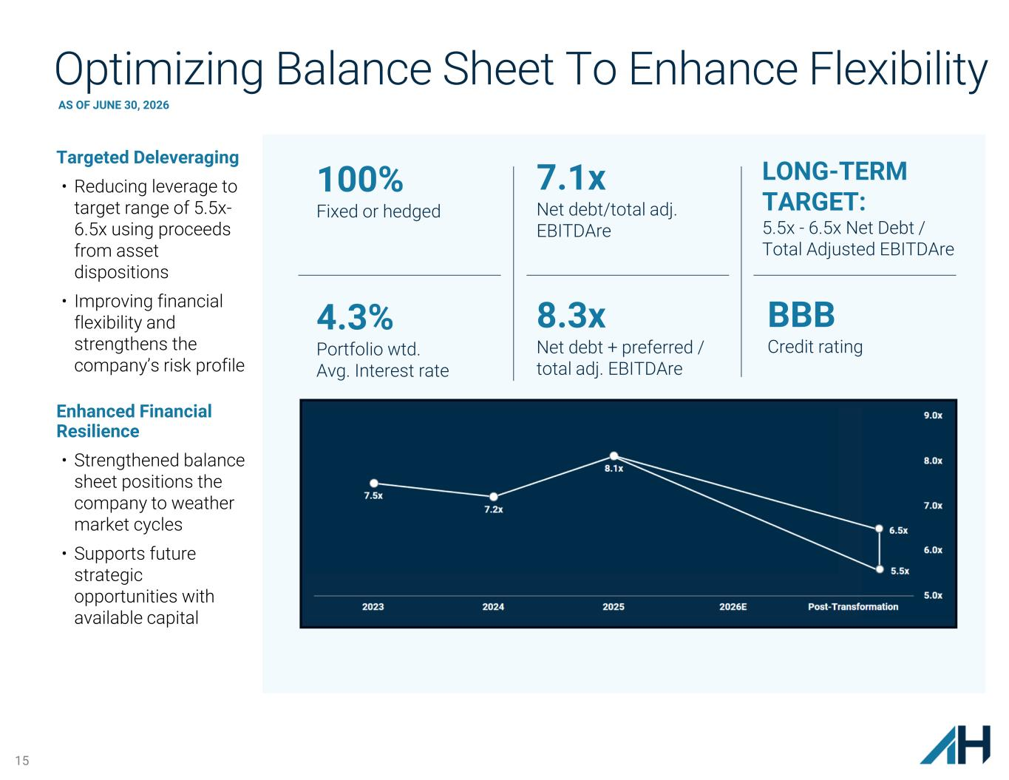
15 BBB Credit rating Optimizing Balance Sheet To Enhance Flexibility Targeted Deleveraging • Reducing leverage to target range of 5.5x- 6.5x using proceeds from asset dispositions • Improving financial flexibility and strengthens the company’s risk profile Enhanced Financial Resilience • Strengthened balance sheet positions the company to weather market cycles • Supports future strategic opportunities with available capital LONG-TERM TARGET: 5.5x - 6.5x Net Debt / Total Adjusted EBITDAre 4.3% Portfolio wtd. Avg. Interest rate 7.1x Net debt/total adj. EBITDAre 8.3x Net debt + preferred / total adj. EBITDAre 100% Fixed or hedged AS OF JUNE 30, 2026

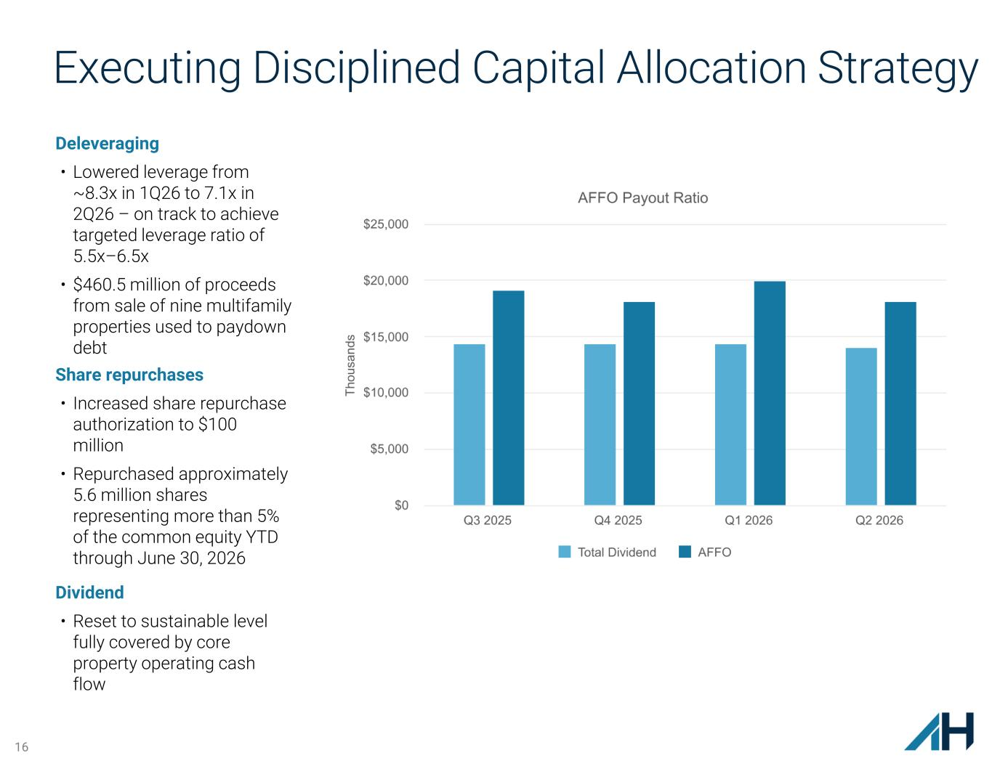
16 Deleveraging • Lowered leverage from ~8.3x in 1Q26 to 7.1x in 2Q26 – on track to achieve targeted leverage ratio of 5.5x–6.5x • $460.5 million of proceeds from sale of nine multifamily properties used to paydown debt Share repurchases • Increased share repurchase authorization to $100 million • Repurchased approximately 5.6 million shares representing more than 5% of the common equity YTD through June 30, 2026 Dividend • Reset to sustainable level fully covered by core property operating cash flow Executing Disciplined Capital Allocation Strategy

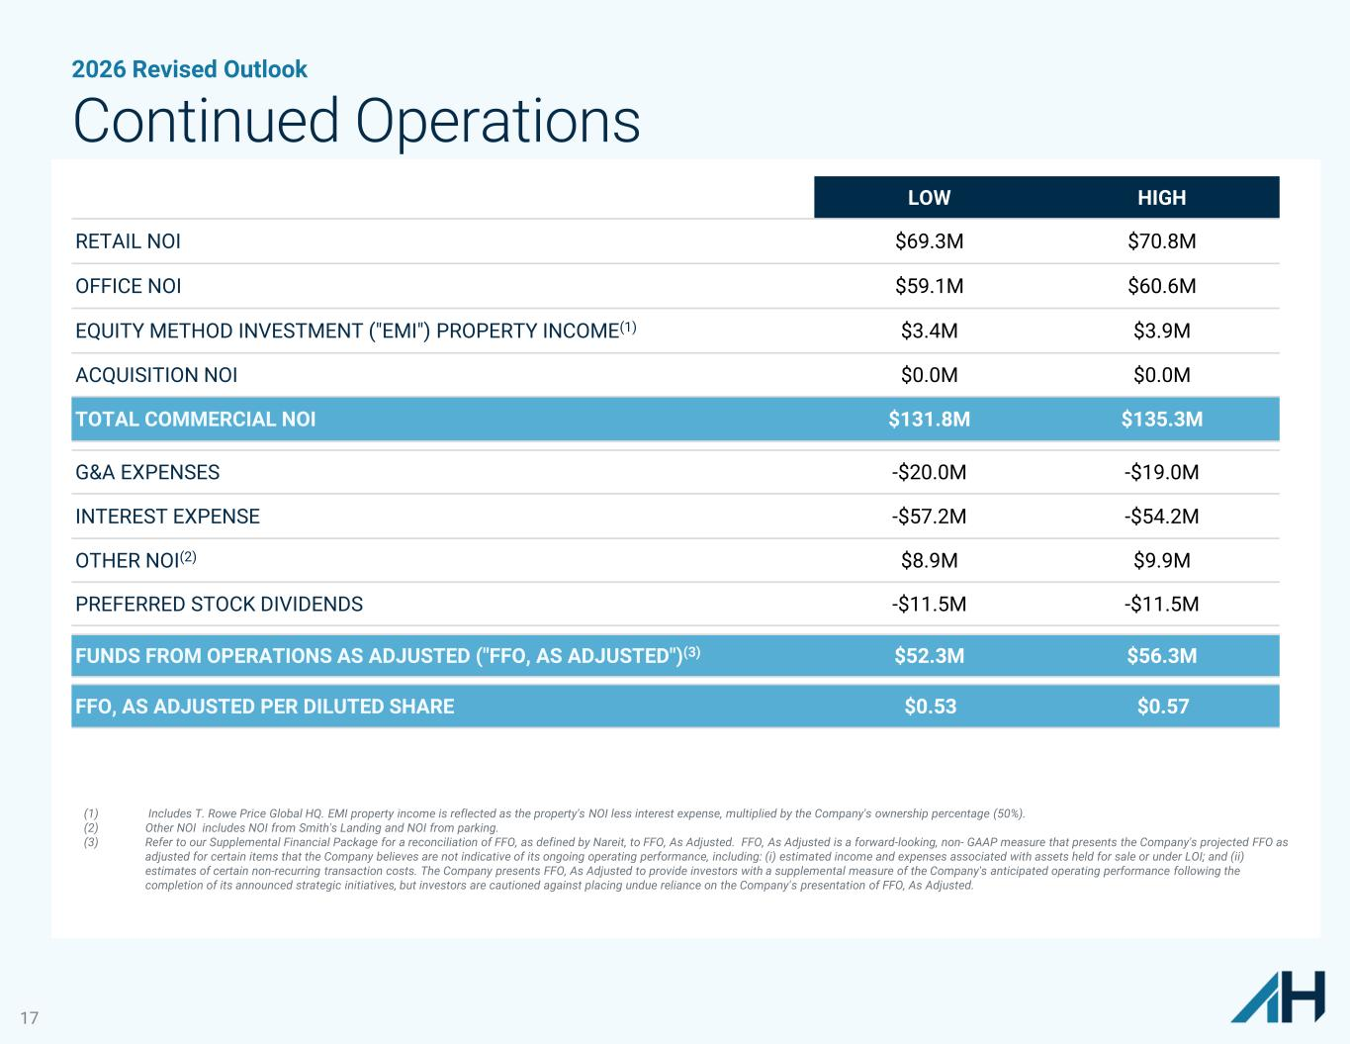
17 2026 Revised Outlook Continued Operations LOW HIGH RETAIL NOI $69.3M $70.8M OFFICE NOI $59.1M $60.6M EQUITY METHOD INVESTMENT ("EMI") PROPERTY INCOME(1) $3.4M $3.9M ACQUISITION NOI $0.0M $0.0M TOTAL COMMERCIAL NOI $131.8M $135.3M G&A EXPENSES -$20.0M -$19.0M INTEREST EXPENSE -$57.2M -$54.2M OTHER NOI(2) $8.9M $9.9M PREFERRED STOCK DIVIDENDS -$11.5M -$11.5M FUNDS FROM OPERATIONS AS ADJUSTED ("FFO, AS ADJUSTED")(3) $52.3M $56.3M FFO, AS ADJUSTED PER DILUTED SHARE $0.53 $0.57 (1) Includes T. Rowe Price Global HQ. EMI property income is reflected as the property's NOI less interest expense, multiplied by the Company's ownership percentage (50%). (2) Other NOI includes NOI from Smith's Landing and NOI from parking. (3) Refer to our Supplemental Financial Package for a reconciliation of FFO, as defined by Nareit, to FFO, As Adjusted. FFO, As Adjusted is a forward-looking, non- GAAP measure that presents the Company's projected FFO as adjusted for certain items that the Company believes are not indicative of its ongoing operating performance, including: (i) estimated income and expenses associated with assets held for sale or under LOI; and (ii) estimates of certain non-recurring transaction costs. The Company presents FFO, As Adjusted to provide investors with a supplemental measure of the Company's anticipated operating performance following the completion of its announced strategic initiatives, but investors are cautioned against placing undue reliance on the Company's presentation of FFO, As Adjusted.

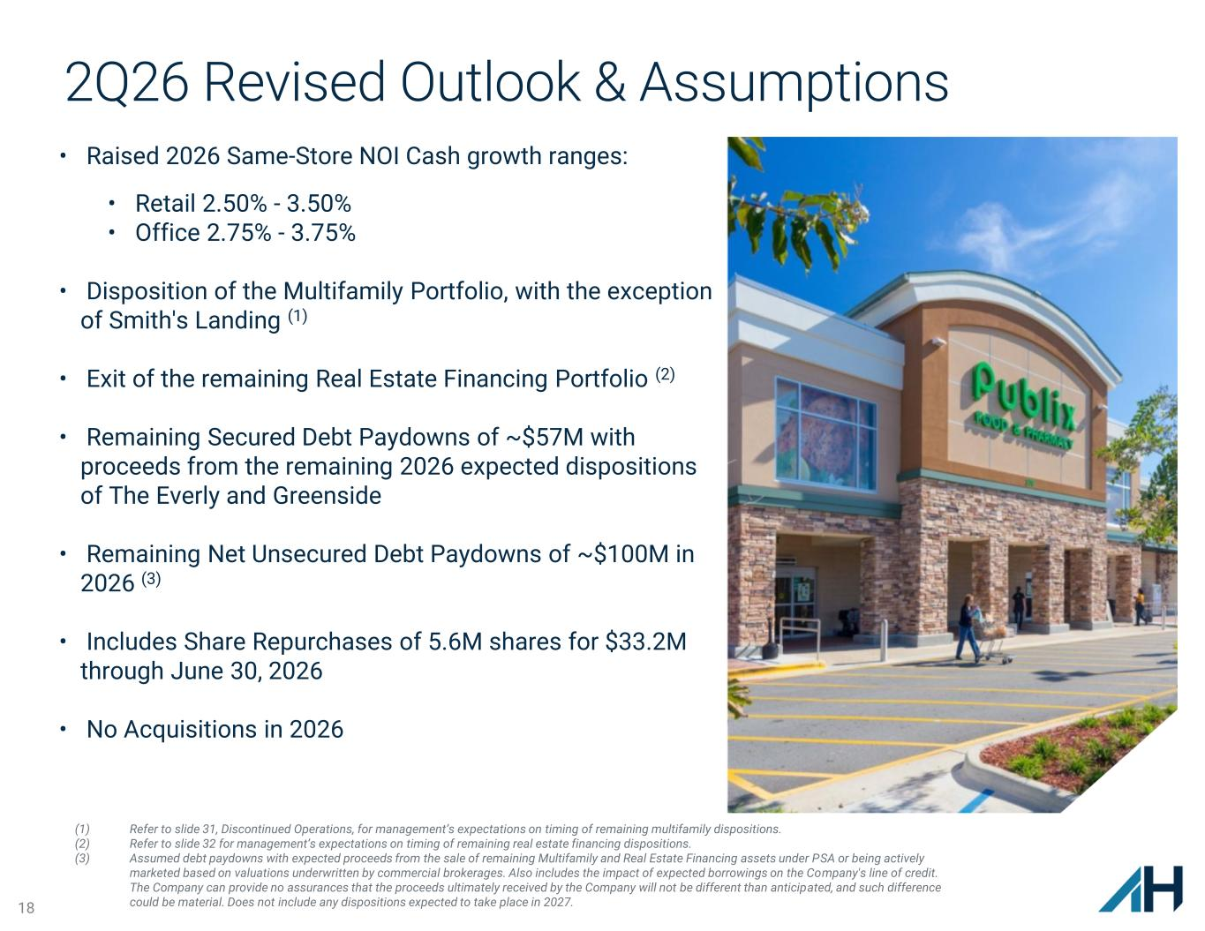
18 2Q26 Revised Outlook & Assumptions • Raised 2026 Same-Store NOI Cash growth ranges: • Retail 2.50% - 3.50% • Office 2.75% - 3.75% • Disposition of the Multifamily Portfolio, with the exception of Smith's Landing (1) • Exit of the remaining Real Estate Financing Portfolio (2) • Remaining Secured Debt Paydowns of ~$57M with proceeds from the remaining 2026 expected dispositions of The Everly and Greenside • Remaining Net Unsecured Debt Paydowns of ~$100M in 2026 (3) • Includes Share Repurchases of 5.6M shares for $33.2M through June 30, 2026 • No Acquisitions in 2026 (1) Refer to slide 31, Discontinued Operations, for management’s expectations on timing of remaining multifamily dispositions. (2) Refer to slide 32 for management’s expectations on timing of remaining real estate financing dispositions. (3) Assumed debt paydowns with expected proceeds from the sale of remaining Multifamily and Real Estate Financing assets under PSA or being actively marketed based on valuations underwritten by commercial brokerages. Also includes the impact of expected borrowings on the Company's line of credit. The Company can provide no assurances that the proceeds ultimately received by the Company will not be different than anticipated, and such difference could be material. Does not include any dispositions expected to take place in 2027.

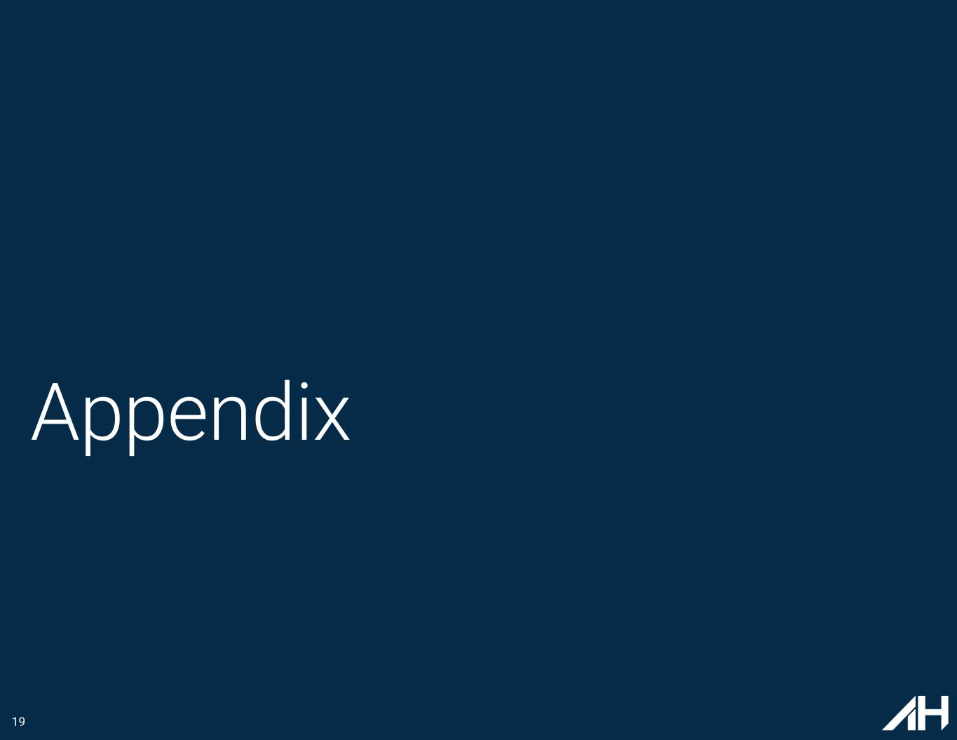
19 Appendix

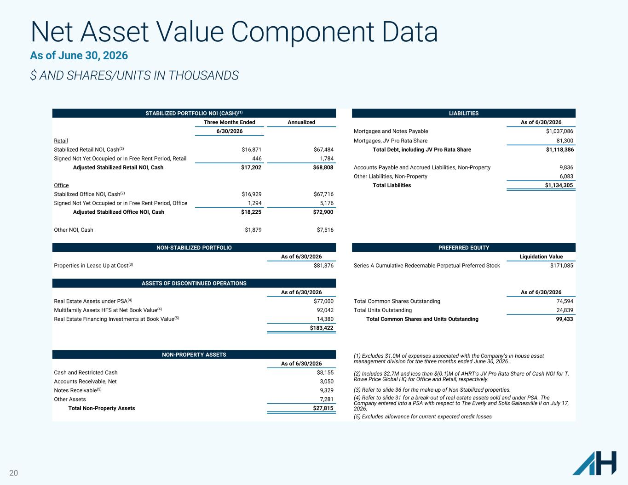
20 Net Asset Value Component Data As of June 30, 2026 $ AND SHARES/UNITS IN THOUSANDS STABILIZED PORTFOLIO NOI (CASH)(1) LIABILITIES Three Months Ended Annualized As of 6/30/2026 6/30/2026 Mortgages and Notes Payable $1,037,086 Retail Mortgages, JV Pro Rata Share 81,300 Stabilized Retail NOI, Cash(2) $16,871 $67,484 Total Debt, including JV Pro Rata Share $1,118,386 Signed Not Yet Occupied or in Free Rent Period, Retail 446 1,784 Adjusted Stabilized Retail NOI, Cash $17,202 $68,808 Accounts Payable and Accrued Liabilities, Non-Property 9,836 Other Liabilities, Non-Property 6,083 Office Total Liabilities $1,134,305 Stabilized Office NOI, Cash(2) $16,929 $67,716 Signed Not Yet Occupied or in Free Rent Period, Office 1,294 5,176 Adjusted Stabilized Office NOI, Cash $18,225 $72,900 Other NOI, Cash $1,879 $7,516 NON-STABILIZED PORTFOLIO PREFERRED EQUITY As of 6/30/2026 Liquidation Value Properties in Lease Up at Cost(3) $81,376 Series A Cumulative Redeemable Perpetual Preferred Stock $171,085 ASSETS OF DISCONTINUED OPERATIONS COMMON EQUITY As of 6/30/2026 As of 6/30/2026 Real Estate Assets under PSA(4) $77,000 Total Common Shares Outstanding 74,594 Multifamily Assets HFS at Net Book Value(4) 92,042 Total Units Outstanding 24,839 Real Estate Financing Investments at Book Value(5) 14,380 Total Common Shares and Units Outstanding 99,433 $183,422 NON-PROPERTY ASSETS (1) Excludes $1.0M of expenses associated with the Company’s in-house asset management division for the three months ended June 30, 2026.As of 6/30/2026 Cash and Restricted Cash $8,155 (2) Includes $2.7M and less than $(0.1)M of AHRT’s JV Pro Rata Share of Cash NOI for T. Rowe Price Global HQ for Office and Retail, respectively.Accounts Receivable, Net 3,050 Notes Receivable(5) 9,329 (3) Refer to slide 36 for the make-up of Non-Stabilized properties. Other Assets 7,281 (4) Refer to slide 31 for a break-out of real estate assets sold and under PSA. The Company entered into a PSA with respect to The Everly and Solis Gainesville II on July 17, 2026.Total Non-Property Assets $27,815 (5) Excludes allowance for current expected credit losses

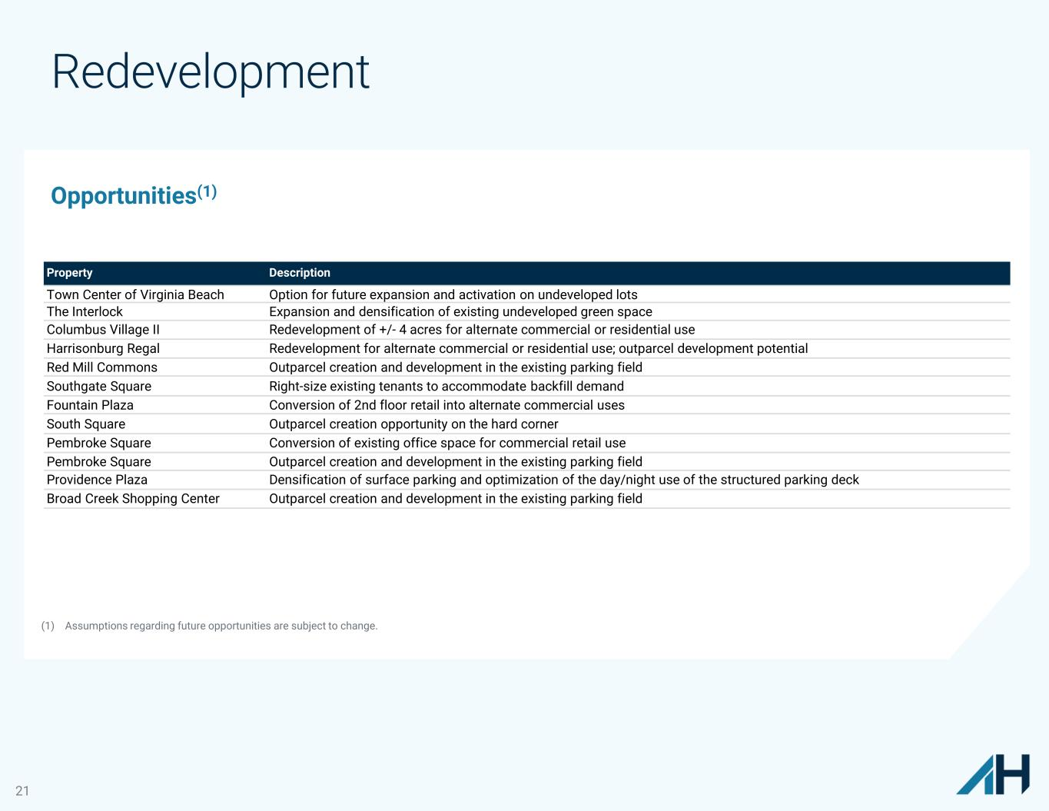
21 Redevelopment Property Description Town Center of Virginia Beach Option for future expansion and activation on undeveloped lots The Interlock Expansion and densification of existing undeveloped green space Columbus Village II Redevelopment of +/- 4 acres for alternate commercial or residential use Harrisonburg Regal Redevelopment for alternate commercial or residential use; outparcel development potential Red Mill Commons Outparcel creation and development in the existing parking field Southgate Square Right-size existing tenants to accommodate backfill demand Fountain Plaza Conversion of 2nd floor retail into alternate commercial uses South Square Outparcel creation opportunity on the hard corner Pembroke Square Conversion of existing office space for commercial retail use Pembroke Square Outparcel creation and development in the existing parking field Providence Plaza Densification of surface parking and optimization of the day/night use of the structured parking deck Broad Creek Shopping Center Outparcel creation and development in the existing parking field Opportunities(1) (1) Assumptions regarding future opportunities are subject to change.

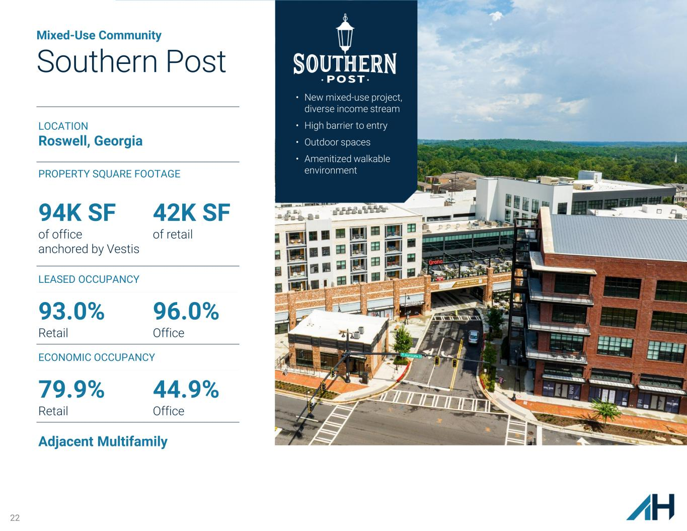
22 Mixed-Use Community Southern Post • New mixed-use project, diverse income stream • High barrier to entry • Outdoor spaces • Amenitized walkable environment LOCATION Roswell, Georgia PROPERTY SQUARE FOOTAGE 94K SF of office anchored by Vestis 42K SF of retail LEASED OCCUPANCY 93.0% Retail 96.0% Office ECONOMIC OCCUPANCY 79.9% Retail 44.9% Office Adjacent Multifamily

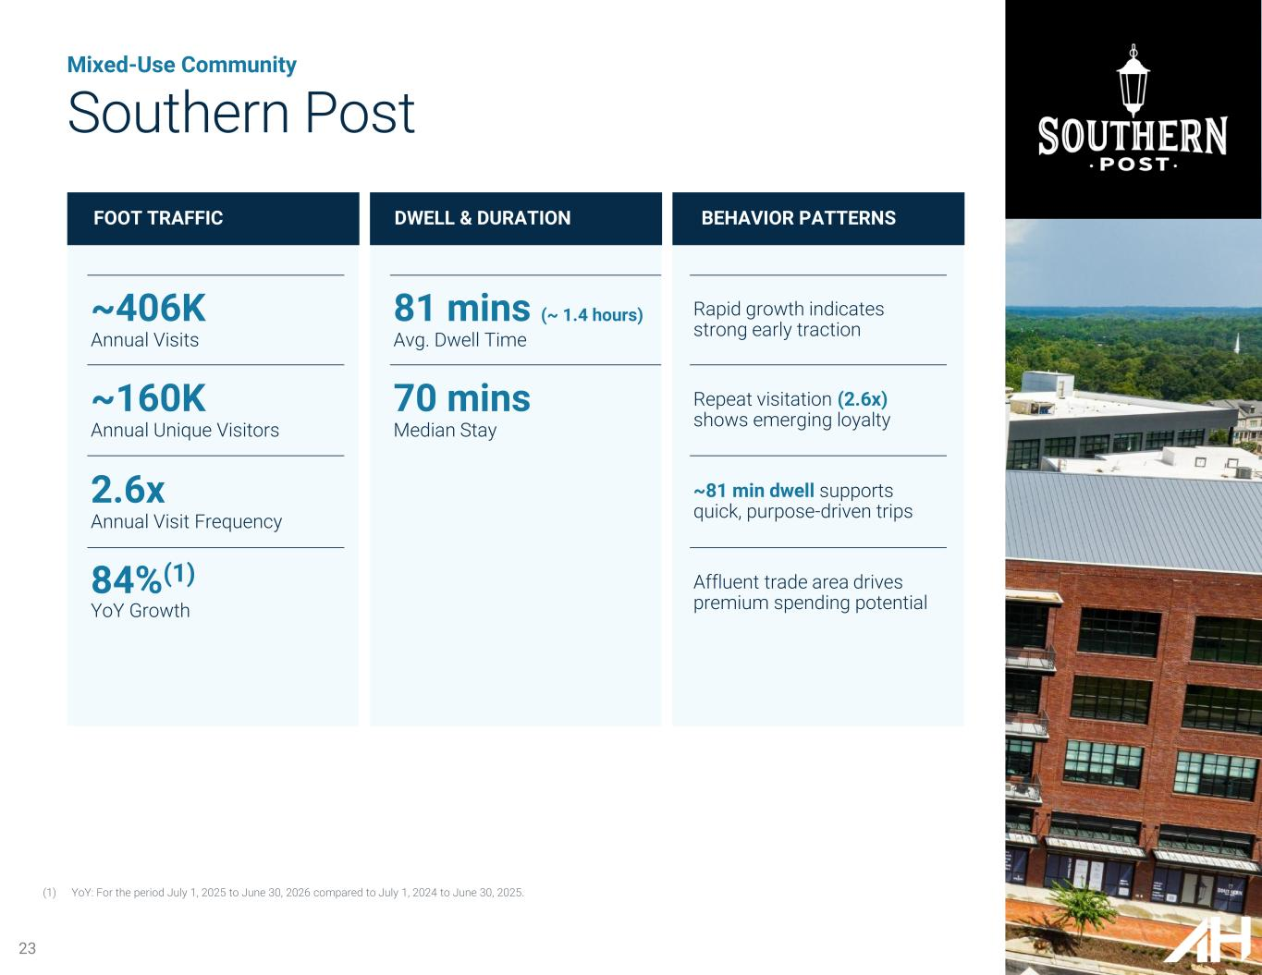
Mixed-Use Community Southern Post FOOT TRAFFIC DWELL & DURATION BEHAVIOR PATTERNS ~406K Annual Visits ~160K Annual Unique Visitors 2.6x Annual Visit Frequency 84%(1) YoY Growth 81 mins (~ 1.4 hours) Avg. Dwell Time 70 mins Median Stay Rapid growth indicates strong early traction Repeat visitation (2.6x) shows emerging loyalty ~81 min dwell supports quick, purpose-driven trips Affluent trade area drives premium spending potential (1) YoY: For the period July 1, 2025 to June 30, 2026 compared to July 1, 2024 to June 30, 2025. 23

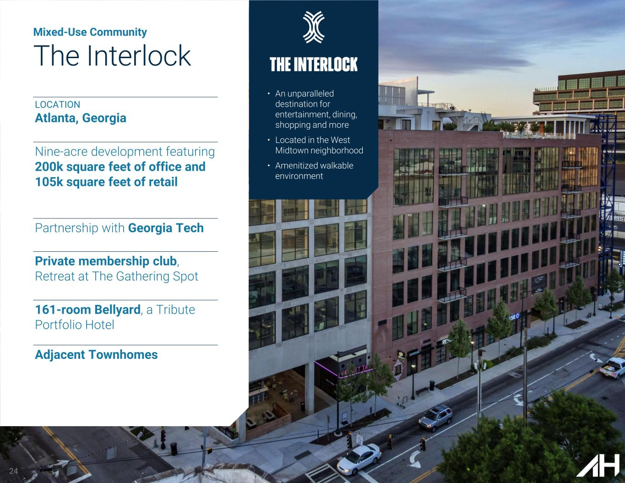
24 Mixed-Use Community The Interlock • An unparalleled destination for entertainment, dining, shopping and more • Located in the West Midtown neighborhood • Amenitized walkable environment LOCATION Atlanta, Georgia Nine-acre development featuring 200k square feet of office and 105k square feet of retail Partnership with Georgia Tech Private membership club, Retreat at The Gathering Spot 161-room Bellyard, a Tribute Portfolio Hotel Adjacent Townhomes

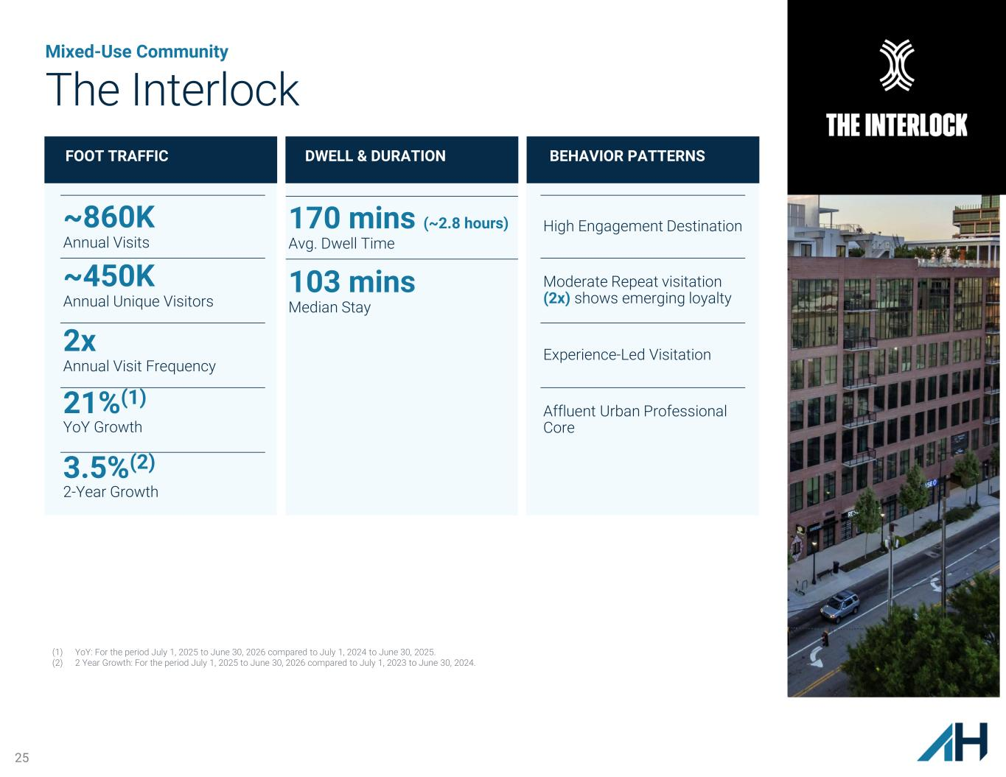
25 Mixed-Use Community The Interlock FOOT TRAFFIC DWELL & DURATION BEHAVIOR PATTERNS ~860K Annual Visits ~450K Annual Unique Visitors 2x Annual Visit Frequency 21%(1) YoY Growth 3.5%(2) 2-Year Growth 170 mins (~2.8 hours) Avg. Dwell Time 103 mins Median Stay High Engagement Destination Moderate Repeat visitation (2x) shows emerging loyalty Experience-Led Visitation Affluent Urban Professional Core (1) YoY: For the period July 1, 2025 to June 30, 2026 compared to July 1, 2024 to June 30, 2025. (2) 2 Year Growth: For the period July 1, 2025 to June 30, 2026 compared to July 1, 2023 to June 30, 2024.

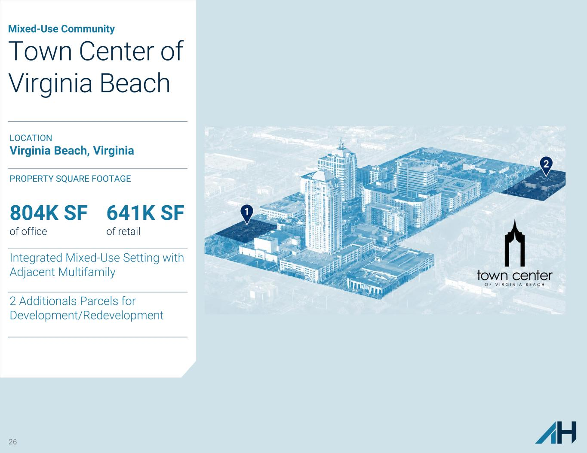
26 Mixed-Use Community Town Center of Virginia Beach LOCATION Virginia Beach, Virginia PROPERTY SQUARE FOOTAGE 804K SF of office 641K SF of retail Integrated Mixed-Use Setting with Adjacent Multifamily 2 Additionals Parcels for Development/Redevelopment

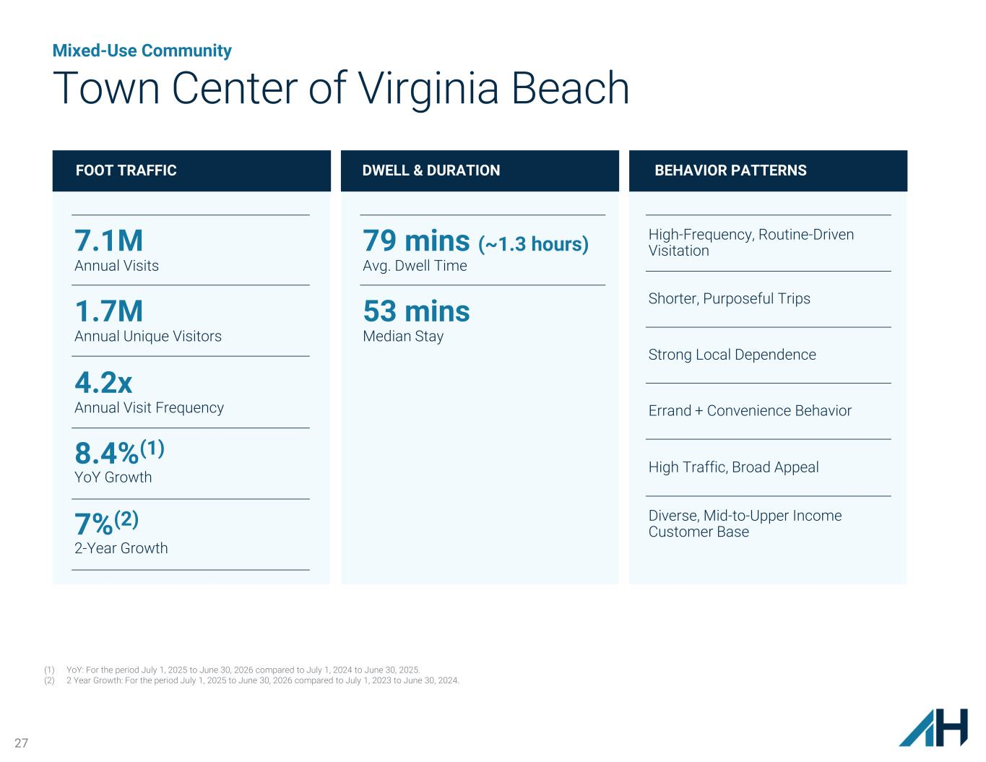
27 Mixed-Use Community Town Center of Virginia Beach FOOT TRAFFIC DWELL & DURATION BEHAVIOR PATTERNS 7.1M Annual Visits 1.7M Annual Unique Visitors 4.2x Annual Visit Frequency 8.4%(1) YoY Growth 7%(2) 2-Year Growth 79 mins (~1.3 hours) Avg. Dwell Time 53 mins Median Stay High-Frequency, Routine-Driven Visitation Shorter, Purposeful Trips Strong Local Dependence Errand + Convenience Behavior High Traffic, Broad Appeal Diverse, Mid-to-Upper Income Customer Base (1) YoY: For the period July 1, 2025 to June 30, 2026 compared to July 1, 2024 to June 30, 2025. (2) 2 Year Growth: For the period July 1, 2025 to June 30, 2026 compared to July 1, 2023 to June 30, 2024.

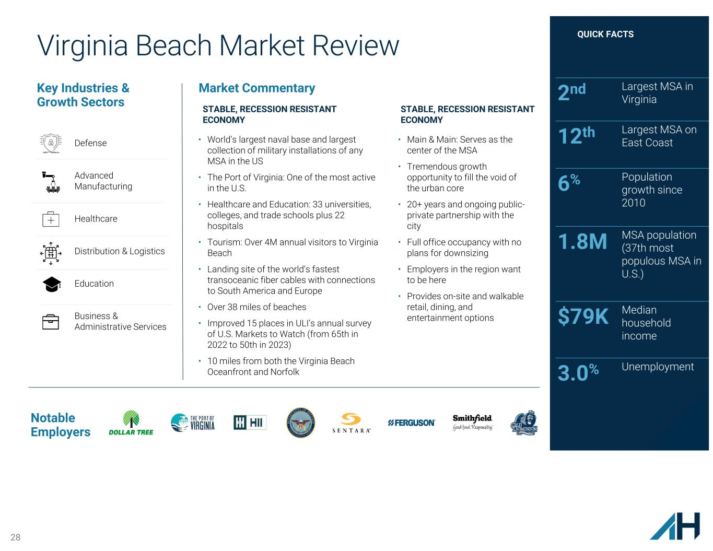
28 Virginia Beach Market Review Key Industries & Growth Sectors 2nd Largest MSA in Virginia 12th Largest MSA on East Coast 6% Population growth since 2010 1.8M MSA population (37th most populous MSA in U.S.) $79K Median household income 3.0% Unemployment QUICK FACTS Notable Employers Market Commentary STABLE, RECESSION RESISTANT ECONOMY • World’s largest naval base and largest collection of military installations of any MSA in the US • The Port of Virginia: One of the most active in the U.S. • Healthcare and Education: 33 universities, colleges, and trade schools plus 22 hospitals • Tourism: Over 4M annual visitors to Virginia Beach • Landing site of the world’s fastest transoceanic fiber cables with connections to South America and Europe • Over 38 miles of beaches • Improved 15 places in ULI’s annual survey of U.S. Markets to Watch (from 65th in 2022 to 50th in 2023) • 10 miles from both the Virginia Beach Oceanfront and Norfolk STABLE, RECESSION RESISTANT ECONOMY • Main & Main: Serves as the center of the MSA • Tremendous growth opportunity to fill the void of the urban core • 20+ years and ongoing public- private partnership with the city • Full office occupancy with no plans for downsizing • Employers in the region want to be here • Provides on-site and walkable retail, dining, and entertainment options Defense Advanced Manufacturing Healthcare Distribution & Logistics Education Business & Administrative Services

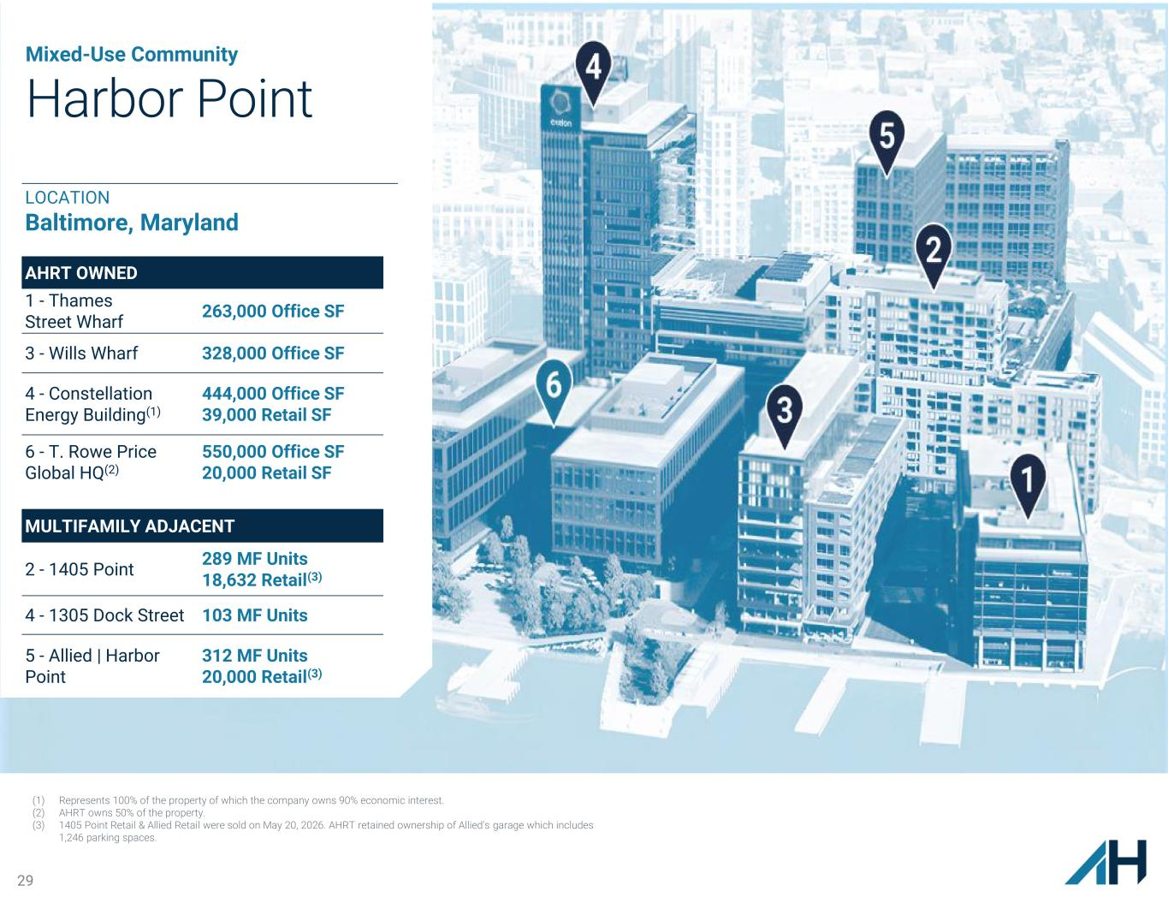
29 Mixed-Use Community Harbor Point AHRT OWNED 1 - Thames Street Wharf 263,000 Office SF 3 - Wills Wharf 328,000 Office SF 4 - Constellation Energy Building(1) 444,000 Office SF 39,000 Retail SF 6 - T. Rowe Price Global HQ(2) 550,000 Office SF 20,000 Retail SF MULTIFAMILY ADJACENT 2 - 1405 Point 289 MF Units 18,632 Retail(3) 4 - 1305 Dock Street 103 MF Units 5 - Allied | Harbor Point 312 MF Units 20,000 Retail(3) (1) Represents 100% of the property of which the company owns 90% economic interest. (2) AHRT owns 50% of the property. (3) 1405 Point Retail & Allied Retail were sold on May 20, 2026. AHRT retained ownership of Allied's garage which includes 1,246 parking spaces. LOCATION Baltimore, Maryland

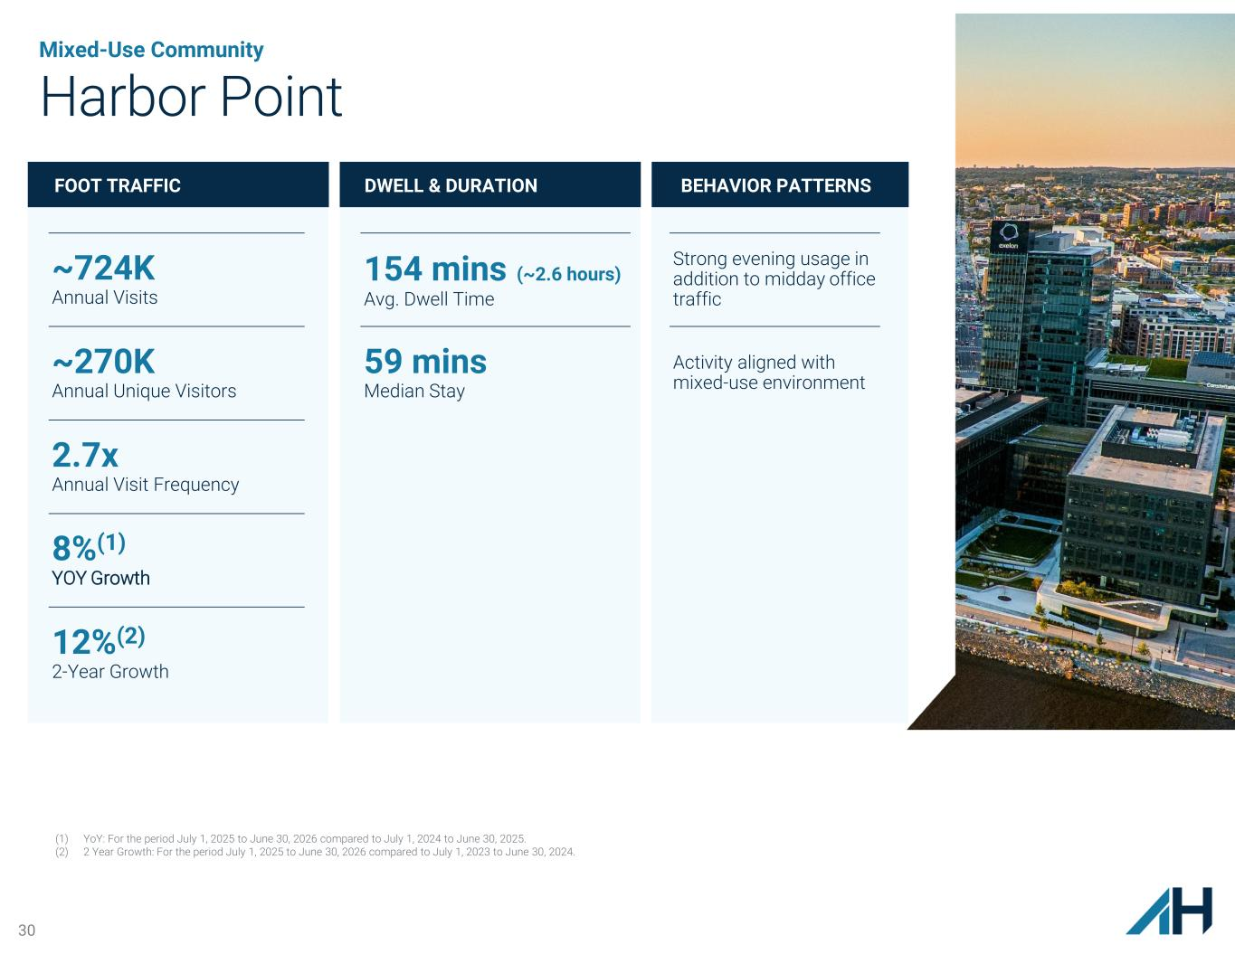
30 Mixed-Use Community Harbor Point FOOT TRAFFIC DWELL & DURATION BEHAVIOR PATTERNS ~724K Annual Visits ~270K Annual Unique Visitors 2.7x Annual Visit Frequency 8%(1) YOY Growth 12%(2) 2-Year Growth 154 mins (~2.6 hours) Avg. Dwell Time 59 mins Median Stay Strong evening usage in addition to midday office traffic Activity aligned with mixed-use environment 30 (1) YoY: For the period July 1, 2025 to June 30, 2026 compared to July 1, 2024 to June 30, 2025. (2) 2 Year Growth: For the period July 1, 2025 to June 30, 2026 compared to July 1, 2023 to June 30, 2024.

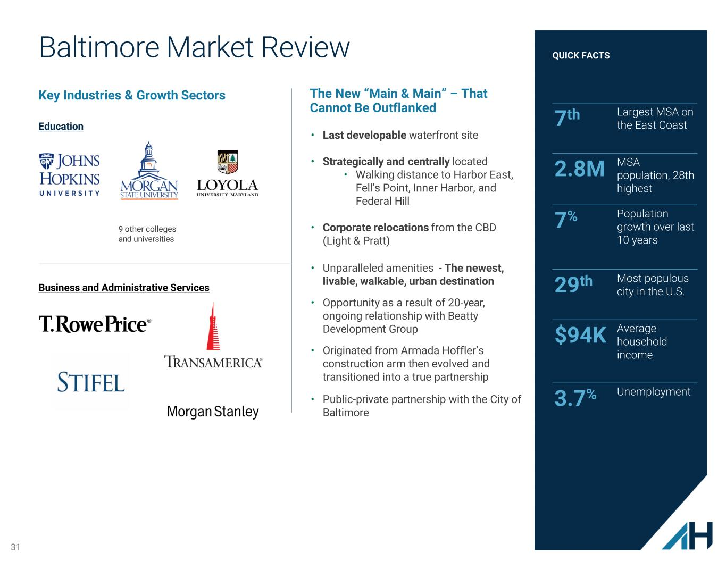
31 Baltimore Market Review Key Industries & Growth Sectors 7th Largest MSA on the East Coast 2.8M MSA population, 28th highest 7% Population growth over last 10 years 29th Most populous city in the U.S. $94K Average household income 3.7% Unemployment QUICK FACTS The New “Main & Main” – That Cannot Be Outflanked • Last developable waterfront site • Strategically and centrally located • Walking distance to Harbor East, Fell’s Point, Inner Harbor, and Federal Hill • Corporate relocations from the CBD (Light & Pratt) • Unparalleled amenities - The newest, livable, walkable, urban destination • Opportunity as a result of 20-year, ongoing relationship with Beatty Development Group • Originated from Armada Hoffler’s construction arm then evolved and transitioned into a true partnership • Public-private partnership with the City of Baltimore 9 other colleges and universities Education Business and Administrative Services

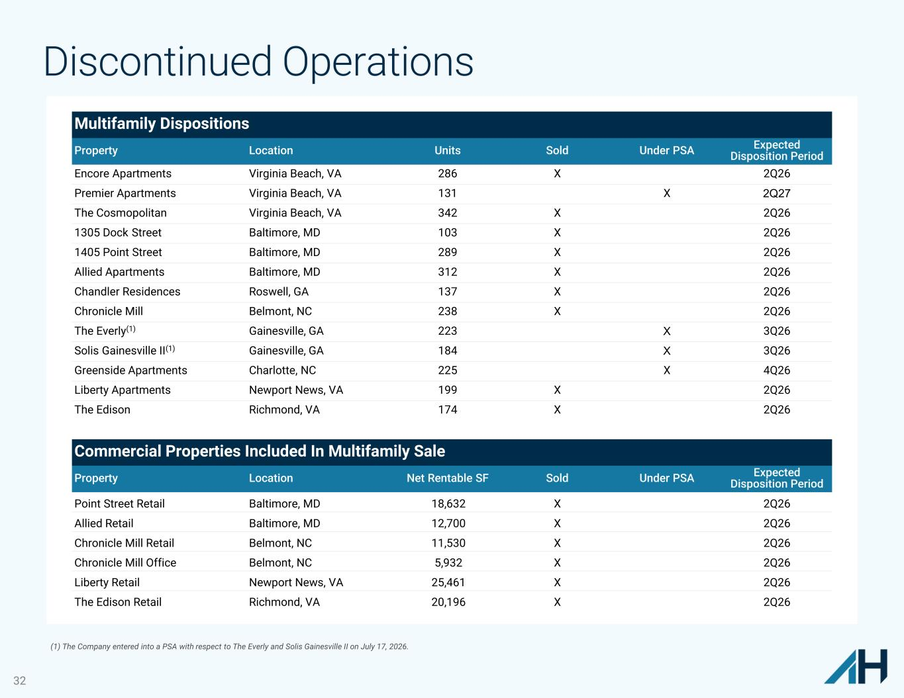
32 Discontinued Operations Multifamily Dispositions Property Location Units Sold Under PSA Expected Disposition Period Encore Apartments Virginia Beach, VA 286 X 2Q26 Premier Apartments Virginia Beach, VA 131 X 2Q27 The Cosmopolitan Virginia Beach, VA 342 X 2Q26 1305 Dock Street Baltimore, MD 103 X 2Q26 1405 Point Street Baltimore, MD 289 X 2Q26 Allied Apartments Baltimore, MD 312 X 2Q26 Chandler Residences Roswell, GA 137 X 2Q26 Chronicle Mill Belmont, NC 238 X 2Q26 The Everly(1) Gainesville, GA 223 X 3Q26 Solis Gainesville II(1) Gainesville, GA 184 X 3Q26 Greenside Apartments Charlotte, NC 225 X 4Q26 Liberty Apartments Newport News, VA 199 X 2Q26 The Edison Richmond, VA 174 X 2Q26 Commercial Properties Included In Multifamily Sale Property Location Net Rentable SF Sold Under PSA Expected Disposition Period Point Street Retail Baltimore, MD 18,632 X 2Q26 Allied Retail Baltimore, MD 12,700 X 2Q26 Chronicle Mill Retail Belmont, NC 11,530 X 2Q26 Chronicle Mill Office Belmont, NC 5,932 X 2Q26 Liberty Retail Newport News, VA 25,461 X 2Q26 The Edison Retail Richmond, VA 20,196 X 2Q26 (1) The Company entered into a PSA with respect to The Everly and Solis Gainesville II on July 17, 2026.

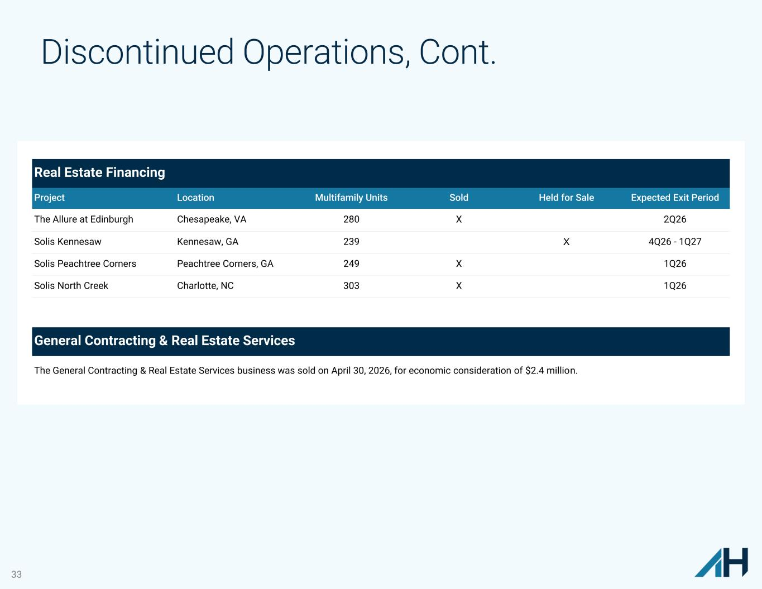
33 Discontinued Operations, Cont. Real Estate Financing Project Location Multifamily Units Sold Held for Sale Expected Exit Period The Allure at Edinburgh Chesapeake, VA 280 X 2Q26 Solis Kennesaw Kennesaw, GA 239 X 4Q26 - 1Q27 Solis Peachtree Corners Peachtree Corners, GA 249 X 1Q26 Solis North Creek Charlotte, NC 303 X 1Q26 General Contracting & Real Estate Services The General Contracting & Real Estate Services business was sold on April 30, 2026, for economic consideration of $2.4 million.

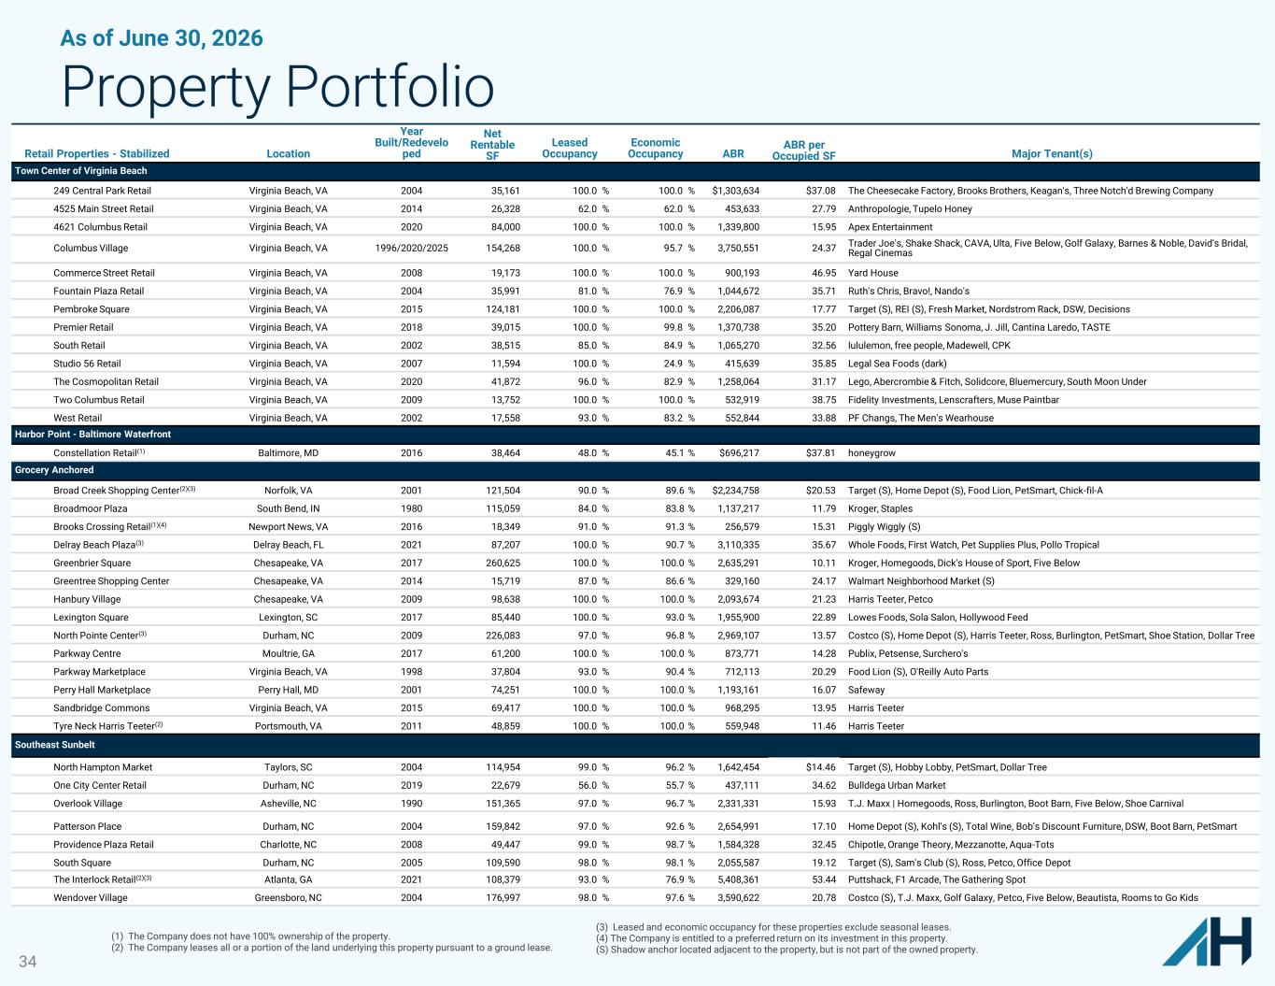
34 As of June 30, 2026 Property Portfolio Retail Properties - Stabilized Location Year Built/Redevelo ped Net Rentable SF Leased Occupancy Economic Occupancy ABR ABR per Occupied SF Major Tenant(s) Town Center of Virginia Beach 249 Central Park Retail Virginia Beach, VA 2004 35,161 100.0 % 100.0 % $1,303,634 $37.08 The Cheesecake Factory, Brooks Brothers, Keagan's, Three Notch'd Brewing Company 4525 Main Street Retail Virginia Beach, VA 2014 26,328 62.0 % 62.0 % 453,633 27.79 Anthropologie, Tupelo Honey 4621 Columbus Retail Virginia Beach, VA 2020 84,000 100.0 % 100.0 % 1,339,800 15.95 Apex Entertainment Columbus Village Virginia Beach, VA 1996/2020/2025 154,268 100.0 % 95.7 % 3,750,551 24.37 Trader Joe's, Shake Shack, CAVA, Ulta, Five Below, Golf Galaxy, Barnes & Noble, David's Bridal, Regal Cinemas Commerce Street Retail Virginia Beach, VA 2008 19,173 100.0 % 100.0 % 900,193 46.95 Yard House Fountain Plaza Retail Virginia Beach, VA 2004 35,991 81.0 % 76.9 % 1,044,672 35.71 Ruth's Chris, Bravo!, Nando's Pembroke Square Virginia Beach, VA 2015 124,181 100.0 % 100.0 % 2,206,087 17.77 Target (S), REI (S), Fresh Market, Nordstrom Rack, DSW, Decisions Premier Retail Virginia Beach, VA 2018 39,015 100.0 % 99.8 % 1,370,738 35.20 Pottery Barn, Williams Sonoma, J. Jill, Cantina Laredo, TASTE South Retail Virginia Beach, VA 2002 38,515 85.0 % 84.9 % 1,065,270 32.56 lululemon, free people, Madewell, CPK Studio 56 Retail Virginia Beach, VA 2007 11,594 100.0 % 24.9 % 415,639 35.85 Legal Sea Foods (dark) The Cosmopolitan Retail Virginia Beach, VA 2020 41,872 96.0 % 82.9 % 1,258,064 31.17 Lego, Abercrombie & Fitch, Solidcore, Bluemercury, South Moon Under Two Columbus Retail Virginia Beach, VA 2009 13,752 100.0 % 100.0 % 532,919 38.75 Fidelity Investments, Lenscrafters, Muse Paintbar West Retail Virginia Beach, VA 2002 17,558 93.0 % 83.2 % 552,844 33.88 PF Changs, The Men's Wearhouse Harbor Point - Baltimore Waterfront Constellation Retail(1) Baltimore, MD 2016 38,464 48.0 % 45.1 % $696,217 $37.81 honeygrow Grocery Anchored Broad Creek Shopping Center(2)(3) Norfolk, VA 2001 121,504 90.0 % 89.6 % $2,234,758 $20.53 Target (S), Home Depot (S), Food Lion, PetSmart, Chick-fil-A Broadmoor Plaza South Bend, IN 1980 115,059 84.0 % 83.8 % 1,137,217 11.79 Kroger, Staples Brooks Crossing Retail(1)(4) Newport News, VA 2016 18,349 91.0 % 91.3 % 256,579 15.31 Piggly Wiggly (S) Delray Beach Plaza(3) Delray Beach, FL 2021 87,207 100.0 % 90.7 % 3,110,335 35.67 Whole Foods, First Watch, Pet Supplies Plus, Pollo Tropical Greenbrier Square Chesapeake, VA 2017 260,625 100.0 % 100.0 % 2,635,291 10.11 Kroger, Homegoods, Dick's House of Sport, Five Below Greentree Shopping Center Chesapeake, VA 2014 15,719 87.0 % 86.6 % 329,160 24.17 Walmart Neighborhood Market (S) Hanbury Village Chesapeake, VA 2009 98,638 100.0 % 100.0 % 2,093,674 21.23 Harris Teeter, Petco Lexington Square Lexington, SC 2017 85,440 100.0 % 93.0 % 1,955,900 22.89 Lowes Foods, Sola Salon, Hollywood Feed North Pointe Center(3) Durham, NC 2009 226,083 97.0 % 96.8 % 2,969,107 13.57 Costco (S), Home Depot (S), Harris Teeter, Ross, Burlington, PetSmart, Shoe Station, Dollar Tree Parkway Centre Moultrie, GA 2017 61,200 100.0 % 100.0 % 873,771 14.28 Publix, Petsense, Surchero's Parkway Marketplace Virginia Beach, VA 1998 37,804 93.0 % 90.4 % 712,113 20.29 Food Lion (S), O'Reilly Auto Parts Perry Hall Marketplace Perry Hall, MD 2001 74,251 100.0 % 100.0 % 1,193,161 16.07 Safeway Sandbridge Commons Virginia Beach, VA 2015 69,417 100.0 % 100.0 % 968,295 13.95 Harris Teeter Tyre Neck Harris Teeter(2) Portsmouth, VA 2011 48,859 100.0 % 100.0 % 559,948 11.46 Harris Teeter Southeast Sunbelt North Hampton Market Taylors, SC 2004 114,954 99.0 % 96.2 % 1,642,454 $14.46 Target (S), Hobby Lobby, PetSmart, Dollar Tree One City Center Retail Durham, NC 2019 22,679 56.0 % 55.7 % 437,111 34.62 Bulldega Urban Market Overlook Village Asheville, NC 1990 151,365 97.0 % 96.7 % 2,331,331 15.93 T.J. Maxx | Homegoods, Ross, Burlington, Boot Barn, Five Below, Shoe Carnival Patterson Place Durham, NC 2004 159,842 97.0 % 92.6 % 2,654,991 17.10 Home Depot (S), Kohl's (S), Total Wine, Bob's Discount Furniture, DSW, Boot Barn, PetSmart Providence Plaza Retail Charlotte, NC 2008 49,447 99.0 % 98.7 % 1,584,328 32.45 Chipotle, Orange Theory, Mezzanotte, Aqua-Tots South Square Durham, NC 2005 109,590 98.0 % 98.1 % 2,055,587 19.12 Target (S), Sam's Club (S), Ross, Petco, Office Depot The Interlock Retail(2)(3) Atlanta, GA 2021 108,379 93.0 % 76.9 % 5,408,361 53.44 Puttshack, F1 Arcade, The Gathering Spot Wendover Village Greensboro, NC 2004 176,997 98.0 % 97.6 % 3,590,622 20.78 Costco (S), T.J. Maxx, Golf Galaxy, Petco, Five Below, Beautista, Rooms to Go Kids (1) The Company does not have 100% ownership of the property. (2) The Company leases all or a portion of the land underlying this property pursuant to a ground lease. (3) Leased and economic occupancy for these properties exclude seasonal leases. (4) The Company is entitled to a preferred return on its investment in this property. (S) Shadow anchor located adjacent to the property, but is not part of the owned property.

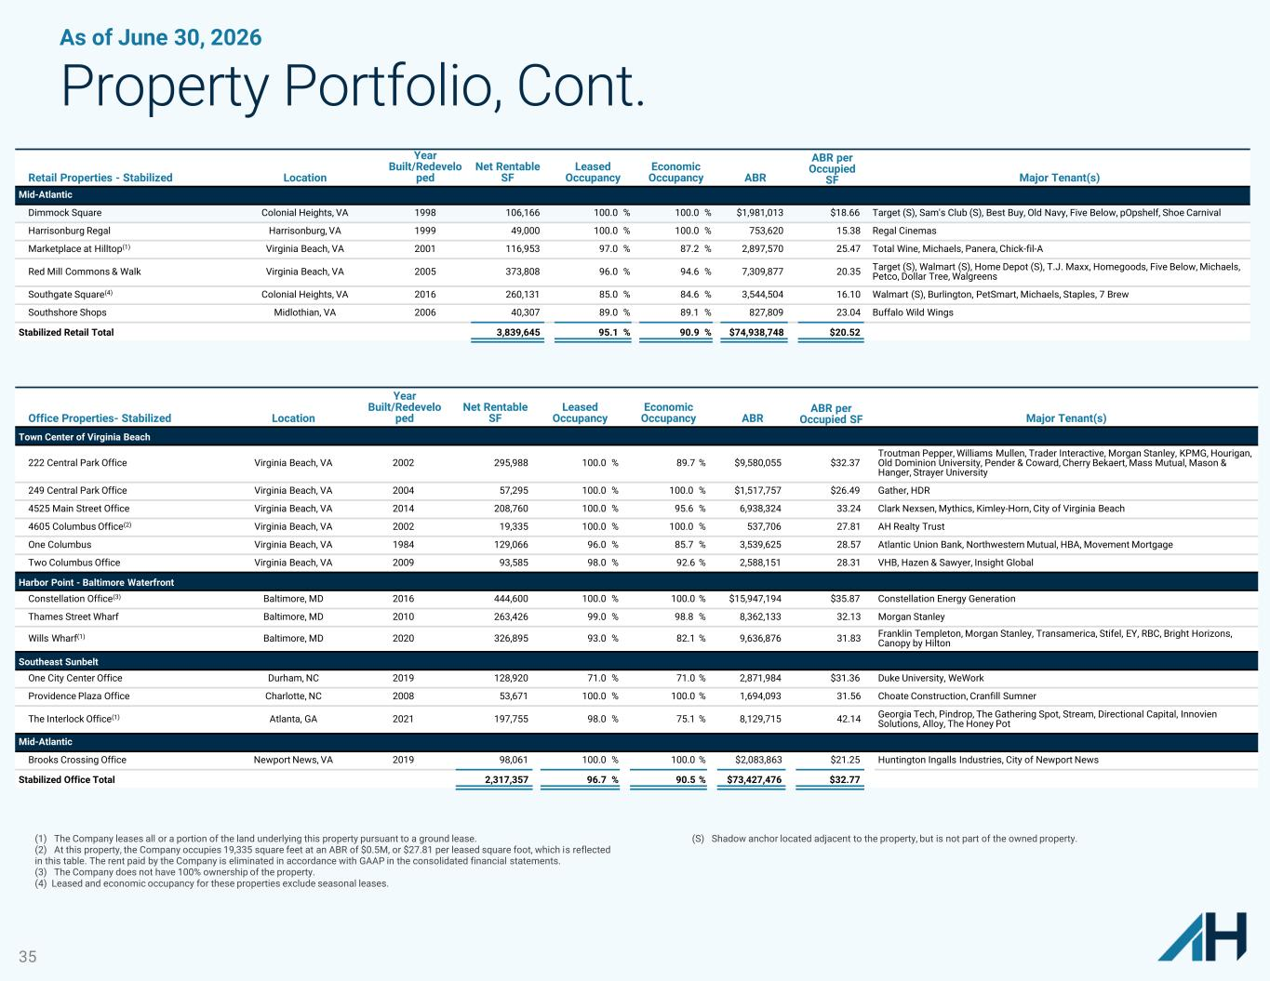
35 As of June 30, 2026 Property Portfolio, Cont. Retail Properties - Stabilized Location Year Built/Redevelo ped Net Rentable SF Leased Occupancy Economic Occupancy ABR ABR per Occupied SF Major Tenant(s) Mid-Atlantic Dimmock Square Colonial Heights, VA 1998 106,166 100.0 % 100.0 % $1,981,013 $18.66 Target (S), Sam's Club (S), Best Buy, Old Navy, Five Below, pOpshelf, Shoe Carnival Harrisonburg Regal Harrisonburg, VA 1999 49,000 100.0 % 100.0 % 753,620 15.38 Regal Cinemas Marketplace at Hilltop(1) Virginia Beach, VA 2001 116,953 97.0 % 87.2 % 2,897,570 25.47 Total Wine, Michaels, Panera, Chick-fil-A Red Mill Commons & Walk Virginia Beach, VA 2005 373,808 96.0 % 94.6 % 7,309,877 20.35 Target (S), Walmart (S), Home Depot (S), T.J. Maxx, Homegoods, Five Below, Michaels, Petco, Dollar Tree, Walgreens Southgate Square(4) Colonial Heights, VA 2016 260,131 85.0 % 84.6 % 3,544,504 16.10 Walmart (S), Burlington, PetSmart, Michaels, Staples, 7 Brew Southshore Shops Midlothian, VA 2006 40,307 89.0 % 89.1 % 827,809 23.04 Buffalo Wild Wings Stabilized Retail Total 3,839,645 95.1 % 90.9 % $74,938,748 $20.52 Office Properties- Stabilized Location Year Built/Redevelo ped Net Rentable SF Leased Occupancy Economic Occupancy ABR ABR per Occupied SF Major Tenant(s) Town Center of Virginia Beach 222 Central Park Office Virginia Beach, VA 2002 295,988 100.0 % 89.7 % $9,580,055 $32.37 Troutman Pepper, Williams Mullen, Trader Interactive, Morgan Stanley, KPMG, Hourigan, Old Dominion University, Pender & Coward, Cherry Bekaert, Mass Mutual, Mason & Hanger, Strayer University 249 Central Park Office Virginia Beach, VA 2004 57,295 100.0 % 100.0 % $1,517,757 $26.49 Gather, HDR 4525 Main Street Office Virginia Beach, VA 2014 208,760 100.0 % 95.6 % 6,938,324 33.24 Clark Nexsen, Mythics, Kimley-Horn, City of Virginia Beach 4605 Columbus Office(2) Virginia Beach, VA 2002 19,335 100.0 % 100.0 % 537,706 27.81 AH Realty Trust One Columbus Virginia Beach, VA 1984 129,066 96.0 % 85.7 % 3,539,625 28.57 Atlantic Union Bank, Northwestern Mutual, HBA, Movement Mortgage Two Columbus Office Virginia Beach, VA 2009 93,585 98.0 % 92.6 % 2,588,151 28.31 VHB, Hazen & Sawyer, Insight Global Harbor Point - Baltimore Waterfront Constellation Office(3) Baltimore, MD 2016 444,600 100.0 % 100.0 % $15,947,194 $35.87 Constellation Energy Generation Thames Street Wharf Baltimore, MD 2010 263,426 99.0 % 98.8 % 8,362,133 32.13 Morgan Stanley Wills Wharf(1) Baltimore, MD 2020 326,895 93.0 % 82.1 % 9,636,876 31.83 Franklin Templeton, Morgan Stanley, Transamerica, Stifel, EY, RBC, Bright Horizons, Canopy by Hilton Southeast Sunbelt One City Center Office Durham, NC 2019 128,920 71.0 % 71.0 % 2,871,984 $31.36 Duke University, WeWork Providence Plaza Office Charlotte, NC 2008 53,671 100.0 % 100.0 % 1,694,093 31.56 Choate Construction, Cranfill Sumner The Interlock Office(1) Atlanta, GA 2021 197,755 98.0 % 75.1 % 8,129,715 42.14 Georgia Tech, Pindrop, The Gathering Spot, Stream, Directional Capital, Innovien Solutions, Alloy, The Honey Pot Mid-Atlantic Brooks Crossing Office Newport News, VA 2019 98,061 100.0 % 100.0 % $2,083,863 $21.25 Huntington Ingalls Industries, City of Newport News Stabilized Office Total 2,317,357 96.7 % 90.5 % $73,427,476 $32.77 (1) The Company leases all or a portion of the land underlying this property pursuant to a ground lease. (2) At this property, the Company occupies 19,335 square feet at an ABR of $0.5M, or $27.81 per leased square foot, which is reflected in this table. The rent paid by the Company is eliminated in accordance with GAAP in the consolidated financial statements. (3) The Company does not have 100% ownership of the property. (4) Leased and economic occupancy for these properties exclude seasonal leases. (S) Shadow anchor located adjacent to the property, but is not part of the owned property.

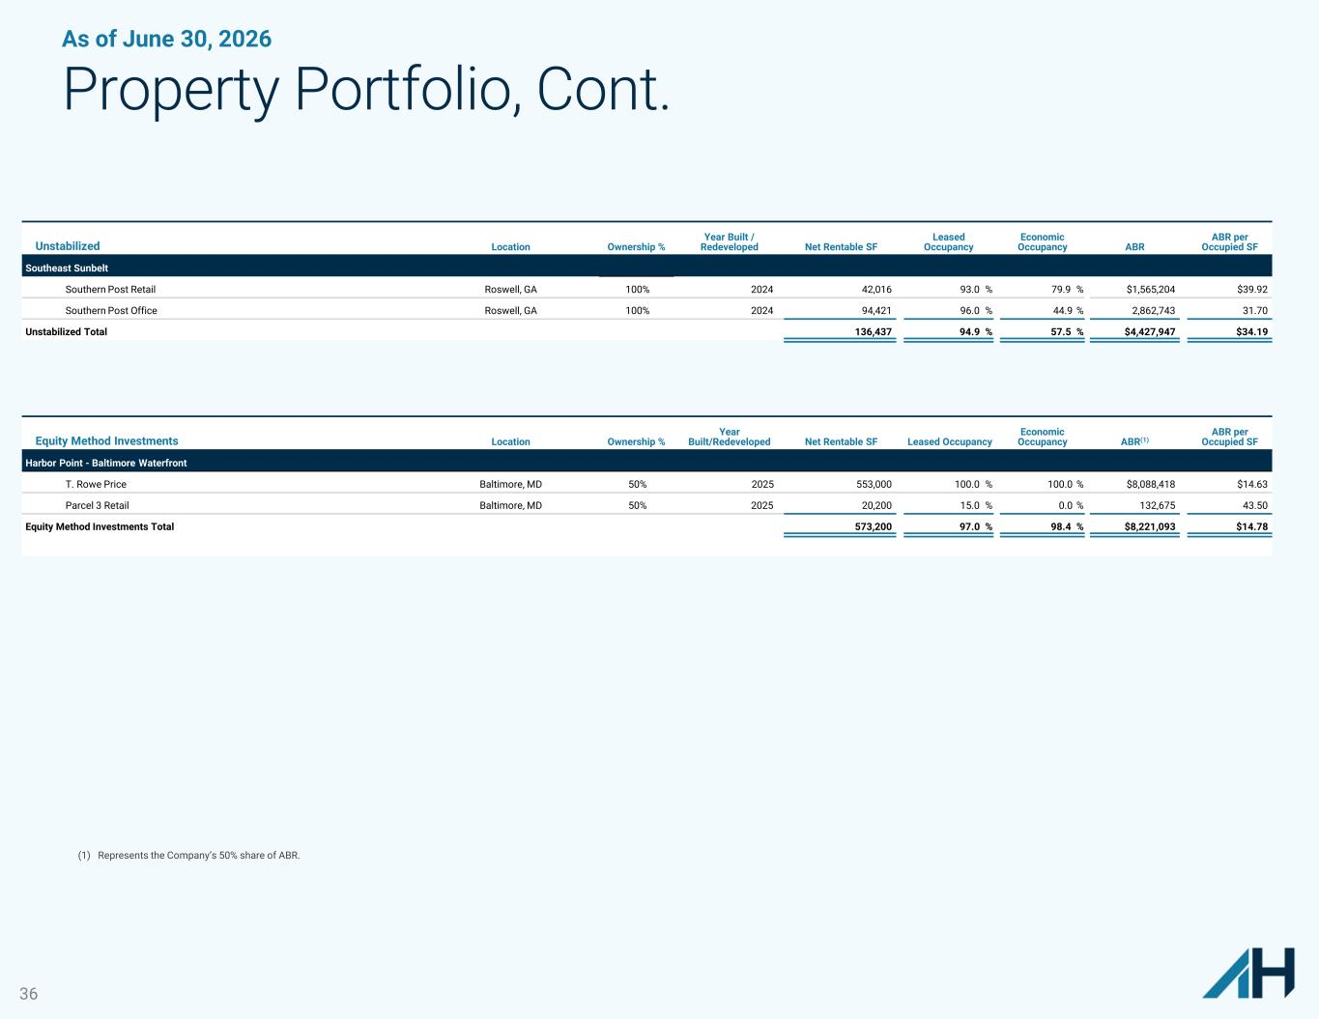
36 As of June 30, 2026 Property Portfolio, Cont. Unstabilized Location Ownership % Year Built / Redeveloped Net Rentable SF Leased Occupancy Economic Occupancy ABR ABR per Occupied SF Southeast Sunbelt Southern Post Retail Roswell, GA 100% 2024 42,016 93.0 % 79.9 % $1,565,204 $39.92 Southern Post Office Roswell, GA 100% 2024 94,421 96.0 % 44.9 % 2,862,743 31.70 Unstabilized Total 136,437 94.9 % 57.5 % $4,427,947 $34.19 Equity Method Investments Location Ownership % Year Built/Redeveloped Net Rentable SF Leased Occupancy Economic Occupancy ABR(1) ABR per Occupied SF Harbor Point - Baltimore Waterfront T. Rowe Price Baltimore, MD 50% 2025 553,000 100.0 % 100.0 % $8,088,418 $14.63 Parcel 3 Retail Baltimore, MD 50% 2025 20,200 15.0 % 0.0 % 132,675 43.50 Equity Method Investments Total 573,200 97.0 % 98.4 % $8,221,093 $14.78 (1) Represents the Company’s 50% share of ABR.

