UNITED STATES
SECURITIES AND EXCHANGE COMMISSION
Washington, D.C. 20549
FORM 8-K

CURRENT REPORT
Pursuant to Section 13 or 15(d) of the Securities Exchange Act of 1934

Date of Report (Date of earliest event reported): August 3, 2026

AH REALTY TRUST, INC.
(Exact name of registrant as specified in its charter)

Maryland |  |  |  |  |  | 001-35908 |  |  |  |  |  | 46-1214914
(State or other jurisdiction of incorporation) |  |  |  |  |  | (Commission File Number) |  |  |  |  |  | (IRS Employer Identification No.)

4605 Columbus St.
Virginia Beach |  |  | , |  |  | Virginia |  |  |  |  |  |  |  |  | 23462
(Address of principal executive offices) |  |  |  |  |  |  |  |  |  |  |  |  |  |  | (Zip Code)

Registrant’s telephone number, including area code: (757) 366-4000

222 Central Park Avenue, Suite 1000
Virginia Beach, Virginia
(Former name or former address, if changed since last report)

Check the appropriate box below if the Form 8-K filing is intended to simultaneously satisfy the filing obligation of the registrant under any of the following provisions:

☐ Written communications pursuant to Rule 425 under the Securities Act (17 CFR 230.425)

☐ Soliciting material pursuant to Rule 14a-12 under the Exchange Act (17 CFR 240.14a-12)

☐ Pre-commencement communications pursuant to Rule 14d-2(b) under the Exchange Act (17 CFR 240.14d-2(b))

☐ Pre-commencement communications pursuant to Rule 13e-4(c) under the Exchange Act (17 CFR 240.13e-4(c))

Securities registered pursuant to Section 12(b) of the Act:
Title of each class |  |  |  |  |  | Trading Symbol(s) |  |  |  |  |  | Name of each exchange on which registered
Common Stock, $0.01 par value per share |  |  |  |  |  | AHRT |  |  |  |  |  | New York Stock Exchange
6.75% Series A Cumulative Redeemable Perpetual Preferred Stock, $0.01 par value per share |  |  |  |  |  | AHRT-PA |  |  |  |  |  | New York Stock Exchange

Indicate by check mark whether the registrant is an emerging growth company as defined in Rule 405 of the Securities Act of 1933 (§230.405 of this chapter) or Rule 12b-2 of the Securities Exchange Act of 1934 (§240.12b-2 of this chapter).

Emerging growth company ☐

If an emerging growth company, indicate by check mark if the registrant has elected not to use the extended transition period for complying with any new or revised financial accounting standards provided pursuant to Section 13(a) of the Exchange Act. ☐

Item 2.02. Results of Operations and Financial Condition.

On August 3, 2026, AH Realty Trust, Inc. (the “Company”) issued a press release announcing its financial position as of June 30, 2026, results of operations for the three months ended June 30, 2026, and other related information. Also on August 3, 2026, the Company made available on its website at ir.ahrealtytrust.com/financials/quarterly-results certain supplemental information concerning the Company’s financial results and operations for the three months ended June 30, 2026. Copies of such press release and supplemental information are furnished as Exhibits 99.1 and 99.2, respectively, to this Current Report on Form 8-K and are incorporated herein by reference.

In accordance with General Instructions B.2 and B.6 of Form 8-K, the information included in this Current Report on Form 8-K, including Exhibits 99.1 and 99.2 hereto, shall not be deemed “filed” for purposes of Section 18 of the Securities Exchange Act of 1934, as amended (the “Exchange Act”), or otherwise subject to the liabilities of that section, nor shall it be deemed incorporated by reference into any filing made by the Company under the Exchange Act or the Securities Act of 1933, as amended, except as shall be expressly set forth by specific reference in such a filing.

Item 7.01. Regulation FD Disclosure.

The disclosure contained in Item 2.02 is incorporated herein by reference.

Item 9.01. Financial Statements and Exhibits.

(d) Exhibits.

Exhibit  No. |  |  |  |  |  | Description
99.1 |  |  |  |  |  | Press Release, dated August 3, 2026, issued by AH Realty Trust, Inc., providing its financial position as of June 30, 2026 and results of operations for the three months ended June 30, 2026.
99.2 |  |  |  |  |  | AH Realty Trust, Inc. Second Quarter 2026 Supplemental Information.
104 |  |  |  |  |  | Cover Page Interactive Data File - the cover page XBRL tags are embedded within the Inline XBRL document.

SIGNATURES

Pursuant to the requirements of the Securities Exchange Act of 1934, the Registrant has duly caused this report to be signed on its behalf by the undersigned hereunto duly authorized.

 |  |  | AH REALTY TRUST, INC.
Date: August 3, 2026 |  |  | By: |  |  | /s/ Matthew T. Barnes-Smith
 |  |  |  |  |  | Matthew T. Barnes-Smith
 |  |  |  |  |  | Chief Financial Officer and Treasurer

Exhibit 99.1

 |  |  |  |  |  | PRESS RELEASE

AH REALTY TRUST REPORTS SECOND QUARTER 2026 RESULTS

GAAP Net Loss of $0.25 Per Diluted Share for the Second Quarter

FFO, As Adjusted of $0.14 Per Diluted Share for the Second Quarter

Raised Full Year 2026 FFO, As Adjusted Guidance to $0.53 to $0.57 Per Diluted Share

Office Same Store NOI Growth of 8.3% (Cash)
Positive Office New Lease Spreads of 20.5% (GAAP) and 9.5% (Cash)

Retail Same Store NOI Growth of 2.9% (Cash)
Positive Retail Renewal Spreads of 11.5% (GAAP) and 8.7% (Cash)

VIRGINIA BEACH, VA, August 3, 2026 – AH Realty Trust (NYSE: AHRT) today announced its results for the quarter ended June 30, 2026 and provided an update on current events and earnings guidance.

Second Quarter and Recent Highlights:

•Raised full-year 2026 FFO, as Adjusted by 6% from original guidance to $0.53 to $0.57 per diluted share, driven by continued NOI growth across the retail and mixed-use office portfolio, sooner than anticipated debt paydowns from closing the Multifamily Portfolio Sale First Closing sooner than anticipated, and the accretive impact of the Company's share repurchase activity. Portfolio performance was highlighted by:
◦Better than anticipated office leasing activity and spreads
◦Sooner than expected retail tenant openings and rent commencements
◦Higher than anticipated percentage rent from retail tenants
◦OpEx savings resulting from successful real estate tax appeals
◦Lower than anticipated bad debt

•As part of its ongoing governance enhancements supporting the Company’s strategic transformation, the Company advanced its board refreshment process by electing Theodore Bigman and Lori Wittman as independent directors at the Company’s 2026 Annual Meeting of Stockholders (the “2026 Annual Meeting”); Following the 2026 Annual Meeting, Dennis Gartman and George Allen retired from the board and each of Mr. Bigman and Ms. Wittman were appointed to the board’s Audit Committee. Additionally, F. Blair Wimbush was appointed Chair of the board's Nominating and Corporate Governance Committee and was appointed to the board's Compensation Committee.

•On May 20, 2026, the Company completed the sale of nine multifamily properties and six of the retail and office components of the properties, for aggregate gross proceeds of $485.0 million, generating a net gain on sale of $18.8 million, after transaction costs and escrow amounts (the "Multifamily Portfolio Sale First Closing"). Using these proceeds, the Company repaid $265.5 million of secured debt and $195.0 million of unsecured debt on the revolving credit facility, reducing our Net Debt to Total Adjusted EBITDAre leverage metric to 7.1x. Two multifamily properties remain under contract for $77.0 million.

"This has been the most consequential and productive quarter in AH Realty Trust's history," said Shawn Tibbetts, Chairman, President and Chief Executive Officer. "In a matter of months, we fundamentally transformed this company, closing $485 million in multifamily sales, redeploying approximately $460 million of those proceeds directly to debt paydown, and expanding our share repurchase

authorization to $100 million, actions that have rebuilt the foundation of this company. Most importantly, we have done so while operating our retail and mixed-use office portfolio with efficiency and excellence. Given the continued strength of our portfolio, the transformational actions we have completed, and our visibility into the coming quarters, we are raising our full-year 2026 FFO, As Adjusted guidance range to $0.53 to $0.57 per diluted share, underscoring the progress we are making to simplify AH Realty Trust into a more focused real estate platform centered on disciplined capital allocation and long term shareholder value creation."
Second Quarter and Recent Highlights Continued:

•On April 30, 2026, the Company fully realized $17.2 million for The Allure at Edinburgh real estate financing investment and used the proceeds to pay down debt.

•On April 30, 2026, the Company completed the sale of the general contracting and real estate services business for total economic consideration of $2.4 million, further advancing our strategic plan to simplify the business and focus on core retail and office operations.

•During the quarter ended June 30, 2026, the Company repurchased 2.0 million shares of common stock for $12.4 million, bringing the total for the year to 5.6 million for a total of $33.2 million.

•Net loss attributable to common stockholders and OP Unitholders of $24.2 million, or $0.25 per diluted share, compared to net income attributable to common stockholders and OP Unitholders of $3.9 million, or $0.04 per diluted share, for the three months ended June 30, 2025.

•Funds from operations attributable to common stockholders and OP Unitholders ("FFO") of $15.4 million, or $0.16 per diluted share, compared to $19.0 million, or $0.19 per diluted share, for the three months ended June 30, 2025. See "Non-GAAP Financial Measures."

•FFO, As Adjusted attributable to common stockholders and OP Unitholders ("FFO, As Adjusted") of $14.1 million, or $0.14 per diluted share, compared to $13.8 million, or $0.14 per diluted share, for the three months ended June 30, 2025. See "Non-GAAP Financial Measures."

•As of June 30, 2026, weighted average stabilized portfolio leased occupancy was 95.9%. Retail leased occupancy increased 0.3% to 95.1% and office leased occupancy increased 0.7% to 96.7%.

•As of June 30, 2026, weighted average stabilized portfolio economic occupancy was 90.7%. Retail economic occupancy decreased 1.6% to 90.9%, and office economic occupancy increased 2.8% to 90.5%.

•Executed 11 retail lease renewals and 6 new leases during the second quarter for an aggregate of 107,736 net rentable square feet. Positive spreads on both new leases and renewals:
◦New leasing spreads of 9.4% (GAAP) and 5.2% (Cash).
◦Renewal leasing spreads of 11.5% (GAAP) and 8.7% (Cash).

•Executed 3 office lease renewals and 5 new leases during the second quarter for an aggregate of $55,739 net rentable square feet. Positive spreads on both new leases and renewals.
◦New leasing spreads of 20.5% (GAAP) and 9.5% (Cash).
◦Renewal leasing spreads of 40.2% (GAAP) and 21.6% (Cash).

•Same Store Net Operating Income ("NOI") on a cash basis increased 2.9% for the retail segment and 8.3% for the office segment compared to the quarter ended June 30, 2025.

•During the second quarter of 2026, unrealized losses on non-designated interest rate derivatives that negatively affected FFO were $2.2 million. As of June 30, 2026, the value of the Company’s entire interest rate derivative portfolio, net of unrealized losses, was $4.0 million.

2
Financial Results

Net loss attributable to common stockholders and OP Unitholders for the second quarter of 2026 was $24.2 million compared to net income attributable to common stockholders and OP Unitholders of $3.9 million for the second quarter of 2025. The period-over-period change was driven by various non-recurring events in 2026. During the quarter, the Company recognized impairment of $20.9 million in our multifamily portfolio, including $8.7 million related to our Greenside Apartments asset and $12.2 million related to our Gainesville, GA assets, impairment of notes receivable (included in loss from discontinued operations) of $13.5 million taken in the second quarter of 2026 for the Solis Kennesaw real estate financing investment, due to updated estimates on the selling price, and $1.8 million of impairment related to certain development projects that management has determined will no longer be pursued. Additionally, the Company recognized a net gain of $18.8 million related to the nine multifamily, including the retail components of five properties and the office component of one property, included in the Multifamily Portfolio Sale First Closing, and repaid $265.5 million in mortgages as a result of the sale, resulting in a $2.7 million loss on extinguishment of debt. The Company also recognized a $2.2 million loss on the disposition of the general contracting and real estate services business, and a $3.0 million tax provision for the period as a result of the sale, primarily due to deferred tax assets that are no longer expected to be realized.

FFO attributable to common stockholders and OP Unitholders for the second quarter of 2026 was $15.4 million compared to $19.0 million for the second quarter of 2025. The period-over-period decrease in FFO was primarily due to the $2.7 million loss on extinguishment of debt, $1.3 million decrease in general contracting and real estate services gross profit as a result of the disposition and decreased volume, and $3.0 million tax provision for the period as a result of the disposition of the general contracting and real estate services business, primarily due to deferred tax assets that are no longer expected to be realized. FFO, As Adjusted attributable to common stockholders and OP Unitholders for the second quarter of 2026 increased to $14.1 million compared to $13.8 million for the second quarter of 2025. The year-over-year increase in FFO, As Adjusted was primarily due to decreased interest expense due to approximately $456.0 million of debt repayments (net of additional borrowings) as a result of the Multifamily Portfolio Sale First Closing and an increase in portfolio NOI as a result of Columbus Village II coming out of redevelopment and increased economic occupancy at The Interlock and Southern Post. These increases were partially offset by increased general and administrative expenses and the loss on extinguishment of debt in continuing operations related to mortgages extinguished using proceeds from the Multifamily Portfolio Sale First Closing.

Operating Performance

At the end of the second quarter of 2026, the Company’s retail and office weighted average stabilized operating property portfolio leased occupancy were 95.1% and 96.7%, respectively, and weighted average stabilized portfolio economic occupancy were 90.9% and 90.5%.

Interest income from real estate financing investments was $5.0 million for the three months ended June 30, 2026, as a result of the Company's contractual preferred return on the real estate financing investment secured by The Allure at Edinburgh, which was fully redeemed during the quarter and was reported in income from discontinued operations.

Balance Sheet and Financing Activity

As of June 30, 2026, the Company had $1.0 billion of total debt outstanding, including $21.0 million outstanding under its revolving credit facility. Total debt outstanding excludes GAAP adjustments and deferred financing costs. As of June 30, 2026, the Company’s debt was 100.0% fixed or economically hedged after considering interest rate swaps.

3
Outlook

The Company raised its 2026 full-year FFO, As Adjusted guidance range to $0.53 to $0.57 per diluted share. The following table updates the Company's assumptions underpinning its full-year guidance. The Company's executive management will provide further details regarding its 2026 earnings guidance during tomorrow's webcast and conference call.

Full-year 2026 Guidance (1) |  |  |  |  |  | Expected Ranges
 |  |  |  |  |  | Low |  |  | High
RETAIL NOI |  |  |  |  |  | $69.3M |  |  | $70.8M
OFFICE NOI |  |  |  |  |  | 59.1M |  |  | 60.6M
EQUITY METHOD INVESTMENT ("EMI") PROPERTY INCOME(2) |  |  |  |  |  | 3.4M |  |  | 3.9M
ACQUISITION NOI |  |  |  |  |  | 0.0M |  |  | 0.0M
TOTAL COMMERCIAL NOI |  |  |  |  |  | $131.8M |  |  | $135.3M
G&A EXPENSES |  |  |  |  |  | -20.0M |  |  | -19.0M
INTEREST EXPENSE |  |  |  |  |  | -57.2M |  |  | -54.2M
OTHER NOI(3) |  |  |  |  |  | 8.9M |  |  | 9.9M
PREFERRED STOCK DIVIDENDS |  |  |  |  |  | -11.5M |  |  | -11.5M
FUNDS FROM OPERATIONS, AS ADJUSTED ("FFO, AS ADJUSTED")(4) |  |  |  |  |  | $52.3M |  |  | $56.3M
FFO, AS ADJUSTED PER DILUTED SHARE |  |  |  |  |  | $0.53 |  |  | $0.57

(1) Includes the following assumptions:
•Raised 2026 Same-Store NOI Cash growth ranges:
◦Retail 2.50% - 3.50%
◦Office 2.75% - 3.75%
•Disposition of the Multifamily Portfolio, with the exception of Smith's Landing
•Exit of the remaining Real Estate Financing Portfolio
•Remaining Secured Debt Paydowns of ~$57M with proceeds from the remaining 2026 expected dispositions of The Everly and Greenside
•Remaining Net Unsecured Debt Paydowns of ~$100M in 2026
•Includes Share Repurchases of 5.6M shares for $33.2M through June 30, 2026
•No Acquisitions in 2026
(2) Includes T. Rowe Price Global HQ. EMI property income is reflected as the property's NOI less interest expense, times the Company's ownership percentage (50%).
(3) Other income includes NOI from Smith's Landing and NOI from parking income.
(4) Ranges exclude certain items per the Company's FFO, As Adjusted definition. FFO, As Adjusted is a forward-looking, non-GAAP measure that presents the Company's projected Funds From Operations as adjusted for certain items that the Company believes are not indicative of its ongoing operating performance, including: (i) estimated income and expenses associated with assets held for sale or under LOI; and (ii) estimates of certain non-recurring transaction costs. The Company presents FFO, As Adjusted to provide investors with a supplemental measure of the Company's anticipated operating performance following the completion of its announced strategic initiatives, but investors are cautioned against placing undue reliance on the Company's presentation of FFO, As Adjusted. See "Non-GAAP Financial Measures." The Company does not provide a reconciliation for its guidance range of FFO, As Adjusted or FFO, As Adjusted per diluted share to net income or net income per diluted share, the most directly comparable forward-looking GAAP financial measures, because it is unable to provide a meaningful or accurate estimate of reconciling items and the information is not available without unreasonable effort as a result of the inherent difficulty of forecasting the timing and/or amounts of various items that would impact net income per diluted share. For the same reasons, the Company is unable to address the probable significance of the unavailable information and believes that providing a reconciliation for its guidance range of FFO, As Adjusted and FFO, As Adjusted per diluted share would
4
imply a degree of precision for its forward-looking net income per diluted share that could be misleading to investors.

Supplemental Financial Information

Further details regarding operating results, properties, and leasing statistics can be found in the Company’s supplemental financial package available on the Investors page at AHRealtyTrust.com.

Webcast and Conference Call

The Company will host a webcast and conference call on Tuesday, August 4, 2026 at 8:30 a.m. Eastern Time to review financial results and discuss recent events. The recorded webcast will be available through the Investors page of the Company’s website, AHRealtyTrust.com. To participate in the call, please dial (+1) 800 715 9871 (toll-free dial-in number) or (+1) 646 307 1963 (toll dial-in number). The conference ID is 7079783. A telephonic replay will be available shortly after the conclusion of the call through Thursday, September 3, 2026. This replay may be accessed by dialing (+1) 800 770 2030 and providing passcode 7079783#. A replay of the webcast will also be available for 30 days beginning approximately two hours after the conclusion of the conference call.

About AH Realty Trust

AH Realty Trust is a pure-play, high-quality retail and mixed-use office REIT focused on identifying and realizing dominant market competitive advantages throughout the Sunbelt, mid-Atlantic and Southeast. Our company is primarily comprised of and focused on open-air shopping centers and mixed-use ecosystems within our markets.

Forward-Looking Statements

Certain matters within this press release are discussed using forward-looking language as specified in the Private Securities Litigation Reform Act of 1995, and, as such, may involve known and unknown risks, uncertainties and other factors that may cause the actual results or performance to differ from those projected in the forward-looking statement. These forward-looking statements may include comments relating to the current and future performance of the Company’s operating property portfolio, the Company’s development pipeline, financing activities, as well as acquisitions, dispositions, and the Company’s financial outlook, guidance, and expectations. Forward-looking statements depend on assumptions, data or methods which may be incorrect or imprecise, and the Company may not be able to realize any forward-looking statement. For a description of factors that may cause the Company’s actual results or performance to differ from its forward-looking statements, please review the information under the heading “Risk Factors” included in the Company’s Annual Report on Form 10-K for the year ended December 31, 2025, and the other documents filed by the Company with the Securities and Exchange Commission from time to time. The Company expressly disclaims any obligation or undertaking to update or revise any forward-looking statement contained herein, to reflect any change in the Company's expectations with regard thereto, or any other change in events, conditions, or circumstances on which any such statement is based, except to the extent otherwise required by applicable law.

Non-GAAP Financial Measures

The Company calculates FFO in accordance with the standards established by the National Association of Real Estate Investment Trusts ("Nareit"). Nareit defines FFO as net income (loss) (calculated in accordance with GAAP), excluding depreciation and amortization related to real estate, gains or losses from the sale of certain real estate assets, gains and losses from change in control, and impairment write-downs of certain real estate assets and investments in entities when the impairment is directly attributable to decreases in the value of depreciable real estate held by the entity.

FFO is a supplemental non-GAAP financial measure. The Company uses FFO as a supplemental performance measure because it believes that FFO is beneficial to investors as a starting point in
5
measuring the Company’s operational performance. Specifically, in excluding real estate related depreciation and amortization and gains and losses from property dispositions, which do not relate to or are not indicative of operating performance, FFO provides a performance measure that, when compared period-over-period, captures trends in occupancy rates, rental rates, and operating costs. We also believe that, as a widely recognized measure of the performance of REITs, FFO will be used by investors as a basis to compare the Company’s operating performance with that of other REITs.

However, because FFO excludes depreciation and amortization and captures neither the changes in the value of the Company’s properties that result from use or market conditions nor the level of capital expenditures and leasing commissions necessary to maintain the operating performance of the Company’s properties, all of which have real economic effects and could materially impact the Company’s results from operations, the utility of FFO as a measure of the Company’s performance is limited. In addition, other equity REITs may not calculate FFO in accordance with the Nareit definition as the Company does, and, accordingly, the Company’s FFO may not be comparable to such other REITs’ FFO. Accordingly, FFO should be considered only as a supplement to net income as a measure of the Company’s performance. FFO should not be used as a measure of our liquidity, nor is it indicative of funds available to fund our cash needs, including our ability to pay dividends or service indebtedness. Also, FFO should not be used as a supplement to or substitute for cash flow from operating activities computed in accordance with GAAP.

Management also believes that the computation of FFO in accordance with Nareit’s definition includes certain items that are not indicative of the results provided by the Company’s operating property portfolio and affect the comparability of the Company’s period-over-period performance. Accordingly, management believes that FFO, As Adjusted is a more useful performance measure that excludes income or loss from discontinued operations related to general contracting and real estate services, multifamily, and real estate financing. Other equity REITs may not calculate FFO, As Adjusted in the same manner as we do, and, accordingly, our FFO, As Adjusted may not be comparable to such other REITs' FFO, As Adjusted.

NOI is the measure used by the Company’s chief operating decision-maker to assess segment performance. The Company calculates NOI as segment revenues less segment expenses. Segment revenues include rental revenues (base rent, expense reimbursements, termination fees, and other revenue) for our property segments. Segment expenses include rental expenses and real estate taxes for our property segments. NOI is not a measure of operating income or cash flows from operating activities as measured in accordance with GAAP and is not indicative of cash available to fund cash needs. As a result, NOI should not be considered an alternative to cash flows as a measure of liquidity. Not all companies calculate NOI in the same manner. The Company considers NOI to be an appropriate supplemental measure to net income because it assists both investors and management in understanding the core operations of the Company’s retail and office real estate businesses. To calculate NOI on a cash basis, we adjust NOI to exclude the net effects of straight line rent and the amortization of lease incentives and above/below market rents.

Total Adjusted EBITDAre is calculated as EBITDAre further adjusted for debt extinguishment losses, non-cash stock compensation, mark-to-market adjustments on interest rate derivatives, preferred dividends, accelerated amortization of intangible assets and liabilities, acquisition, development, and other pursuit costs, unrealized credit loss release or provision, non-controlling interest in investment entities, development/redevelopment net operating income, and other one-time adjustments including non-recurring bad debt and termination fees. Management believes Total Adjusted EBITDAre is useful to investors in evaluating and facilitating comparisons of our operating performance between periods and with other REITs by removing the impact of our capital structure (primarily interest expense) and asset base (primarily depreciation and amortization) from our operating results along with other non-comparable items.

For reference, as an aid in understanding the Company’s computation of NOI, NOI Cash Basis, FFO, and FFO, As Adjusted, a reconciliation of net income calculated in accordance with GAAP to NOI, NOI Cash Basis, FFO, and FFO, As Adjusted has been included further in this release.

6
AH Realty Trust
CONDENSED CONSOLIDATED BALANCE SHEETS
(dollars in thousands)

 |  |  |  |  |  | June 30,  2026 |  |  |  |  |  | December 31,  2025
 |  |  |  |  |  | (UNAUDITED)
ASSETS
Real estate investments:
Income producing property |  |  |  |  |  | $ | 1,784,337 |  |  |  |  | $ | 1,801,279
Held for development |  |  |  |  |  | — |  |  |  |  |  | 5,683
Construction in progress |  |  |  |  |  | 14,239 |  |  |  |  |  | 13,028
 |  |  |  |  |  | 1,798,576 |  |  |  |  |  | 1,819,990
Accumulated depreciation |  |  |  |  |  | (422,439) |  |  |  |  |  | (410,565)
Net real estate investments |  |  |  |  |  | 1,376,137 |  |  |  |  |  | 1,409,425
Real estate investments held for sale, net |  |  |  |  |  | — |  |  |  |  |  | 4,800
Assets of discontinued operations |  |  |  |  |  | 189,913 |  |  |  |  |  | 800,536
Cash and cash equivalents |  |  |  |  |  | 20,662 |  |  |  |  |  | 40,743
Restricted cash |  |  |  |  |  | 1,547 |  |  |  |  |  | 1,622
Accounts receivable, net |  |  |  |  |  | 62,482 |  |  |  |  |  | 64,747
Notes receivable, net |  |  |  |  |  | 9,233 |  |  |  |  |  | —
Equity method investments |  |  |  |  |  | 58,444 |  |  |  |  |  | 47,926
Operating lease right-of-use assets |  |  |  |  |  | 22,491 |  |  |  |  |  | 22,610
Finance lease right-of-use assets |  |  |  |  |  | 76,884 |  |  |  |  |  | 77,539
Acquired lease intangible assets |  |  |  |  |  | 69,954 |  |  |  |  |  | 76,408
Other assets |  |  |  |  |  | 40,217 |  |  |  |  |  | 50,154
Total Assets |  |  |  |  |  | $ | 1,927,964 |  |  |  |  | $ | 2,596,510
LIABILITIES AND EQUITY
Indebtedness, net |  |  |  |  |  | $ | 955,862 |  |  |  |  | $ | 1,283,987
Liabilities of discontinued operations |  |  |  |  |  | 81,011 |  |  |  |  |  | 286,502
Accounts payable and accrued liabilities |  |  |  |  |  | 30,340 |  |  |  |  |  | 36,810
Operating lease liabilities |  |  |  |  |  | 31,108 |  |  |  |  |  | 31,198
Finance lease liabilities |  |  |  |  |  | 85,243 |  |  |  |  |  | 84,835
Other liabilities |  |  |  |  |  | 29,397 |  |  |  |  |  | 43,986
Total Liabilities |  |  |  |  |  | 1,212,961 |  |  |  |  |  | 1,767,318
Total Equity |  |  |  |  |  | 715,003 |  |  |  |  |  | 829,192
Total Liabilities and Equity |  |  |  |  |  | $ | 1,927,964 |  |  |  |  | $ | 2,596,510

7
AH Realty Trust
CONDENSED CONSOLIDATED INCOME STATEMENTS
(in thousands, except per share amounts)
 |  |  |  |  |  | Three Months Ended June 30, |  |  |  |  |  |  |  |  |  |  |  | Six Months Ended June 30,
 |  |  |  |  |  | 2026 |  |  |  |  |  | 2025 |  |  |  |  |  | 2026 |  |  |  |  |  | 2025
 |  |  |  |  |  | (Unaudited)
Revenues
Rental revenues |  |  |  |  |  | $ | 52,548 |  |  |  |  | $ | 50,720 |  |  |  |  | $ | 104,865 |  |  |  |  | $ | 100,902
Total revenues |  |  |  |  |  | 52,548 |  |  |  |  |  | 50,720 |  |  |  |  |  | 104,865 |  |  |  |  |  | 100,902
Expenses
Rental expenses |  |  |  |  |  | 12,440 |  |  |  |  |  | 11,129 |  |  |  |  |  | 25,297 |  |  |  |  |  | 22,498
Real estate taxes |  |  |  |  |  | 4,797 |  |  |  |  |  | 5,056 |  |  |  |  |  | 9,532 |  |  |  |  |  | 9,773
Depreciation and amortization |  |  |  |  |  | 17,902 |  |  |  |  |  | 16,661 |  |  |  |  |  | 36,143 |  |  |  |  |  | 35,691
General and administrative expenses |  |  |  |  |  | 5,002 |  |  |  |  |  | 4,220 |  |  |  |  |  | 9,718 |  |  |  |  |  | 11,375
Acquisition, development, and other pursuit costs |  |  |  |  |  | 16 |  |  |  |  |  | 29 |  |  |  |  |  | 16 |  |  |  |  |  | 83
Impairment charges |  |  |  |  |  | 1,894 |  |  |  |  |  | — |  |  |  |  |  | 1,894 |  |  |  |  |  | —
Total expenses |  |  |  |  |  | 42,051 |  |  |  |  |  | 37,095 |  |  |  |  |  | 82,600 |  |  |  |  |  | 79,420
Loss on real estate dispositions, net |  |  |  |  |  | (713) |  |  |  |  |  | — |  |  |  |  |  | (854) |  |  |  |  |  | —
Operating income |  |  |  |  |  | 9,784 |  |  |  |  |  | 13,625 |  |  |  |  |  | 21,411 |  |  |  |  |  | 21,482
Interest income |  |  |  |  |  | 234 |  |  |  |  |  | 263 |  |  |  |  |  | 296 |  |  |  |  |  | 492
Interest expense |  |  |  |  |  | (14,122) |  |  |  |  |  | (15,282) |  |  |  |  |  | (27,904) |  |  |  |  |  | (27,719)
Equity in income (loss) of unconsolidated real estate entities |  |  |  |  |  | 334 |  |  |  |  |  | 179 |  |  |  |  |  | 577 |  |  |  |  |  | (1,236)
Gain on consolidation of real estate entities |  |  |  |  |  | — |  |  |  |  |  | 3,920 |  |  |  |  |  | — |  |  |  |  |  | 3,920
Loss on extinguishment of debt |  |  |  |  |  | (523) |  |  |  |  |  | — |  |  |  |  |  | (523) |  |  |  |  |  | —
Change in fair value of derivatives and other |  |  |  |  |  | 618 |  |  |  |  |  | 688 |  |  |  |  |  | 1,962 |  |  |  |  |  | (61)
Unrealized credit loss (provision) release |  |  |  |  |  | (96) |  |  |  |  |  | 242 |  |  |  |  |  | (96) |  |  |  |  |  | 242
Other income (expense), net |  |  |  |  |  | 3 |  |  |  |  |  | 3 |  |  |  |  |  | 16 |  |  |  |  |  | (86)
(Loss) income from continuing operations |  |  |  |  |  | (3,768) |  |  |  |  |  | 3,638 |  |  |  |  |  | (4,261) |  |  |  |  |  | (2,966)
Discontinued operations
(Loss) income from discontinued operations |  |  |  |  |  | (14,271) |  |  |  |  |  | 2,512 |  |  |  |  |  | (43,797) |  |  |  |  |  | 4,963
Income tax (provision) benefit from discontinued operations |  |  |  |  |  | (2,996) |  |  |  |  |  | 567 |  |  |  |  |  | (3,359) |  |  |  |  |  | 377
(Loss) income from discontinued operations, net of taxes |  |  |  |  |  | (17,267) |  |  |  |  |  | 3,079 |  |  |  |  |  | (47,156) |  |  |  |  |  | 5,340
Net (loss) income |  |  |  |  |  | (21,035) |  |  |  |  |  | 6,717 |  |  |  |  |  | (51,417) |  |  |  |  |  | 2,374
Net (income) loss attributable to noncontrolling interests in investment entities |  |  |  |  |  | (243) |  |  |  |  |  | 77 |  |  |  |  |  | (265) |  |  |  |  |  | 80
Preferred stock dividends |  |  |  |  |  | (2,887) |  |  |  |  |  | (2,887) |  |  |  |  |  | (5,774) |  |  |  |  |  | (5,774)
Net (loss) income attributable to common stockholders and OP Unitholders |  |  |  |  |  | $ | (24,165) |  |  |  |  | $ | 3,907 |  |  |  |  | $ | (57,456) |  |  |  |  | $ | (3,320)

8
AH Realty Trust
RECONCILIATION OF NET (LOSS) INCOME TO FFO & FFO, AS ADJUSTED
(in thousands, except per share amounts)
 |  |  |  |  |  | Three Months Ended  June 30, |  |  |  |  |  |  |  |  |  |  |  | Six Months Ended  June 30,
 |  |  |  |  |  | 2026 |  |  |  |  |  | 2025 |  |  |  |  |  | 2026 |  |  |  |  |  | 2025
 |  |  |  |  |  | (Unaudited)
Net (loss) income attributable to common stockholders and OP Unitholders |  |  |  |  |  | $ | (24,165) |  |  |  |  | $ | 3,907 |  |  |  |  | $ | (57,456) |  |  |  |  | $ | (3,320)
Depreciation and amortization, net(1) |  |  |  |  |  | 19,924 |  |  |  |  |  | 21,979 |  |  |  |  |  | 44,584 |  |  |  |  |  | 46,379
Gain on consolidation of real estate entities |  |  |  |  |  | — |  |  |  |  |  | (6,915) |  |  |  |  |  | — |  |  |  |  |  | (6,915)
Gain on operating real estate dispositions, net(2) |  |  |  |  |  | (16,617) |  |  |  |  |  | — |  |  |  |  |  | (16,617) |  |  |  |  |  | —
Impairment of real estate assets(3) |  |  |  |  |  | 36,263 |  |  |  |  |  | — |  |  |  |  |  | 65,492 |  |  |  |  |  | —
FFO attributable to common stockholders and OP Unitholders |  |  |  |  |  | $ | 15,405 |  |  |  |  | $ | 18,971 |  |  |  |  | $ | 36,003 |  |  |  |  | $ | 36,144
FFO attributable to general contracting and real estate services |  |  |  |  |  | 3,081 |  |  |  |  |  | (149) |  |  |  |  |  | 3,650 |  |  |  |  |  | (1,764)
FFO attributable to multifamily |  |  |  |  |  | 463 |  |  |  |  |  | (3,185) |  |  |  |  |  | (2,942) |  |  |  |  |  | (2,386)
FFO attributable to real estate financing |  |  |  |  |  | (4,895) |  |  |  |  |  | (1,817) |  |  |  |  |  | (7,547) |  |  |  |  |  | (3,610)
FFO, As Adjusted available to common stockholders and OP Unitholders |  |  |  |  |  | $ | 14,054 |  |  |  |  | $ | 13,820 |  |  |  |  | $ | 29,164 |  |  |  |  | $ | 28,384
Net (loss) income attributable to common stockholders and OP Unitholders per diluted share and unit |  |  |  |  |  | $ | (0.25) |  |  |  |  | $ | 0.04 |  |  |  |  | $ | (0.57) |  |  |  |  | $ | (0.03)
FFO attributable to common stockholders and OP Unitholders per diluted share and unit |  |  |  |  |  | $ | 0.16 |  |  |  |  | $ | 0.19 |  |  |  |  | $ | 0.36 |  |  |  |  | $ | 0.35
FFO, As Adjusted attributable to common stockholders and OP Unitholders per diluted share and unit |  |  |  |  |  | $ | 0.14 |  |  |  |  | $ | 0.14 |  |  |  |  | $ | 0.29 |  |  |  |  | $ | 0.28
Weighted-average common shares and units - diluted |  |  |  |  |  | 98,009 |  |  |  |  |  | 102,286 |  |  |  |  |  | 100,007 |  |  |  |  |  | 101,930
________________________________________
(1) The adjustment for depreciation and amortization excludes amortization of above and below-market ground lease assets. The adjustment for depreciation and amortization for the three and six months ended June 30, 2026 excludes $0.2 million and $0.4 million, respectively, of depreciation attributable to our partners. The adjustment for depreciation and amortization for the three and six months ended June 30, 2025 excludes $0.3 million and $0.6 million, respectively, of depreciation attributable to our partners.
(2) The adjustment for gain on operating real estate dispositions for the six months ended June 30, 2026 excludes $0.2 million for the loss on the disposition of a non-operating parcel of undeveloped land under predevelopment. The adjustment for gain on operating real estate dispositions for the three and six months ended June 30, 2026 includes the $2.2 million loss on disposition of the general contracting and real estate services business.
(3) Impairment recognized for the three months ended June 30, 2026 represents impairment of the multifamily properties Greenside Apartments, Solis Gainesville II, and The Everly, notes receivable secured by the Solis Kennesaw real estate financing investments, and development projects that management has determined are no longer probably of execution and no longer intends to pursue development of the projects. Impairment recognized for the six months ended June 30, 2026 represents impairment of notes receivable secured by the Solis North Creek, Solis Peachtree Corners, and Solis Kennesaw real estate financing investments.

9
AH Realty Trust
RECONCILIATION OF NET (LOSS) INCOME TO SAME STORE NOI, CASH BASIS
(in thousands) (unaudited)
 |  |  |  |  |  | Three Months Ended  June 30, |  |  |  |  |  |  |  |  |  |  |  | Six Months Ended  June 30,
 |  |  |  |  |  | 2026 |  |  |  |  |  | 2025 |  |  |  |  |  | 2026 |  |  |  |  |  | 2025
Retail Same Store (1)
Same Store NOI, Cash Basis |  |  |  |  |  | $ | 16,816 |  |  |  |  | $ | 16,349 |  |  |  |  | $ | 32,994 |  |  |  |  | $ | 32,181
GAAP Adjustments (2) |  |  |  |  |  | 1,078 |  |  |  |  |  | 1,301 |  |  |  |  |  | 2,471 |  |  |  |  |  | 2,468
Same Store NOI |  |  |  |  |  | 17,894 |  |  |  |  |  | 17,650 |  |  |  |  |  | 35,465 |  |  |  |  |  | 34,649
Non-Same Store NOI (3) |  |  |  |  |  | 87 |  |  |  |  |  | 122 |  |  |  |  |  | 60 |  |  |  |  |  | 460
Segment NOI |  |  |  |  |  | 17,981 |  |  |  |  |  | 17,772 |  |  |  |  |  | 35,525 |  |  |  |  |  | 35,109
Office Same Store (4)
Same Store NOI, Cash Basis |  |  |  |  |  | 13,917 |  |  |  |  |  | 12,846 |  |  |  |  |  | 26,766 |  |  |  |  |  | 25,605
GAAP Adjustments (2) |  |  |  |  |  | 1,321 |  |  |  |  |  | 2,058 |  |  |  |  |  | 3,269 |  |  |  |  |  | 3,860
Same Store NOI |  |  |  |  |  | 15,238 |  |  |  |  |  | 14,904 |  |  |  |  |  | 30,035 |  |  |  |  |  | 29,465
Non-Same Store NOI (3) |  |  |  |  |  | 205 |  |  |  |  |  | 14 |  |  |  |  |  | 31 |  |  |  |  |  | 94
Segment NOI |  |  |  |  |  | 15,443 |  |  |  |  |  | 14,918 |  |  |  |  |  | 30,066 |  |  |  |  |  | 29,559
Other NOI |  |  |  |  |  | 1,887 |  |  |  |  |  | 1,845 |  |  |  |  |  | 4,445 |  |  |  |  |  | 3,963
Total Property NOI |  |  |  |  |  | 35,311 |  |  |  |  |  | 34,535 |  |  |  |  |  | 70,036 |  |  |  |  |  | 68,631
Depreciation and amortization |  |  |  |  |  | (17,902) |  |  |  |  |  | (16,661) |  |  |  |  |  | (36,143) |  |  |  |  |  | (35,691)
General and administrative expenses |  |  |  |  |  | (5,002) |  |  |  |  |  | (4,220) |  |  |  |  |  | (9,718) |  |  |  |  |  | (11,375)
Acquisition, development, and other pursuit costs |  |  |  |  |  | (16) |  |  |  |  |  | (29) |  |  |  |  |  | (16) |  |  |  |  |  | (83)
Impairment charges |  |  |  |  |  | (1,894) |  |  |  |  |  | — |  |  |  |  |  | (1,894) |  |  |  |  |  | —
Loss on real estate dispositions, net |  |  |  |  |  | (713) |  |  |  |  |  | — |  |  |  |  |  | (854) |  |  |  |  |  | —
Interest income |  |  |  |  |  | 234 |  |  |  |  |  | 263 |  |  |  |  |  | 296 |  |  |  |  |  | 492
Interest expense |  |  |  |  |  | (14,122) |  |  |  |  |  | (15,282) |  |  |  |  |  | (27,904) |  |  |  |  |  | (27,719)
Equity income (loss) of unconsolidated real estate entities |  |  |  |  |  | 334 |  |  |  |  |  | 179 |  |  |  |  |  | 577 |  |  |  |  |  | (1,236)
Gain on consolidation of real estate entities |  |  |  |  |  | — |  |  |  |  |  | 3,920 |  |  |  |  |  | — |  |  |  |  |  | 3,920
Loss on extinguishment of debt |  |  |  |  |  | (523) |  |  |  |  |  | — |  |  |  |  |  | (523) |  |  |  |  |  | —
Change in fair value of derivatives and other |  |  |  |  |  | 618 |  |  |  |  |  | 688 |  |  |  |  |  | 1,962 |  |  |  |  |  | (61)
Unrealized credit loss (provision) release |  |  |  |  |  | (96) |  |  |  |  |  | 242 |  |  |  |  |  | (96) |  |  |  |  |  | 242
Other income (expense), net |  |  |  |  |  | 3 |  |  |  |  |  | 3 |  |  |  |  |  | 16 |  |  |  |  |  | (86)
(Loss) income from continuing operations |  |  |  |  |  | (3,768) |  |  |  |  |  | 3,638 |  |  |  |  |  | (4,261) |  |  |  |  |  | (2,966)
Discontinued operations
(Loss) income from discontinued operations |  |  |  |  |  | (14,271) |  |  |  |  |  | 2,512 |  |  |  |  |  | (43,797) |  |  |  |  |  | 4,963
Income tax (provision) benefit from discontinued operations |  |  |  |  |  | (2,996) |  |  |  |  |  | 567 |  |  |  |  |  | (3,359) |  |  |  |  |  | 377
(Loss) income from discontinued operations, net of taxes |  |  |  |  |  | (17,267) |  |  |  |  |  | 3,079 |  |  |  |  |  | (47,156) |  |  |  |  |  | 5,340
Net (loss) income |  |  |  |  |  | (21,035) |  |  |  |  |  | 6,717 |  |  |  |  |  | (51,417) |  |  |  |  |  | 2,374
Net (income) loss attributable to noncontrolling interests in investment entities |  |  |  |  |  | (243) |  |  |  |  |  | 77 |  |  |  |  |  | (265) |  |  |  |  |  | 80
Preferred stock dividends |  |  |  |  |  | (2,887) |  |  |  |  |  | (2,887) |  |  |  |  |  | (5,774) |  |  |  |  |  | (5,774)
Net (loss) income attributable to common stockholders and OP Unitholders |  |  |  |  |  | $ | (24,165) |  |  |  |  | $ | 3,907 |  |  |  |  | $ | (57,456) |  |  |  |  | $ | (3,320)
10
________________________________________
(1) Retail same-store portfolio for the six months ended June 30, 2026 and June 30, 2025 excludes Allied | Harbor Point Retail, Liberty Retail, Point Street Retail, The Edison Retail, and Chronicle Mill Retail, which were sold in May 2026 as part of the Multifamily Portfolio Sale First Closing. They also exclude Southern Post Retail, which is not yet stabilized.
(2) GAAP Adjustments include adjustments for the net effects of straight-line rental revenues, the amortization of lease incentives and above/below market rents, the net effects of straight-line rental expenses, and ground rent expenses for finance leases.
(3) Includes expenses associated with the Company's in-house asset management division.
(4) Office same-store portfolio for the six months ended June 30, 2026 and 2025 excludes Chronicle Mill Office, which was sold in May 2026 as part of the Multifamily Portfolio Sale First Closing, and Southern Post Office, which is not yet stabilized.

11
AH Realty Trust
RECONCILIATION OF NET (LOSS) INCOME TO TOTAL ADJUSTED EBITDAre
(in thousands) (unaudited)
 |  |  |  |  |  | Three Months Ended  June 30, |  |  |  |  |  |  |  |  |  |  |  | Six Months Ended  June 30,
 |  |  |  |  |  | 2026 |  |  |  |  |  | 2025 |  |  |  |  |  | 2026 |  |  |  |  |  | 2025
Net (Loss) Income Attributable to Common Stockholders and OP Unitholders |  |  |  |  |  | $ | (24,165) |  |  |  |  | $ | 3,907 |  |  |  |  | $ | (57,456) |  |  |  |  | $ | (3,320)
Excluding:
Depreciation and Amortization |  |  |  |  |  | 19,323 |  |  |  |  |  | 21,356 |  |  |  |  |  | 43,384 |  |  |  |  |  | 44,177
(Gain) Loss on Real Estate Dispositions |  |  |  |  |  | (16,604) |  |  |  |  |  | — |  |  |  |  |  | (16,463) |  |  |  |  |  | —
Loss on Consolidation of Real Estate Entities |  |  |  |  |  | — |  |  |  |  |  | (6,915) |  |  |  |  |  | — |  |  |  |  |  | (6,915)
Impairment of Real Estate Assets |  |  |  |  |  | 36,264 |  |  |  |  |  | — |  |  |  |  |  | 65,493 |  |  |  |  |  | —
Income Tax (Benefit) Provision |  |  |  |  |  | 2,996 |  |  |  |  |  | (567) |  |  |  |  |  | 3,359 |  |  |  |  |  | (377)
Interest Expense |  |  |  |  |  | 17,876 |  |  |  |  |  | 21,271 |  |  |  |  |  | 39,102 |  |  |  |  |  | 39,380
Interest Expense, Depreciation, & Amortization of Unconsolidated Real Estate Entities |  |  |  |  |  | 2,095 |  |  |  |  |  | 2,801 |  |  |  |  |  | 4,218 |  |  |  |  |  | 5,783
EBITDAre |  |  |  |  |  | 37,785 |  |  |  |  |  | 41,853 |  |  |  |  |  | 81,637 |  |  |  |  |  | 78,728
Change in Fair Value of Derivatives and Other |  |  |  |  |  | (748) |  |  |  |  |  | (648) |  |  |  |  |  | (2,536) |  |  |  |  |  | 562
Preferred Dividends |  |  |  |  |  | 2,887 |  |  |  |  |  | 2,887 |  |  |  |  |  | 5,774 |  |  |  |  |  | 5,774
Loss on Extinguishment of Debt |  |  |  |  |  | 2,650 |  |  |  |  |  | — |  |  |  |  |  | 2,650 |  |  |  |  |  | —
Non-Recurring Bad Debt Adjustment |  |  |  |  |  | 231 |  |  |  |  |  | 140 |  |  |  |  |  | 780 |  |  |  |  |  | 2,306
Non-Recurring Termination and Assignment Fee Adjustment |  |  |  |  |  | (132) |  |  |  |  |  | (142) |  |  |  |  |  | (264) |  |  |  |  |  | (295)
Accelerated Amortization of Intangible Assets and Liabilities |  |  |  |  |  | — |  |  |  |  |  | — |  |  |  |  |  | 15 |  |  |  |  |  | (169)
Acquisition, Development, & Other Pursuit Costs |  |  |  |  |  | (16) |  |  |  |  |  | 286 |  |  |  |  |  | (16) |  |  |  |  |  | 340
Unrealized Credit Loss (Release) Provision |  |  |  |  |  | (78) |  |  |  |  |  | (209) |  |  |  |  |  | (1,827) |  |  |  |  |  | (187)
Investment Entities |  |  |  |  |  | 243 |  |  |  |  |  | (77) |  |  |  |  |  | 265 |  |  |  |  |  | (80)
Non-Cash Stock Compensation |  |  |  |  |  | 1,388 |  |  |  |  |  | 1,364 |  |  |  |  |  | 2,743 |  |  |  |  |  | 4,828
Redemption of REF Investment |  |  |  |  |  | (4,887) |  |  |  |  |  | — |  |  |  |  |  | (4,887) |  |  |  |  |  | —
Dispositions |  |  |  |  |  | (3,109) |  |  |  |  |  | — |  |  |  |  |  | (10,513) |  |  |  |  |  | —
Development/Redevelopment |  |  |  |  |  | (996) |  |  |  |  |  | (475) |  |  |  |  |  | (2,033) |  |  |  |  |  | (1,723)
Total Adjusted EBITDAre |  |  |  |  |  | $ | 35,218 |  |  |  |  | $ | 44,979 |  |  |  |  | $ | 71,788 |  |  |  |  | $ | 90,084
Total Debt(1) |  |  |  |  |  | 1,037,085 |  |  |  |  |  | 1,448,237 |  |  |  |  |  | 1,037,085 |  |  |  |  |  | 1,448,237
Cash |  |  |  |  |  | (35,547) |  |  |  |  |  | (54,601) |  |  |  |  |  | (35,547) |  |  |  |  |  | (54,601)
Net Debt(2) |  |  |  |  |  | $ | 1,001,538 |  |  |  |  | $ | 1,393,636 |  |  |  |  | $ | 1,001,538 |  |  |  |  | $ | 1,393,636
Net Debt/Total Adjusted EBITDAre(3) |  |  |  |  |  | 7.1x |  |  |  |  |  | 7.7x |  |  |  |  |  | 7.0x |  |  |  |  |  | 7.7x
(1) Excludes GAAP Adjustments.
(2) Reflects total debt less GAAP adjustments, cash, restricted cash, and other notes payable.
12
Contact:

Chelsea Forrest
AH Realty Trust
Executive Vice President of Investor Relations and Administration
Email: Chelsea.Forrest@AHRealtyTrust.com
Phone: (757) 612-4248
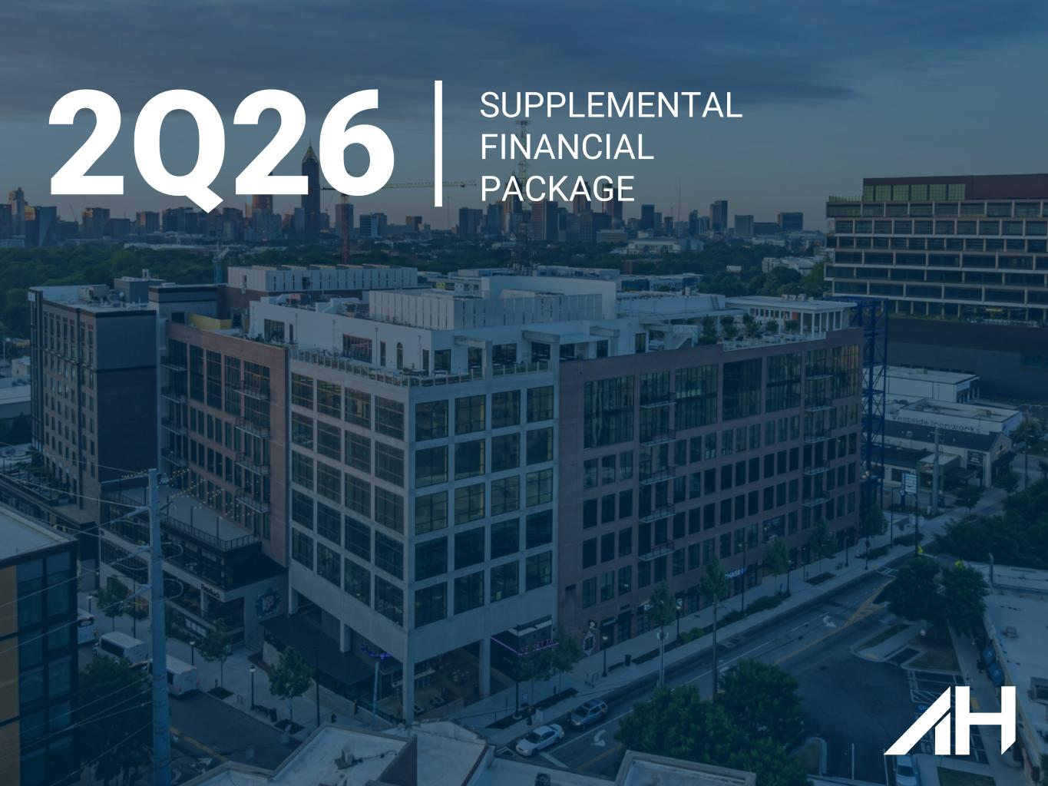
13
2Q26 SUPPLEMENTAL FINANCIAL PACKAGE

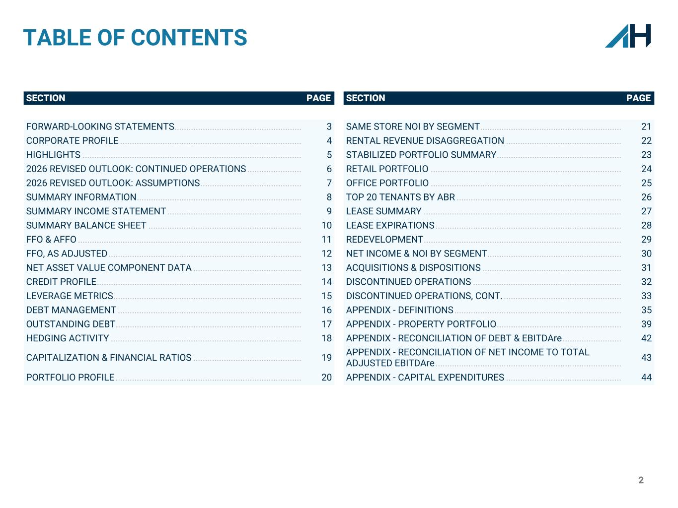
2 TABLE OF CONTENTS SECTION PAGE SECTION PAGE FORWARD-LOOKING STATEMENTS ...................................................... 3 SAME STORE NOI BY SEGMENT ............................................................ 21 CORPORATE PROFILE ............................................................................. 4 RENTAL REVENUE DISAGGREGATION ................................................. 22 HIGHLIGHTS ............................................................................................. 5 STABILIZED PORTFOLIO SUMMARY ..................................................... 23 2026 REVISED OUTLOOK: CONTINUED OPERATIONS ....................... 6 RETAIL PORTFOLIO ................................................................................. 24 2026 REVISED OUTLOOK: ASSUMPTIONS ........................................... 7 OFFICE PORTFOLIO ................................................................................. 25 SUMMARY INFORMATION ...................................................................... 8 TOP 20 TENANTS BY ABR ...................................................................... 26 SUMMARY INCOME STATEMENT ......................................................... 9 LEASE SUMMARY .................................................................................... 27 SUMMARY BALANCE SHEET ................................................................. 10 LEASE EXPIRATIONS ............................................................................... 28 FFO & AFFO ............................................................................................... 11 REDEVELOPMENT .................................................................................... 29 FFO, AS ADJUSTED .................................................................................. 12 NET INCOME & NOI BY SEGMENT ......................................................... 30 NET ASSET VALUE COMPONENT DATA .............................................. 13 ACQUISITIONS & DISPOSITIONS ........................................................... 31 CREDIT PROFILE ....................................................................................... 14 DISCONTINUED OPERATIONS ............................................................... 32 LEVERAGE METRICS ................................................................................ 15 DISCONTINUED OPERATIONS, CONT. .................................................. 33 DEBT MANAGEMENT .............................................................................. 16 APPENDIX - DEFINITIONS ....................................................................... 35 OUTSTANDING DEBT ............................................................................... 17 APPENDIX - PROPERTY PORTFOLIO ..................................................... 39 HEDGING ACTIVITY ................................................................................. 18 APPENDIX - RECONCILIATION OF DEBT & EBITDAre ......................... 42 CAPITALIZATION & FINANCIAL RATIOS .............................................. 19 APPENDIX - RECONCILIATION OF NET INCOME TO TOTAL ADJUSTED EBITDAre ............................................................................... 43 PORTFOLIO PROFILE ............................................................................... 20 APPENDIX - CAPITAL EXPENDITURES ................................................. 44

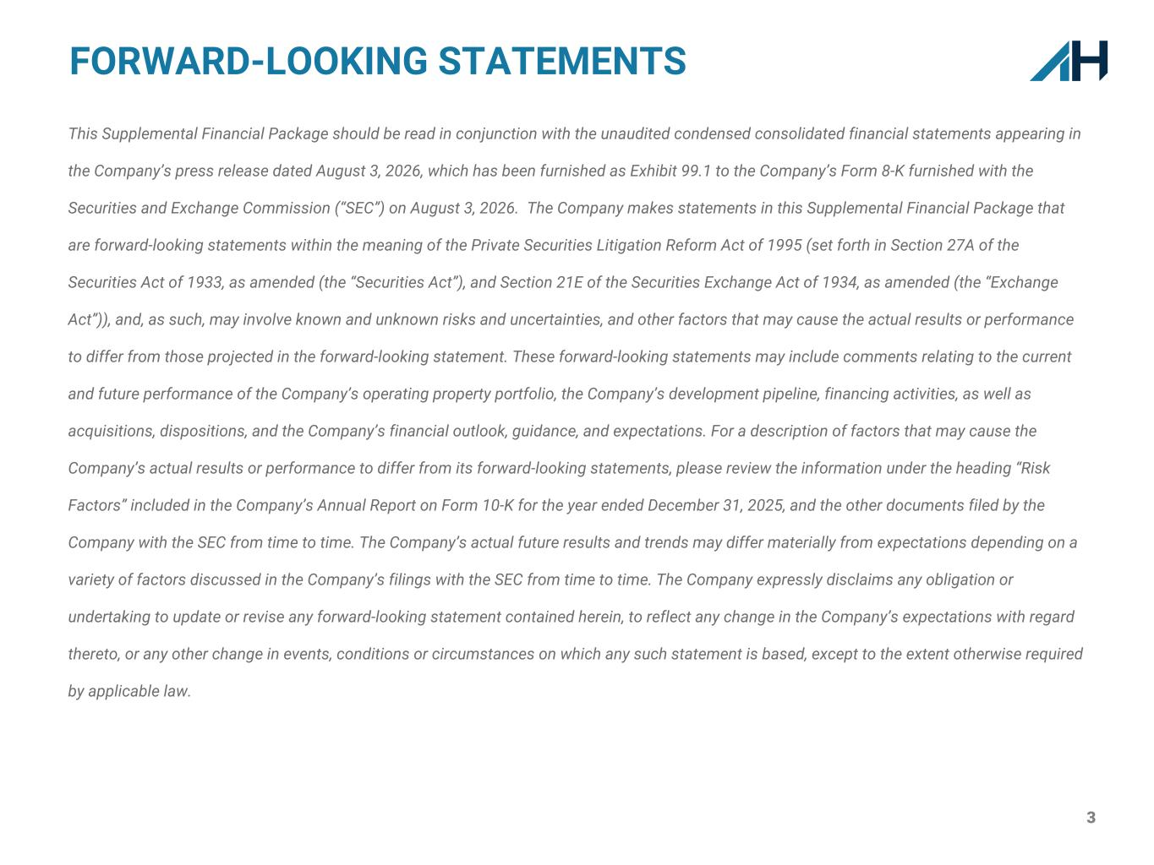
3 This Supplemental Financial Package should be read in conjunction with the unaudited condensed consolidated financial statements appearing in the Company’s press release dated August 3, 2026, which has been furnished as Exhibit 99.1 to the Company’s Form 8-K furnished with the Securities and Exchange Commission (“SEC”) on August 3, 2026. The Company makes statements in this Supplemental Financial Package that are forward-looking statements within the meaning of the Private Securities Litigation Reform Act of 1995 (set forth in Section 27A of the Securities Act of 1933, as amended (the “Securities Act”), and Section 21E of the Securities Exchange Act of 1934, as amended (the “Exchange Act”)), and, as such, may involve known and unknown risks and uncertainties, and other factors that may cause the actual results or performance to differ from those projected in the forward-looking statement. These forward-looking statements may include comments relating to the current and future performance of the Company’s operating property portfolio, the Company’s development pipeline, financing activities, as well as acquisitions, dispositions, and the Company’s financial outlook, guidance, and expectations. For a description of factors that may cause the Company’s actual results or performance to differ from its forward-looking statements, please review the information under the heading “Risk Factors” included in the Company’s Annual Report on Form 10-K for the year ended December 31, 2025, and the other documents filed by the Company with the SEC from time to time. The Company’s actual future results and trends may differ materially from expectations depending on a variety of factors discussed in the Company’s filings with the SEC from time to time. The Company expressly disclaims any obligation or undertaking to update or revise any forward-looking statement contained herein, to reflect any change in the Company’s expectations with regard thereto, or any other change in events, conditions or circumstances on which any such statement is based, except to the extent otherwise required by applicable law. FORWARD-LOOKING STATEMENTS


4 BOARD OF DIRECTORS Shawn J. Tibbetts, Chairman of the Board James A. Carroll, Lead Independent Director Theodore R. Bigman, Independent Director Jennifer R. Boykin, Independent Director James C. Cherry, Independent Director Louis S. Haddad, Director Daniel A. Hoffler, Director F. Blair Wimbush, Independent Director Lori B. Wittman, Independent Director CORPORATE OFFICERS Shawn J. Tibbetts, Chairman, President and Chief Executive Officer Matthew T. Barnes-Smith, Chief Financial Officer and Treasurer Scotia Capital USA Inc Viktor Fediv (212) 225-6911 viktor.fediv@scotiabank.com Bank of America Merrill Lynch Jana Galan (646) 855-5042 jana.galan@bofa.com Jefferies LLC Jonathan Petersen (212) 284-1705 jpetersen@jefferies.com ANALYST COVERAGE AH Realty Trust (NYSE: AHRT) AH Realty Trust is a pure-play, high-quality retail and mixed-use office REIT focused on identifying and realizing dominant market competitive advantages throughout the Sunbelt, mid-Atlantic and Southeast. Our company is primarily comprised of and focused on open-air shopping centers and mixed-use ecosystems within our markets. CORPORATE PROFILE CREDIT RATING Rating: BBB Agency: Morningstar DBRS Stifel Simon Yarmak (443) 224-1345 yarmaks@stifel.com

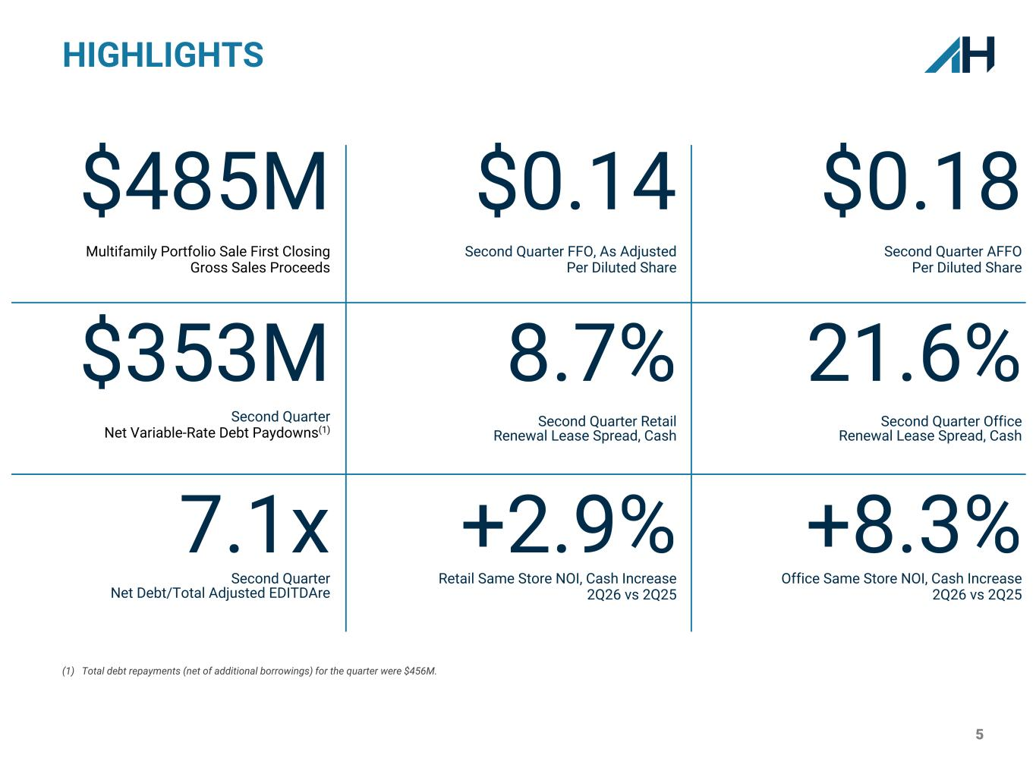
5 HIGHLIGHTS $485M Multifamily Portfolio Sale First Closing Gross Sales Proceeds $0.14 Second Quarter FFO, As Adjusted Per Diluted Share $0.18 Second Quarter AFFO Per Diluted Share $353M Second Quarter Net Variable-Rate Debt Paydowns(1) 8.7% Second Quarter Retail Renewal Lease Spread, Cash 21.6% Second Quarter Office Renewal Lease Spread, Cash 7.1x Second Quarter Net Debt/Total Adjusted EDITDAre +2.9% Retail Same Store NOI, Cash Increase 2Q26 vs 2Q25 +8.3% Office Same Store NOI, Cash Increase 2Q26 vs 2Q25 (1) Total debt repayments (net of additional borrowings) for the quarter were $456M.

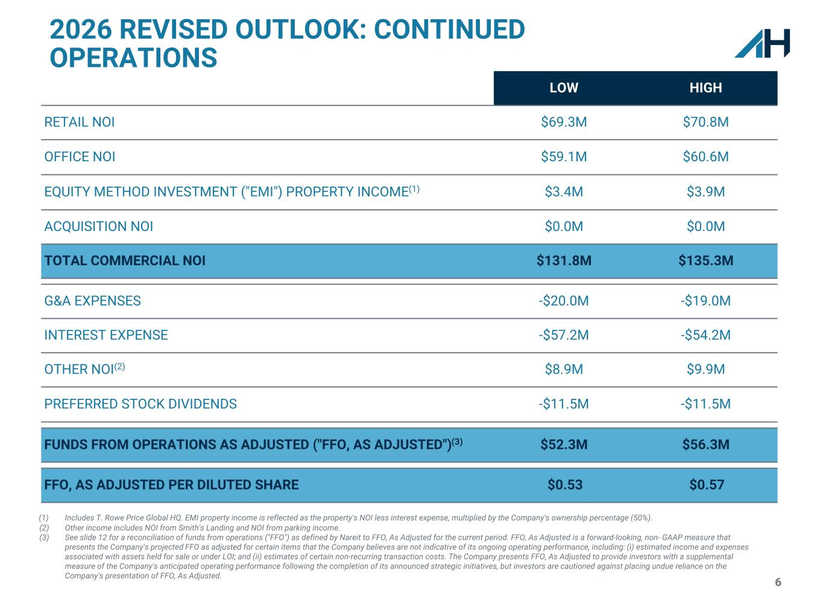
6 2026 REVISED OUTLOOK: CONTINUED OPERATIONS LOW HIGH RETAIL NOI $69.3M $70.8M OFFICE NOI $59.1M $60.6M EQUITY METHOD INVESTMENT ("EMI") PROPERTY INCOME(1) $3.4M $3.9M ACQUISITION NOI $0.0M $0.0M TOTAL COMMERCIAL NOI $131.8M $135.3M G&A EXPENSES -$20.0M -$19.0M INTEREST EXPENSE -$57.2M -$54.2M OTHER NOI(2) $8.9M $9.9M PREFERRED STOCK DIVIDENDS -$11.5M -$11.5M FUNDS FROM OPERATIONS AS ADJUSTED ("FFO, AS ADJUSTED")(3) $52.3M $56.3M FFO, AS ADJUSTED PER DILUTED SHARE $0.53 $0.57 (1) Includes T. Rowe Price Global HQ. EMI property income is reflected as the property's NOI less interest expense, multiplied by the Company's ownership percentage (50%). (2) Other income includes NOI from Smith's Landing and NOI from parking income. (3) See slide 12 for a reconciliation of funds from operations ("FFO") as defined by Nareit to FFO, As Adjusted for the current period. FFO, As Adjusted is a forward-looking, non- GAAP measure that presents the Company's projected FFO as adjusted for certain items that the Company believes are not indicative of its ongoing operating performance, including: (i) estimated income and expenses associated with assets held for sale or under LOI; and (ii) estimates of certain non-recurring transaction costs. The Company presents FFO, As Adjusted to provide investors with a supplemental measure of the Company's anticipated operating performance following the completion of its announced strategic initiatives, but investors are cautioned against placing undue reliance on the Company's presentation of FFO, As Adjusted.

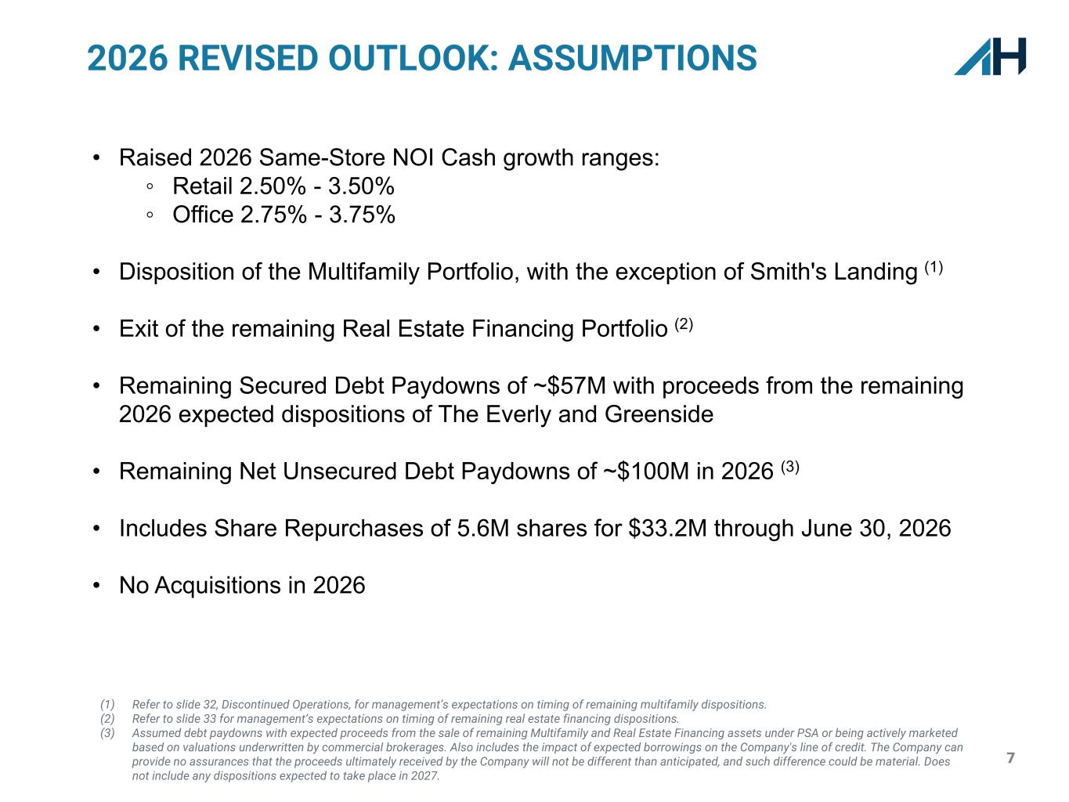
7 • Raised 2026 Same-Store NOI Cash growth ranges: ◦ Retail 2.50% - 3.50% ◦ Office 2.75% - 3.75% • Disposition of the Multifamily Portfolio, with the exception of Smith's Landing (1) • Exit of the remaining Real Estate Financing Portfolio (2) • Remaining Secured Debt Paydowns of ~$57M with proceeds from the remaining 2026 expected dispositions of The Everly and Greenside • Remaining Net Unsecured Debt Paydowns of ~$100M in 2026 (3) • Includes Share Repurchases of 5.6M shares for $33.2M through June 30, 2026 • No Acquisitions in 2026 (1) Refer to slide 32, Discontinued Operations, for management’s expectations on timing of remaining multifamily dispositions. (2) Refer to slide 33 for management’s expectations on timing of remaining real estate financing dispositions. (3) Assumed debt paydowns with expected proceeds from the sale of remaining Multifamily and Real Estate Financing assets under PSA or being actively marketed based on valuations underwritten by commercial brokerages. Also includes the impact of expected borrowings on the Company's line of credit. The Company can provide no assurances that the proceeds ultimately received by the Company will not be different than anticipated, and such difference could be material. Does not include any dispositions expected to take place in 2027. 2026 REVISED OUTLOOK: ASSUMPTIONS

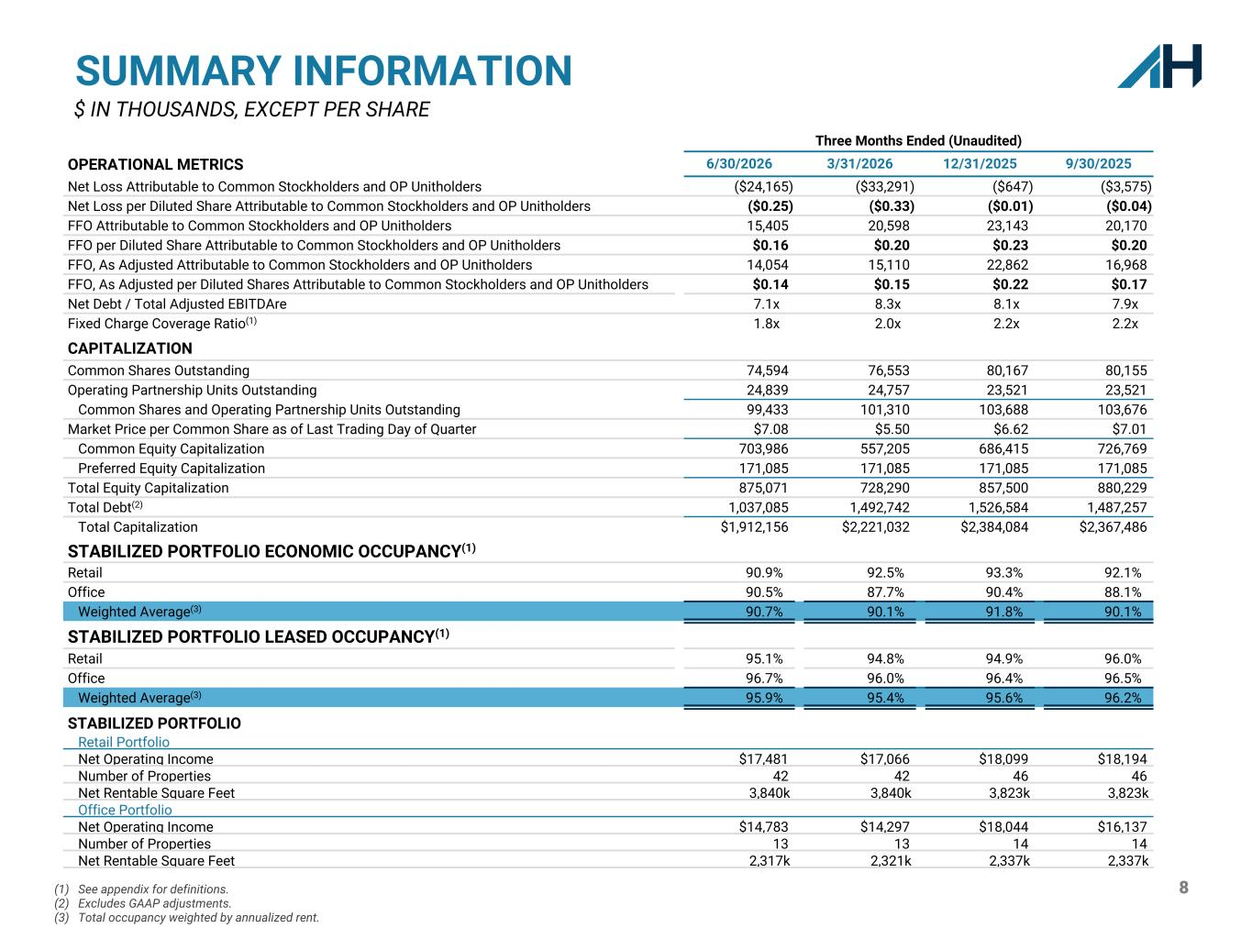
8(1) See appendix for definitions. (2) Excludes GAAP adjustments. (3) Total occupancy weighted by annualized rent. SUMMARY INFORMATION $ IN THOUSANDS, EXCEPT PER SHARE Three Months Ended (Unaudited) OPERATIONAL METRICS 6/30/2026 3/31/2026 12/31/2025 9/30/2025 Net Loss Attributable to Common Stockholders and OP Unitholders ($24,165) ($33,291) ($647) ($3,575) Net Loss per Diluted Share Attributable to Common Stockholders and OP Unitholders ($0.25) ($0.33) ($0.01) ($0.04) FFO Attributable to Common Stockholders and OP Unitholders 15,405 20,598 23,143 20,170 FFO per Diluted Share Attributable to Common Stockholders and OP Unitholders $0.16 $0.20 $0.23 $0.20 FFO, As Adjusted Attributable to Common Stockholders and OP Unitholders 14,054 15,110 22,862 16,968 FFO, As Adjusted per Diluted Shares Attributable to Common Stockholders and OP Unitholders $0.14 $0.15 $0.22 $0.17 Net Debt / Total Adjusted EBITDAre 7.1x 8.3x 8.1x 7.9x Fixed Charge Coverage Ratio(1) 1.8x 2.0x 2.2x 2.2x CAPITALIZATION Common Shares Outstanding 74,594 76,553 80,167 80,155 Operating Partnership Units Outstanding 24,839 24,757 23,521 23,521 Common Shares and Operating Partnership Units Outstanding 99,433 101,310 103,688 103,676 Market Price per Common Share as of Last Trading Day of Quarter $7.08 $5.50 $6.62 $7.01 Common Equity Capitalization 703,986 557,205 686,415 726,769 Preferred Equity Capitalization 171,085 171,085 171,085 171,085 Total Equity Capitalization 875,071 728,290 857,500 880,229 Total Debt(2) 1,037,085 1,492,742 1,526,584 1,487,257 Total Capitalization $1,912,156 $2,221,032 $2,384,084 $2,367,486 STABILIZED PORTFOLIO ECONOMIC OCCUPANCY(1) Retail 90.9 % 92.5 % 93.3 % 92.1 % Office 90.5 % 87.7 % 90.4 % 88.1 % Weighted Average(3) 90.7 % 90.1 % 91.8 % 90.1 % STABILIZED PORTFOLIO LEASED OCCUPANCY(1) Retail 95.1 % 94.8 % 94.9 % 96.0 % Office 96.7 % 96.0 % 96.4 % 96.5 % Weighted Average(3) 95.9 % 95.4 % 95.6 % 96.2 % STABILIZED PORTFOLIO Retail Portfolio Net Operating Income $17,481 $17,066 $18,099 $18,194 Number of Properties 42 42 46 46 Net Rentable Square Feet 3,840k 3,840k 3,823k 3,823k Office Portfolio Net Operating Income $14,783 $14,297 $18,044 $16,137 Number of Properties 13 13 14 14 Net Rentable Square Feet 2,317k 2,321k 2,337k 2,337k

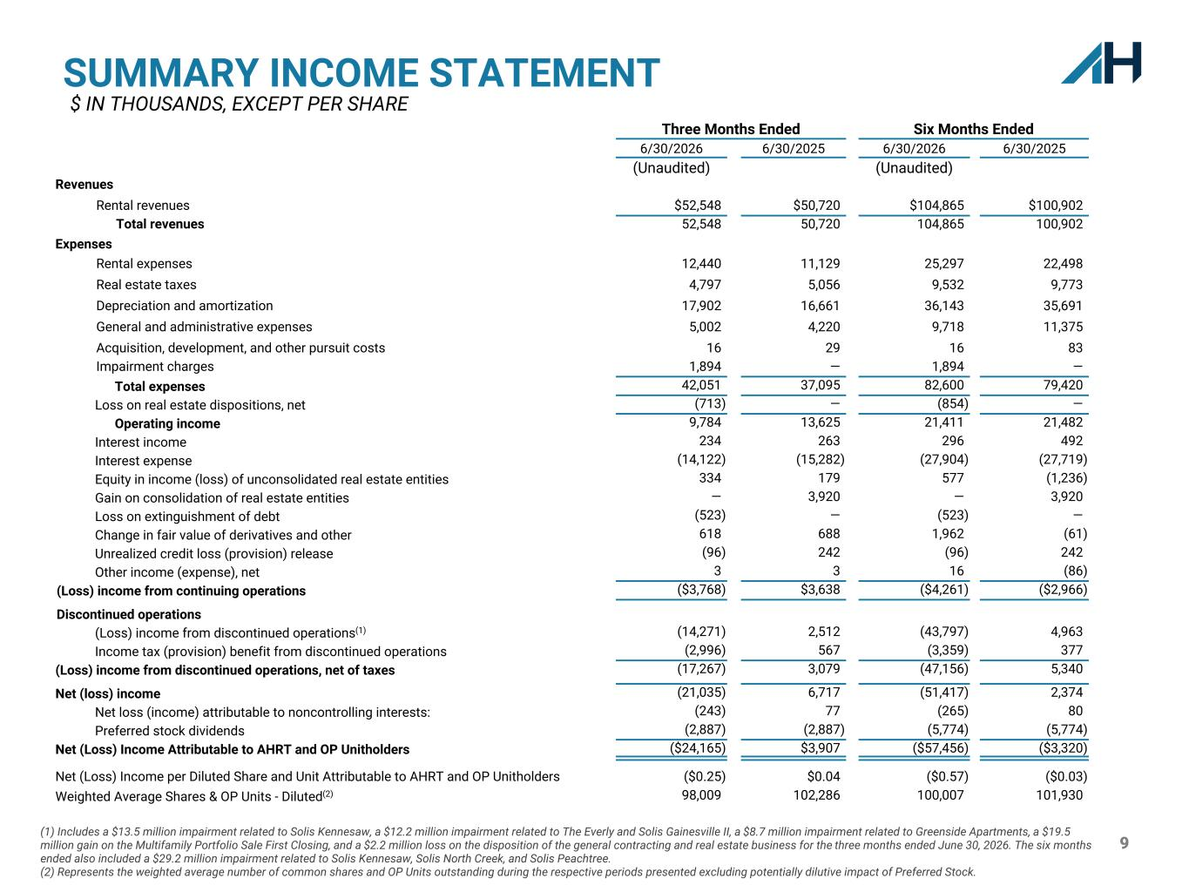
9 Three Months Ended Six Months Ended 6/30/2026 6/30/2025 6/30/2026 6/30/2025 (Unaudited) (Unaudited) Revenues Rental revenues $52,548 $50,720 $104,865 $100,902 Total revenues 52,548 50,720 104,865 100,902 Expenses Rental expenses 12,440 11,129 25,297 22,498 Real estate taxes 4,797 5,056 9,532 9,773 Depreciation and amortization 17,902 16,661 36,143 35,691 General and administrative expenses 5,002 4,220 9,718 11,375 Acquisition, development, and other pursuit costs 16 29 16 83 Impairment charges 1,894 — 1,894 — Total expenses 42,051 37,095 82,600 79,420 Loss on real estate dispositions, net (713) — (854) — Operating income 9,784 13,625 21,411 21,482 Interest income 234 263 296 492 Interest expense (14,122) (15,282) (27,904) (27,719) Equity in income (loss) of unconsolidated real estate entities 334 179 577 (1,236) Gain on consolidation of real estate entities — 3,920 — 3,920 Loss on extinguishment of debt (523) — (523) — Change in fair value of derivatives and other 618 688 1,962 (61) Unrealized credit loss (provision) release (96) 242 (96) 242 Other income (expense), net 3 3 16 (86) (Loss) income from continuing operations ($3,768) $3,638 ($4,261) ($2,966) Discontinued operations (Loss) income from discontinued operations(1) (14,271) 2,512 (43,797) 4,963 Income tax (provision) benefit from discontinued operations (2,996) 567 (3,359) 377 (Loss) income from discontinued operations, net of taxes (17,267) 3,079 (47,156) 5,340 Net (loss) income (21,035) 6,717 (51,417) 2,374 Net loss (income) attributable to noncontrolling interests: (243) 77 (265) 80 Preferred stock dividends (2,887) (2,887) (5,774) (5,774) Net (Loss) Income Attributable to AHRT and OP Unitholders ($24,165) $3,907 ($57,456) ($3,320) Net (Loss) Income per Diluted Share and Unit Attributable to AHRT and OP Unitholders ($0.25) $0.04 ($0.57) ($0.03) Weighted Average Shares & OP Units - Diluted(2) 98,009 102,286 100,007 101,930 SUMMARY INCOME STATEMENT $ IN THOUSANDS, EXCEPT PER SHARE (1) Includes a $13.5 million impairment related to Solis Kennesaw, a $12.2 million impairment related to The Everly and Solis Gainesville II, a $8.7 million impairment related to Greenside Apartments, a $19.5 million gain on the Multifamily Portfolio Sale First Closing, and a $2.2 million loss on the disposition of the general contracting and real estate business for the three months ended June 30, 2026. The six months ended also included a $29.2 million impairment related to Solis Kennesaw, Solis North Creek, and Solis Peachtree. (2) Represents the weighted average number of common shares and OP Units outstanding during the respective periods presented excluding potentially dilutive impact of Preferred Stock.

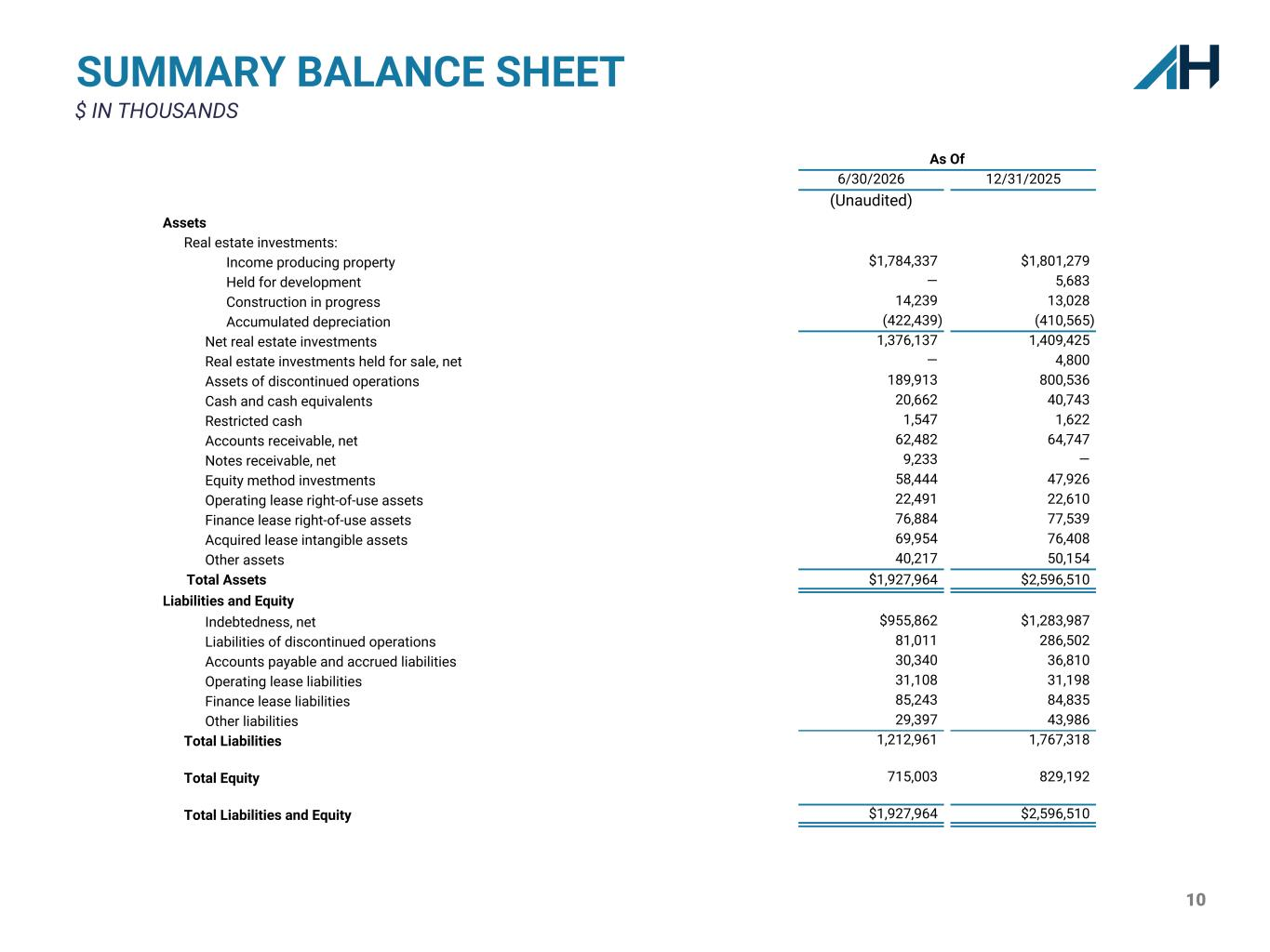
10 SUMMARY BALANCE SHEET $ IN THOUSANDS As Of 6/30/2026 12/31/2025 (Unaudited) Assets Real estate investments: Income producing property $1,784,337 $1,801,279 Held for development — 5,683 Construction in progress 14,239 13,028 Accumulated depreciation (422,439) (410,565) Net real estate investments 1,376,137 1,409,425 Real estate investments held for sale, net — 4,800 Assets of discontinued operations 189,913 800,536 Cash and cash equivalents 20,662 40,743 Restricted cash 1,547 1,622 Accounts receivable, net 62,482 64,747 Notes receivable, net 9,233 — Equity method investments 58,444 47,926 Operating lease right-of-use assets 22,491 22,610 Finance lease right-of-use assets 76,884 77,539 Acquired lease intangible assets 69,954 76,408 Other assets 40,217 50,154 Total Assets $1,927,964 $2,596,510 Liabilities and Equity Indebtedness, net $955,862 $1,283,987 Liabilities of discontinued operations 81,011 286,502 Accounts payable and accrued liabilities 30,340 36,810 Operating lease liabilities 31,108 31,198 Finance lease liabilities 85,243 84,835 Other liabilities 29,397 43,986 Total Liabilities 1,212,961 1,767,318 Total Equity 715,003 829,192 Total Liabilities and Equity $1,927,964 $2,596,510

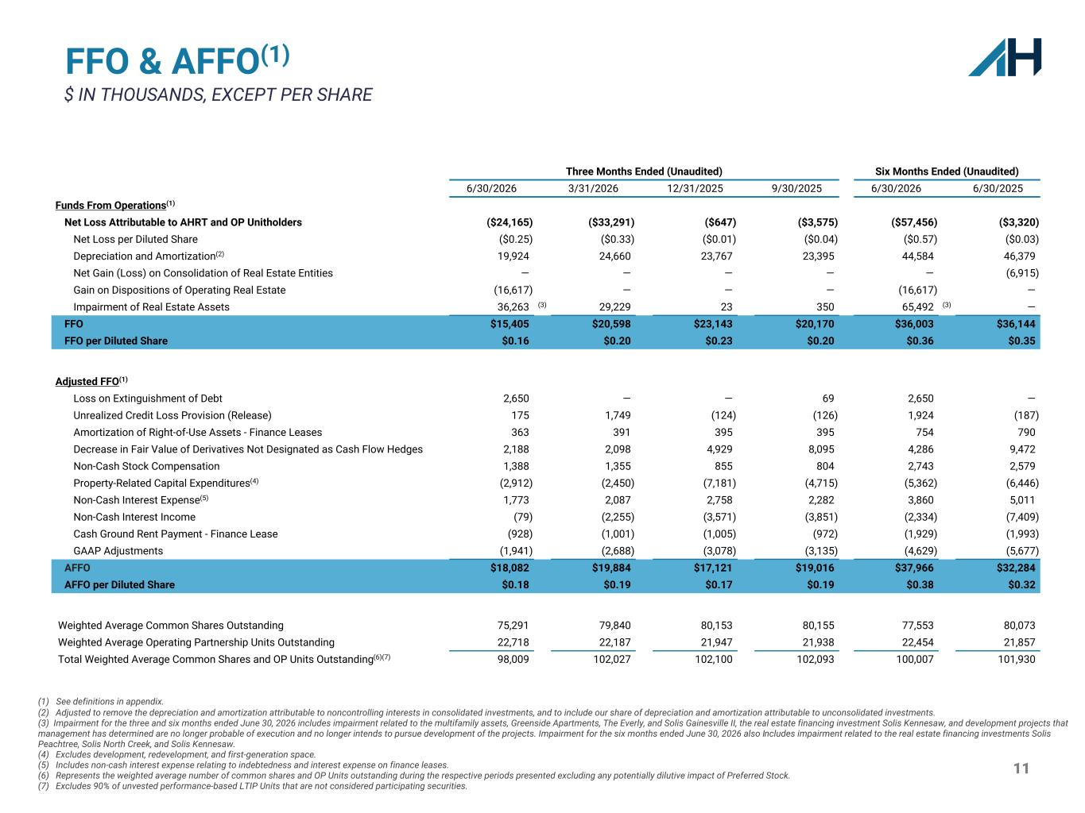
11 FFO & AFFO(1) $ IN THOUSANDS, EXCEPT PER SHARE Three Months Ended (Unaudited) Six Months Ended (Unaudited) 6/30/2026 3/31/2026 12/31/2025 9/30/2025 6/30/2026 6/30/2025 Funds From Operations(1) Net Loss Attributable to AHRT and OP Unitholders ($24,165) ($33,291) ($647) ($3,575) ($57,456) ($3,320) Net Loss per Diluted Share ($0.25) ($0.33) ($0.01) ($0.04) ($0.57) ($0.03) Depreciation and Amortization(2) 19,924 24,660 23,767 23,395 44,584 46,379 Net Gain (Loss) on Consolidation of Real Estate Entities — — — — — (6,915) Gain on Dispositions of Operating Real Estate (16,617) — — — (16,617) — Impairment of Real Estate Assets 36,263 (3) 29,229 23 350 65,492 (3) — FFO $15,405 $20,598 $23,143 $20,170 $36,003 $36,144 FFO per Diluted Share $0.16 $0.20 $0.23 $0.20 $0.36 $0.35 Adjusted FFO(1) Loss on Extinguishment of Debt 2,650 — — 69 2,650 — Unrealized Credit Loss Provision (Release) 175 1,749 (124) (126) 1,924 (187) Amortization of Right-of-Use Assets - Finance Leases 363 391 395 395 754 790 Decrease in Fair Value of Derivatives Not Designated as Cash Flow Hedges 2,188 2,098 4,929 8,095 4,286 9,472 Non-Cash Stock Compensation 1,388 1,355 855 804 2,743 2,579 Property-Related Capital Expenditures(4) (2,912) (2,450) (7,181) (4,715) (5,362) (6,446) Non-Cash Interest Expense(5) 1,773 2,087 2,758 2,282 3,860 5,011 Non-Cash Interest Income (79) (2,255) (3,571) (3,851) (2,334) (7,409) Cash Ground Rent Payment - Finance Lease (928) (1,001) (1,005) (972) (1,929) (1,993) GAAP Adjustments (1,941) (2,688) (3,078) (3,135) (4,629) (5,677) AFFO $18,082 $19,884 $17,121 $19,016 $37,966 $32,284 AFFO per Diluted Share $0.18 $0.19 $0.17 $0.19 $0.38 $0.32 Weighted Average Common Shares Outstanding 75,291 79,840 80,153 80,155 77,553 80,073 Weighted Average Operating Partnership Units Outstanding 22,718 22,187 21,947 21,938 22,454 21,857 Total Weighted Average Common Shares and OP Units Outstanding(6)(7) 98,009 102,027 102,100 102,093 100,007 101,930 (1) See definitions in appendix. (2) Adjusted to remove the depreciation and amortization attributable to noncontrolling interests in consolidated investments, and to include our share of depreciation and amortization attributable to unconsolidated investments. (3) Impairment for the three and six months ended June 30, 2026 includes impairment related to the multifamily assets, Greenside Apartments, The Everly, and Solis Gainesville II, the real estate financing investment Solis Kennesaw, and development projects that management has determined are no longer probable of execution and no longer intends to pursue development of the projects. Impairment for the six months ended June 30, 2026 also Includes impairment related to the real estate financing investments Solis Peachtree, Solis North Creek, and Solis Kennesaw. (4) Excludes development, redevelopment, and first-generation space. (5) Includes non-cash interest expense relating to indebtedness and interest expense on finance leases. (6) Represents the weighted average number of common shares and OP Units outstanding during the respective periods presented excluding any potentially dilutive impact of Preferred Stock. (7) Excludes 90% of unvested performance-based LTIP Units that are not considered participating securities.

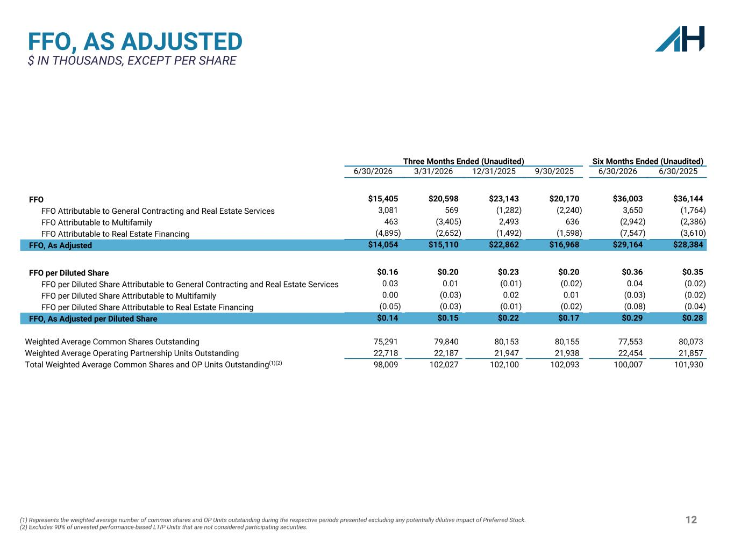
12 FFO, AS ADJUSTED $ IN THOUSANDS, EXCEPT PER SHARE Three Months Ended (Unaudited) Six Months Ended (Unaudited) 6/30/2026 3/31/2026 12/31/2025 9/30/2025 6/30/2026 6/30/2025 FFO $15,405 $20,598 $23,143 $20,170 $36,003 $36,144 FFO Attributable to General Contracting and Real Estate Services 3,081 569 (1,282) (2,240) 3,650 (1,764) FFO Attributable to Multifamily 463 (3,405) 2,493 636 (2,942) (2,386) FFO Attributable to Real Estate Financing (4,895) (2,652) (1,492) (1,598) (7,547) (3,610) FFO, As Adjusted $14,054 $15,110 $22,862 $16,968 $29,164 $28,384 FFO per Diluted Share $0.16 $0.20 $0.23 $0.20 $0.36 $0.35 FFO per Diluted Share Attributable to General Contracting and Real Estate Services 0.03 0.01 (0.01) (0.02) 0.04 (0.02) FFO per Diluted Share Attributable to Multifamily 0.00 (0.03) 0.02 0.01 (0.03) (0.02) FFO per Diluted Share Attributable to Real Estate Financing (0.05) (0.03) (0.01) (0.02) (0.08) (0.04) FFO, As Adjusted per Diluted Share $0.14 $0.15 $0.22 $0.17 $0.29 $0.28 Weighted Average Common Shares Outstanding 75,291 79,840 80,153 80,155 77,553 80,073 Weighted Average Operating Partnership Units Outstanding 22,718 22,187 21,947 21,938 22,454 21,857 Total Weighted Average Common Shares and OP Units Outstanding(1)(2) 98,009 102,027 102,100 102,093 100,007 101,930 (1) Represents the weighted average number of common shares and OP Units outstanding during the respective periods presented excluding any potentially dilutive impact of Preferred Stock. (2) Excludes 90% of unvested performance-based LTIP Units that are not considered participating securities.

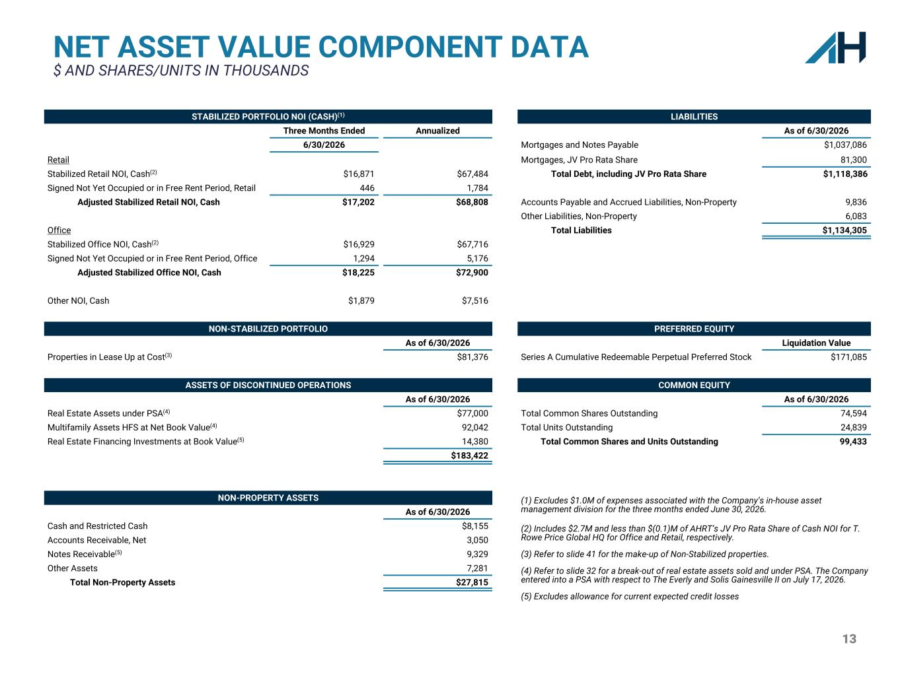
13 STABILIZED PORTFOLIO NOI (CASH)(1) LIABILITIES Three Months Ended Annualized As of 6/30/2026 6/30/2026 Mortgages and Notes Payable $1,037,086 Retail Mortgages, JV Pro Rata Share 81,300 Stabilized Retail NOI, Cash(2) $16,871 $67,484 Total Debt, including JV Pro Rata Share $1,118,386 Signed Not Yet Occupied or in Free Rent Period, Retail 446 1,784 Adjusted Stabilized Retail NOI, Cash $17,202 $68,808 Accounts Payable and Accrued Liabilities, Non-Property 9,836 Other Liabilities, Non-Property 6,083 Office Total Liabilities $1,134,305 Stabilized Office NOI, Cash(2) $16,929 $67,716 Signed Not Yet Occupied or in Free Rent Period, Office 1,294 5,176 Adjusted Stabilized Office NOI, Cash $18,225 $72,900 Other NOI, Cash $1,879 $7,516 NON-STABILIZED PORTFOLIO PREFERRED EQUITY As of 6/30/2026 Liquidation Value Properties in Lease Up at Cost(3) $81,376 Series A Cumulative Redeemable Perpetual Preferred Stock $171,085 ASSETS OF DISCONTINUED OPERATIONS COMMON EQUITY As of 6/30/2026 As of 6/30/2026 Real Estate Assets under PSA(4) $77,000 Total Common Shares Outstanding 74,594 Multifamily Assets HFS at Net Book Value(4) 92,042 Total Units Outstanding 24,839 Real Estate Financing Investments at Book Value(5) 14,380 Total Common Shares and Units Outstanding 99,433 $183,422 NON-PROPERTY ASSETS (1) Excludes $1.0M of expenses associated with the Company’s in-house asset management division for the three months ended June 30, 2026. As of 6/30/2026 Cash and Restricted Cash $8,155 (2) Includes $2.7M and less than $(0.1)M of AHRT’s JV Pro Rata Share of Cash NOI for T. Rowe Price Global HQ for Office and Retail, respectively.Accounts Receivable, Net 3,050 Notes Receivable(5) 9,329 (3) Refer to slide 41 for the make-up of Non-Stabilized properties. Other Assets 7,281 (4) Refer to slide 32 for a break-out of real estate assets sold and under PSA. The Company entered into a PSA with respect to The Everly and Solis Gainesville II on July 17, 2026.Total Non-Property Assets $27,815 (5) Excludes allowance for current expected credit losses NET ASSET VALUE COMPONENT DATA $ AND SHARES/UNITS IN THOUSANDS

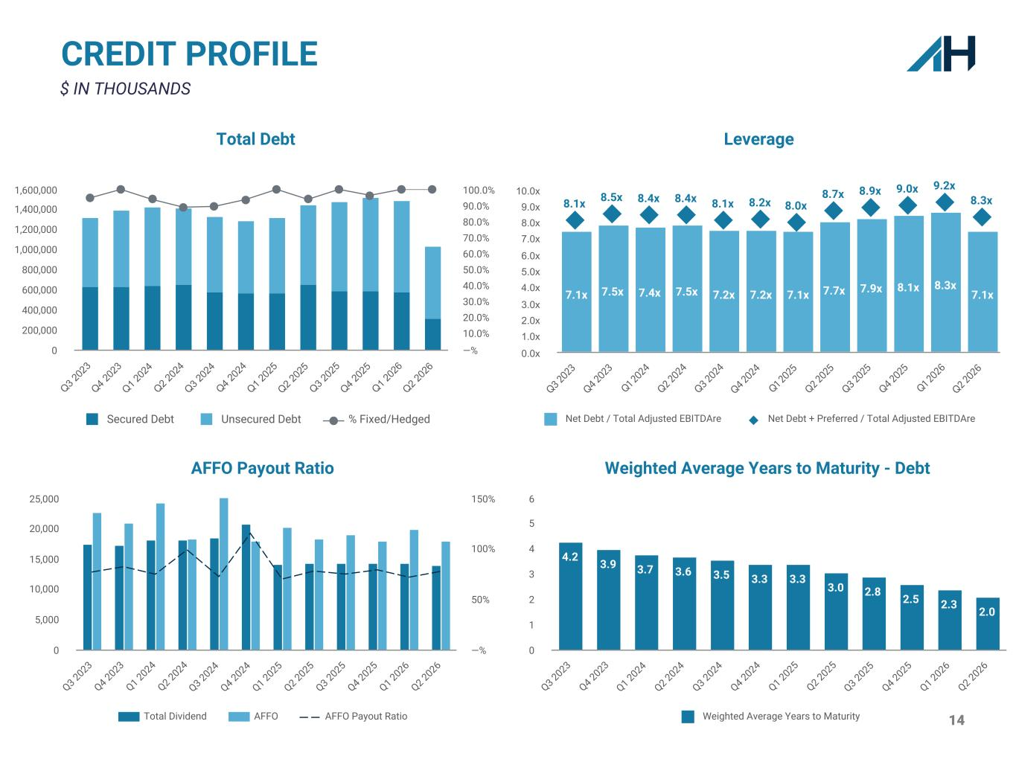
14 CREDIT PROFILE $ IN THOUSANDS Leverage 7.1x 7.5x 7.4x 7.5x 7.2x 7.2x 7.1x 7.7x 7.9x 8.1x 8.3x 7.1x 8.1x 8.5x 8.4x 8.4x 8.1x 8.2x 8.0x 8.7x 8.9x 9.0x 9.2x 8.3x Net Debt / Total Adjusted EBITDAre Net Debt + Preferred / Total Adjusted EBITDAre Q3 2023 Q4 2023 Q1 2 024 Q2 2024 Q3 2024 Q4 2024 Q1 2 025 Q2 2025 Q3 2025 Q4 2025 Q1 2 026 Q2 2026 0.0x 1.0x 2.0x 3.0x 4.0x 5.0x 6.0x 7.0x 8.0x 9.0x 10.0x Total Debt Secured Debt Unsecured Debt % Fixed/Hedged Q3 2 02 3 Q4 2 02 3 Q1 2 02 4 Q2 2 02 4 Q3 2 02 4 Q4 2 02 4 Q1 2 02 5 Q2 2 02 5 Q3 2 02 5 Q4 2 02 5 Q1 2 02 6 Q2 2 02 6 0 200,000 400,000 600,000 800,000 1,000,000 1,200,000 1,400,000 1,600,000 —% 10.0% 20.0% 30.0% 40.0% 50.0% 60.0% 70.0% 80.0% 90.0% 100.0% AFFO Payout Ratio Total Dividend AFFO AFFO Payout Ratio Q3 2023 Q4 2023 Q1 2024 Q2 2024 Q3 2024 Q4 2024 Q1 2025 Q2 2025 Q3 2025 Q4 2025 Q1 2026 Q2 2026 0 5,000 10,000 15,000 20,000 25,000 —% 50% 100% 150% Weighted Average Years to Maturity - Debt 4.2 3.9 3.7 3.6 3.5 3.3 3.3 3.0 2.8 2.5 2.3 2.0 Weighted Average Years to Maturity Q3 2023 Q4 2023 Q1 2024 Q2 2024 Q3 2024 Q4 2024 Q1 2025 Q2 2025 Q3 2025 Q4 2025 Q1 2026 Q2 2026 0 1 2 3 4 5 6

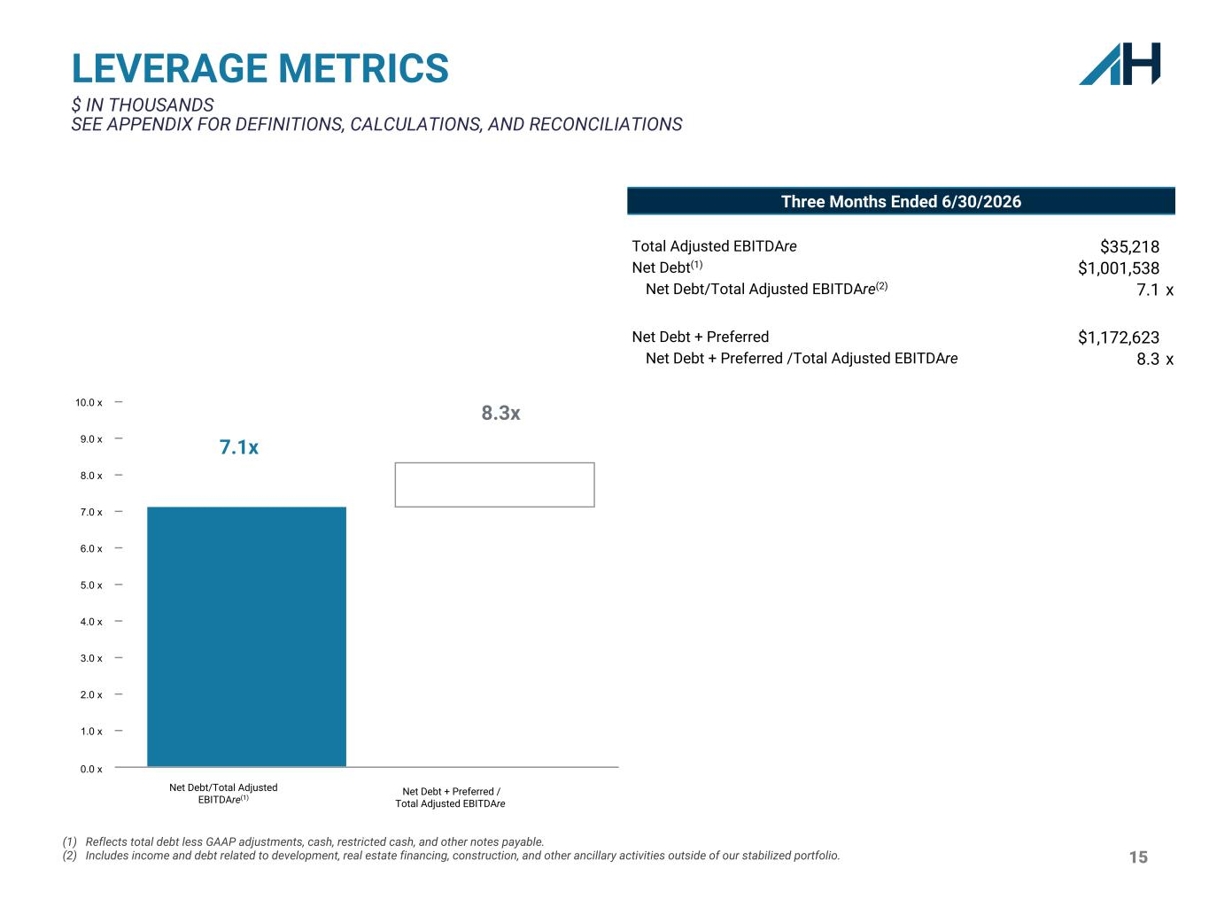
15 LEVERAGE METRICS $ IN THOUSANDS SEE APPENDIX FOR DEFINITIONS, CALCULATIONS, AND RECONCILIATIONS (1) Reflects total debt less GAAP adjustments, cash, restricted cash, and other notes payable. (2) Includes income and debt related to development, real estate financing, construction, and other ancillary activities outside of our stabilized portfolio. Three Months Ended 6/30/2026 Total Adjusted EBITDAre $35,218 Net Debt(1) $1,001,538 Net Debt/Total Adjusted EBITDAre(2) 7.1 x Net Debt + Preferred $1,172,623 Net Debt + Preferred /Total Adjusted EBITDAre 8.3 x 0.0 x 1.0 x 2.0 x 3.0 x 4.0 x 5.0 x 6.0 x 7.0 x 8.0 x 9.0 x 10.0 x 7.1x 8.3x Net Debt/Total Adjusted EBITDAre(1) Net Debt + Preferred / Total Adjusted EBITDAre

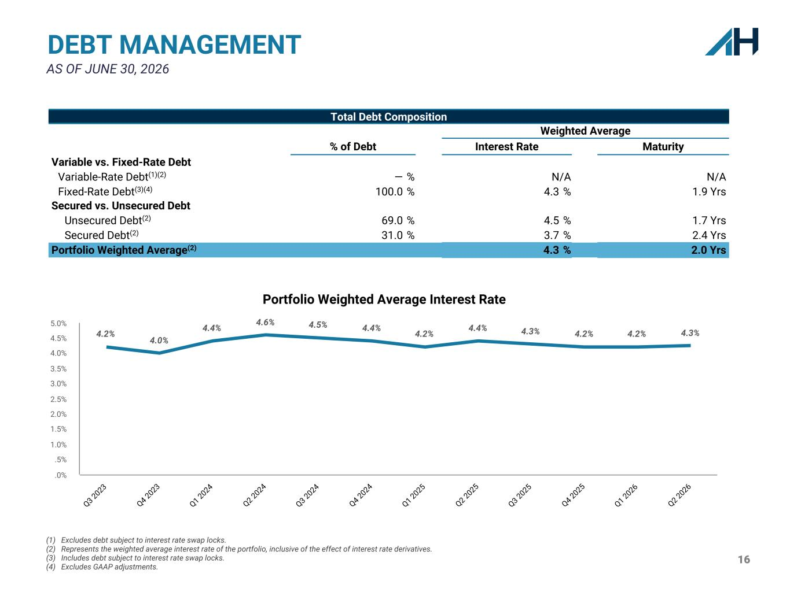
16 DEBT MANAGEMENT AS OF JUNE 30, 2026 Total Debt Composition Weighted Average % of Debt Interest Rate Maturity Variable vs. Fixed-Rate Debt Variable-Rate Debt(1)(2) — % N/A N/A Fixed-Rate Debt(3)(4) 100.0 % 4.3 % 1.9 Yrs Secured vs. Unsecured Debt Unsecured Debt(2) 69.0 % 4.5 % 1.7 Yrs Secured Debt(2) 31.0 % 3.7 % 2.4 Yrs Portfolio Weighted Average(2) 4.3 % 2.0 Yrs (1) Excludes debt subject to interest rate swap locks. (2) Represents the weighted average interest rate of the portfolio, inclusive of the effect of interest rate derivatives. (3) Includes debt subject to interest rate swap locks. (4) Excludes GAAP adjustments. Portfolio Weighted Average Interest Rate 4.2% 4.0% 4.4% 4.6% 4.5% 4.4% 4.2% 4.4% 4.3% 4.2% 4.2% 4.3% Q3 2023 Q4 2023 Q1 2024 Q2 2024 Q3 2024 Q4 2024 Q1 2025 Q2 2025 Q3 2025 Q4 2025 Q1 2026 Q2 2026 .0% .5% 1.0% 1.5% 2.0% 2.5% 3.0% 3.5% 4.0% 4.5% 5.0%

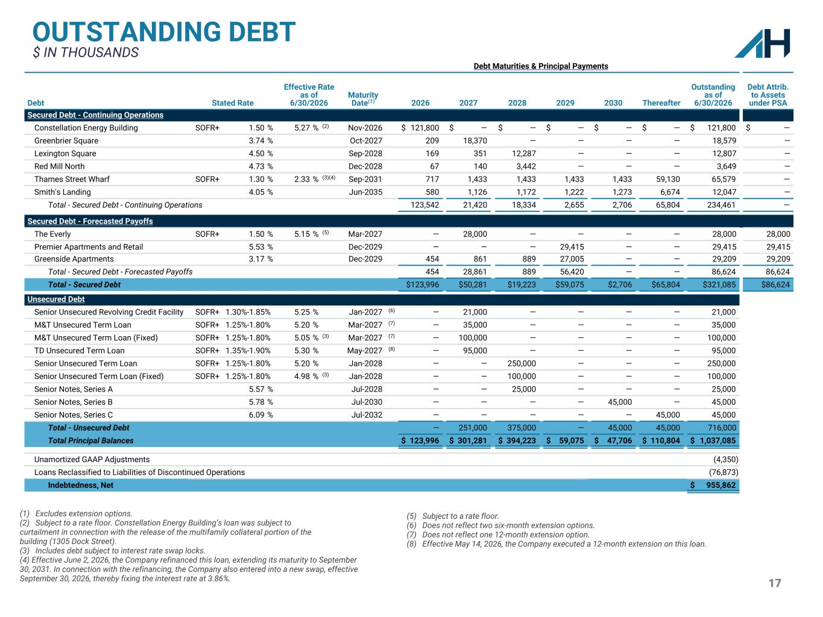
17 OUTSTANDING DEBT $ IN THOUSANDS (1) Excludes extension options. (2) Subject to a rate floor. Constellation Energy Building’s loan was subject to curtailment in connection with the release of the multifamily collateral portion of the building (1305 Dock Street). (3) Includes debt subject to interest rate swap locks. (4) Effective June 2, 2026, the Company refinanced this loan, extending its maturity to September 30, 2031. In connection with the refinancing, the Company also entered into a new swap, effective September 30, 2026, thereby fixing the interest rate at 3.86%. Debt Maturities & Principal Payments Debt Stated Rate Effective Rate as of 6/30/2026 Maturity Date(1) 2026 2027 2028 2029 2030 Thereafter Outstanding as of 6/30/2026 Debt Attrib. to Assets under PSA Secured Debt - Continuing Operations Constellation Energy Building SOFR+ 1.50 % 5.27 % (2) Nov-2026 $ 121,800 $ — $ — $ — $ — $ — $ 121,800 $ — Greenbrier Square 3.74 % Oct-2027 209 18,370 — — — — 18,579 — Lexington Square 4.50 % Sep-2028 169 351 12,287 — — — 12,807 — Red Mill North 4.73 % Dec-2028 67 140 3,442 — — — 3,649 — Thames Street Wharf SOFR+ 1.30 % 2.33 % (3)(4) Sep-2031 717 1,433 1,433 1,433 1,433 59,130 65,579 — Smith's Landing 4.05 % Jun-2035 580 1,126 1,172 1,222 1,273 6,674 12,047 — Total - Secured Debt - Continuing Operations 123,542 21,420 18,334 2,655 2,706 65,804 234,461 — Secured Debt - Forecasted Payoffs The Everly SOFR+ 1.50 % 5.15 % (5) Mar-2027 — 28,000 — — — — 28,000 28,000 Premier Apartments and Retail 5.53 % Dec-2029 — — — 29,415 — — 29,415 29,415 Greenside Apartments 3.17 % Dec-2029 454 861 889 27,005 — — 29,209 29,209 Total - Secured Debt - Forecasted Payoffs 454 28,861 889 56,420 — — 86,624 86,624 Total - Secured Debt $123,996 $50,281 $19,223 $59,075 $2,706 $65,804 $321,085 $86,624 Unsecured Debt Senior Unsecured Revolving Credit Facility SOFR+ 1.30%-1.85% 5.25 % Jan-2027 (6) — 21,000 — — — — 21,000 M&T Unsecured Term Loan SOFR+ 1.25%-1.80% 5.20 % Mar-2027 (7) — 35,000 — — — — 35,000 M&T Unsecured Term Loan (Fixed) SOFR+ 1.25%-1.80% 5.05 % (3) Mar-2027 (7) — 100,000 — — — — 100,000 TD Unsecured Term Loan SOFR+ 1.35%-1.90% 5.30 % May-2027 (8) — 95,000 — — — — 95,000 Senior Unsecured Term Loan SOFR+ 1.25%-1.80% 5.20 % Jan-2028 — — 250,000 — — — 250,000 Senior Unsecured Term Loan (Fixed) SOFR+ 1.25%-1.80% 4.98 % (3) Jan-2028 — — 100,000 — — — 100,000 Senior Notes, Series A 5.57 % Jul-2028 — — 25,000 — — — 25,000 Senior Notes, Series B 5.78 % Jul-2030 — — — — 45,000 — 45,000 Senior Notes, Series C 6.09 % Jul-2032 — — — — — 45,000 45,000 Total - Unsecured Debt — 251,000 375,000 — 45,000 45,000 716,000 Total Principal Balances $ 123,996 $ 301,281 $ 394,223 $ 59,075 $ 47,706 $ 110,804 $ 1,037,085 Unamortized GAAP Adjustments (4,350) Loans Reclassified to Liabilities of Discontinued Operations (76,873) Indebtedness, Net $ 955,862 (5) Subject to a rate floor. (6) Does not reflect two six-month extension options. (7) Does not reflect one 12-month extension option. (8) Effective May 14, 2026, the Company executed a 12-month extension on this loan.

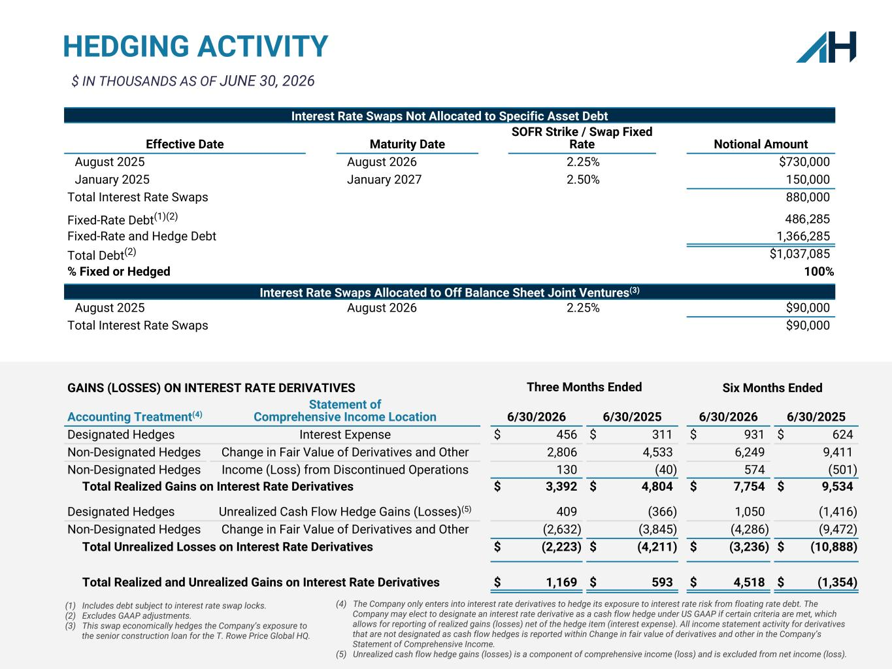
18 (1) Includes debt subject to interest rate swap locks. (2) Excludes GAAP adjustments. (3) This swap economically hedges the Company’s exposure to the senior construction loan for the T. Rowe Price Global HQ. HEDGING ACTIVITY GAINS (LOSSES) ON INTEREST RATE DERIVATIVES Three Months Ended Six Months Ended Accounting Treatment(4) Statement of Comprehensive Income Location 6/30/2026 6/30/2025 6/30/2026 6/30/2025 Designated Hedges Interest Expense $ 456 $ 311 $ 931 $ 624 Non-Designated Hedges Change in Fair Value of Derivatives and Other 2,806 4,533 6,249 9,411 Non-Designated Hedges Income (Loss) from Discontinued Operations 130 (40) 574 (501) Total Realized Gains on Interest Rate Derivatives $ 3,392 $ 4,804 $ 7,754 $ 9,534 Designated Hedges Unrealized Cash Flow Hedge Gains (Losses)(5) 409 (366) 1,050 (1,416) Non-Designated Hedges Change in Fair Value of Derivatives and Other (2,632) (3,845) (4,286) (9,472) Total Unrealized Losses on Interest Rate Derivatives $ (2,223) $ (4,211) $ (3,236) $ (10,888) Total Realized and Unrealized Gains on Interest Rate Derivatives $ 1,169 $ 593 $ 4,518 $ (1,354) Interest Rate Swaps Not Allocated to Specific Asset Debt Effective Date Maturity Date SOFR Strike / Swap Fixed Rate Notional Amount August 2025 August 2026 2.25% $730,000 January 2025 January 2027 2.50% 150,000 Total Interest Rate Swaps 880,000 Fixed-Rate Debt(1)(2) 486,285 Fixed-Rate and Hedge Debt 1,366,285 Total Debt(2) $1,037,085 % Fixed or Hedged 100% Interest Rate Swaps Allocated to Off Balance Sheet Joint Ventures(3) August 2025 August 2026 2.25% $90,000 Total Interest Rate Swaps $90,000 $ IN THOUSANDS AS OF JUNE 30, 2026 (4) The Company only enters into interest rate derivatives to hedge its exposure to interest rate risk from floating rate debt. The Company may elect to designate an interest rate derivative as a cash flow hedge under US GAAP if certain criteria are met, which allows for reporting of realized gains (losses) net of the hedge item (interest expense). All income statement activity for derivatives that are not designated as cash flow hedges is reported within Change in fair value of derivatives and other in the Company’s Statement of Comprehensive Income. (5) Unrealized cash flow hedge gains (losses) is a component of comprehensive income (loss) and is excluded from net income (loss).

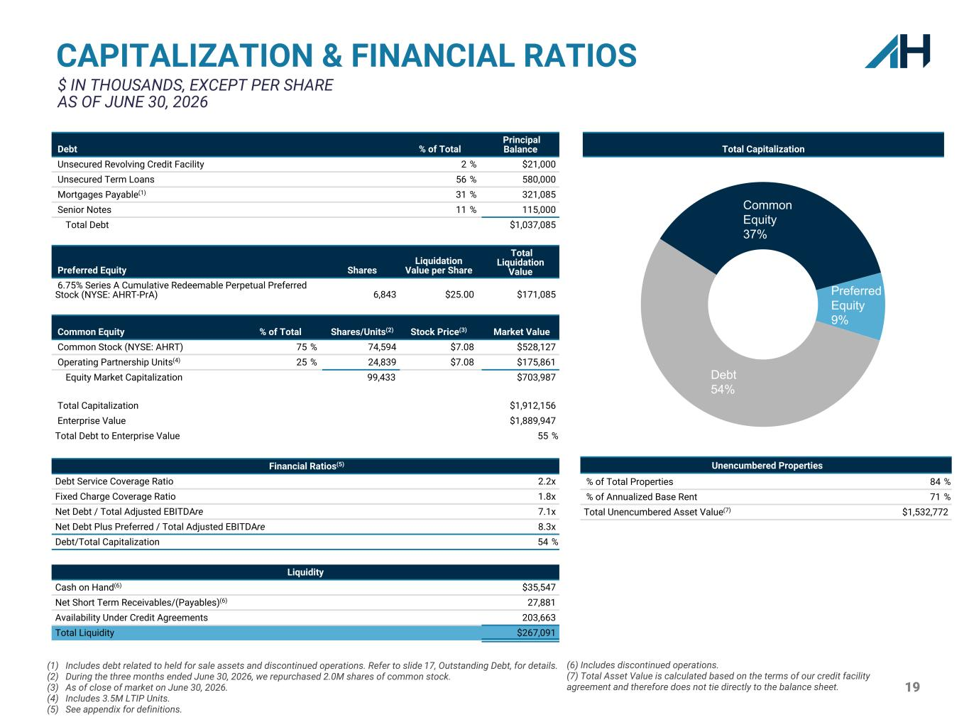
19 CAPITALIZATION & FINANCIAL RATIOS $ IN THOUSANDS, EXCEPT PER SHARE AS OF JUNE 30, 2026 (1) Includes debt related to held for sale assets and discontinued operations. Refer to slide 17, Outstanding Debt, for details. (2) During the three months ended June 30, 2026, we repurchased 2.0M shares of common stock. (3) As of close of market on June 30, 2026. (4) Includes 3.5M LTIP Units. (5) See appendix for definitions. Debt % of Total Principal Balance Unsecured Revolving Credit Facility 2 % $21,000 Unsecured Term Loans 56 % 580,000 Mortgages Payable(1) 31 % 321,085 Senior Notes 11 % 115,000 Total Debt $1,037,085 Preferred Equity Shares Liquidation Value per Share Total Liquidation Value 6.75% Series A Cumulative Redeemable Perpetual Preferred Stock (NYSE: AHRT-PrA) 6,843 $25.00 $171,085 Common Equity % of Total Shares/Units(2) Stock Price(3) Market Value Common Stock (NYSE: AHRT) 75 % 74,594 $7.08 $528,127 Operating Partnership Units(4) 25 % 24,839 $7.08 $175,861 Equity Market Capitalization 99,433 $703,987 Total Capitalization $1,912,156 Enterprise Value $1,889,947 Total Debt to Enterprise Value 55 % Financial Ratios(5) Debt Service Coverage Ratio 2.2x Fixed Charge Coverage Ratio 1.8x Net Debt / Total Adjusted EBITDAre 7.1x Net Debt Plus Preferred / Total Adjusted EBITDAre 8.3x Debt/Total Capitalization 54 % Liquidity Cash on Hand(6) $35,547 Net Short Term Receivables/(Payables)(6) 27,881 Availability Under Credit Agreements 203,663 Total Liquidity $267,091 Unencumbered Properties % of Total Properties 84 % % of Annualized Base Rent 71 % Total Unencumbered Asset Value(7) $1,532,772 Preferred Equity 9% Debt 54% Common Equity 37% (6) Includes discontinued operations. (7) Total Asset Value is calculated based on the terms of our credit facility agreement and therefore does not tie directly to the balance sheet. Total Capitalization

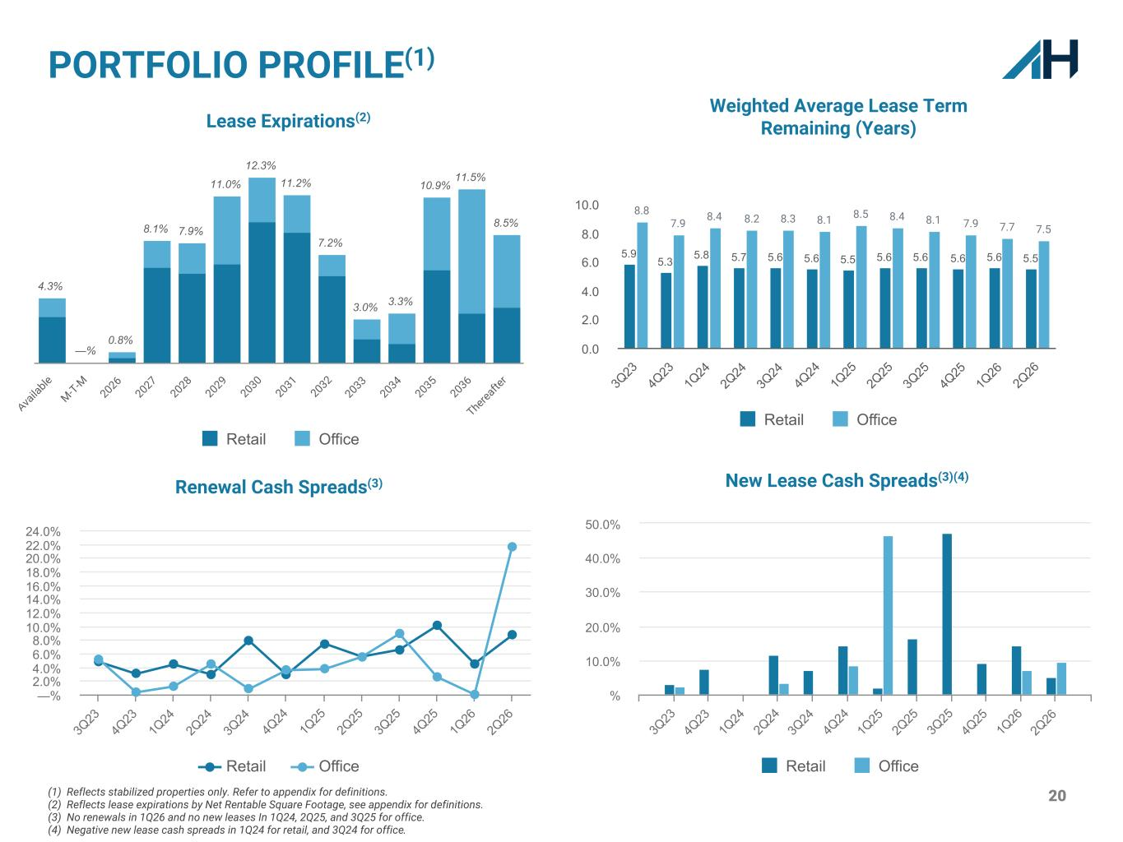
20 PORTFOLIO PROFILE(1) 4.3% —% 0.8% 8.1% 7.9% 11.0% 12.3% 11.2% 7.2% 3.0% 3.3% 10.9% 11.5% 8.5% Retail Office Ava ila ble M-T-M 2026 2027 2028 2029 2030 2031 2032 2033 2034 2035 2036 Thereafte r Weighted Average Lease Term Remaining (Years) (1) Reflects stabilized properties only. Refer to appendix for definitions. (2) Reflects lease expirations by Net Rentable Square Footage, see appendix for definitions. (3) No renewals in 1Q26 and no new leases In 1Q24, 2Q25, and 3Q25 for office. (4) Negative new lease cash spreads in 1Q24 for retail, and 3Q24 for office. 5.9 5.3 5.8 5.7 5.6 5.6 5.5 5.6 5.6 5.6 5.6 5.5 8.8 7.9 8.4 8.2 8.3 8.1 8.5 8.4 8.1 7.9 7.7 7.5 Retail Office 3Q 23 4Q 23 1Q 24 2Q 24 3Q 24 4Q 24 1Q 25 2Q 25 3Q 25 4Q 25 1Q 26 2Q 26 0.0 2.0 4.0 6.0 8.0 10.0 Lease Expirations(2) Renewal Cash Spreads(3) Retail Office 3Q 23 4Q 23 1Q 24 2Q 24 3Q 24 4Q 24 1Q 25 2Q 25 3Q 25 4Q 25 1Q 26 2Q 26 —% 2.0% 4.0% 6.0% 8.0% 10.0% 12.0% 14.0% 16.0% 18.0% 20.0% 22.0% 24.0% New Lease Cash Spreads(3)(4) Retail Office 3Q 23 4Q 23 1Q 24 2Q 24 3Q 24 4Q 24 1Q 25 2Q 25 3Q 25 4Q 25 1Q 26 2Q 26 % 10.0% 20.0% 30.0% 40.0% 50.0%

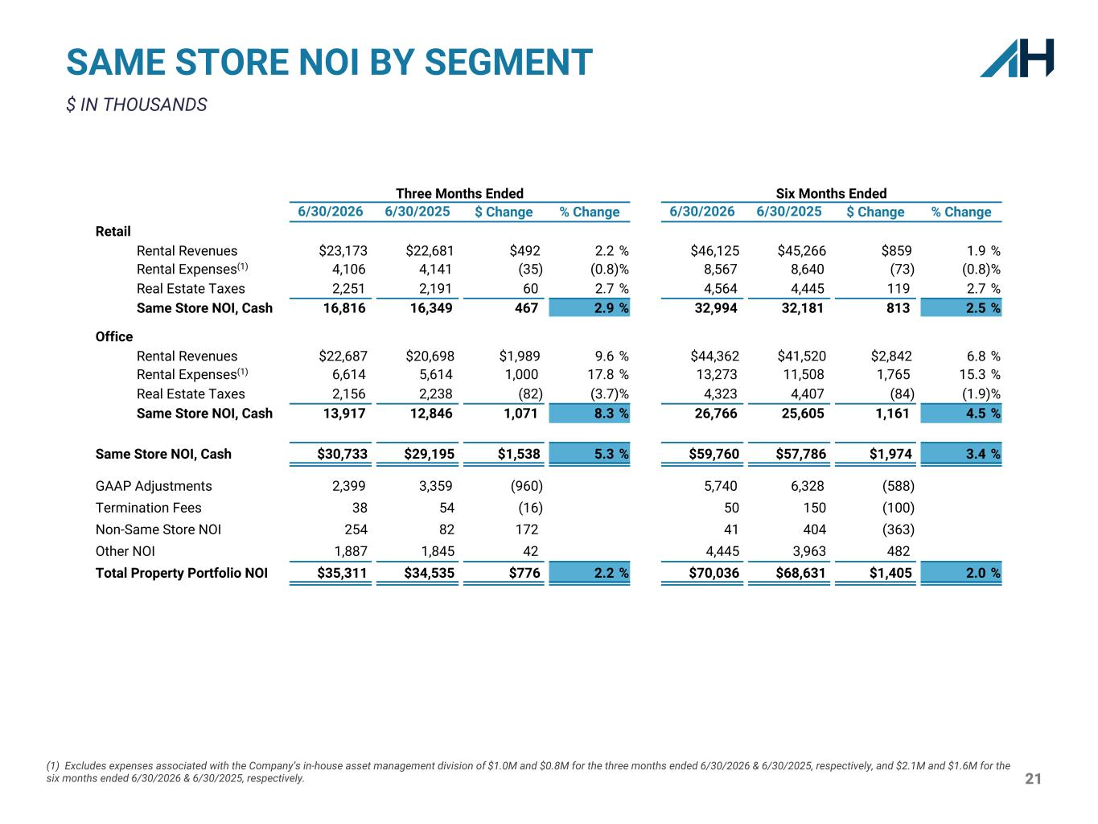
21 (1) Excludes expenses associated with the Company’s in-house asset management division of $1.0M and $0.8M for the three months ended 6/30/2026 & 6/30/2025, respectively, and $2.1M and $1.6M for the six months ended 6/30/2026 & 6/30/2025, respectively. SAME STORE NOI BY SEGMENT $ IN THOUSANDS Three Months Ended Six Months Ended 6/30/2026 6/30/2025 $ Change % Change 6/30/2026 6/30/2025 $ Change % Change Retail Rental Revenues $23,173 $22,681 $492 2.2 % $46,125 $45,266 $859 1.9 % Rental Expenses(1) 4,106 4,141 (35) (0.8) % 8,567 8,640 (73) (0.8) % Real Estate Taxes 2,251 2,191 60 2.7 % 4,564 4,445 119 2.7 % Same Store NOI, Cash 16,816 16,349 467 2.9 % 32,994 32,181 813 2.5 % Office Rental Revenues $22,687 $20,698 $1,989 9.6 % $44,362 $41,520 $2,842 6.8 % Rental Expenses(1) 6,614 5,614 1,000 17.8 % 13,273 11,508 1,765 15.3 % Real Estate Taxes 2,156 2,238 (82) (3.7) % 4,323 4,407 (84) (1.9) % Same Store NOI, Cash 13,917 12,846 1,071 8.3 % 26,766 25,605 1,161 4.5 % Same Store NOI, Cash $30,733 $29,195 $1,538 5.3 % $59,760 $57,786 $1,974 3.4 % GAAP Adjustments 2,399 3,359 (960) 5,740 6,328 0 (588) Termination Fees 38 54 (16) 50 150 (100) Non-Same Store NOI 254 82 172 41 404 (363) Other NOI 1,887 1,845 42 4,445 3,963 482 Total Property Portfolio NOI $35,311 $34,535 $776 2.2 % $70,036 $68,631 $1,405 2.0 %

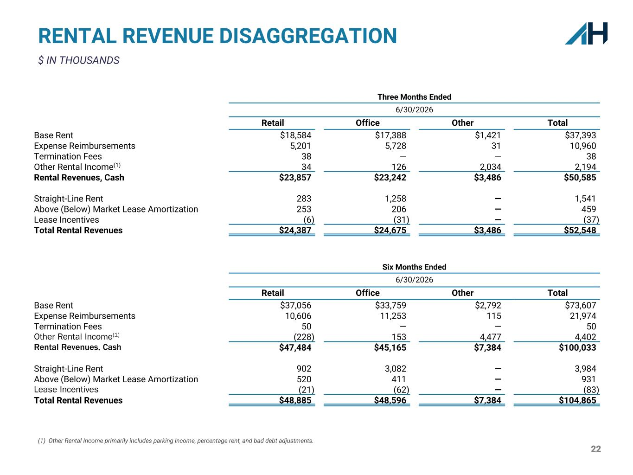
22 (1) Other Rental Income primarily includes parking income, percentage rent, and bad debt adjustments. RENTAL REVENUE DISAGGREGATION $ IN THOUSANDS Three Months Ended 6/30/2026 Retail Office Other Total Base Rent $18,584 $17,388 $1,421 $37,393 Expense Reimbursements 5,201 5,728 31 10,960 Termination Fees 38 — — 38 Other Rental Income(1) 34 126 2,034 2,194 Rental Revenues, Cash $23,857 $23,242 $3,486 $50,585 Straight-Line Rent 283 1,258 — 1,541 Above (Below) Market Lease Amortization 253 206 — 459 Lease Incentives (6) (31) — (37) Total Rental Revenues $24,387 $24,675 $3,486 $52,548 Six Months Ended 6/30/2026 Retail Office Other Total Base Rent $37,056 $33,759 $2,792 $73,607 Expense Reimbursements 10,606 11,253 115 21,974 Termination Fees 50 — — 50 Other Rental Income(1) (228) 153 4,477 4,402 Rental Revenues, Cash $47,484 $45,165 $7,384 $100,033 Straight-Line Rent 902 3,082 — 3,984 Above (Below) Market Lease Amortization 520 411 — 931 Lease Incentives (21) (62) — (83) Total Rental Revenues $48,885 $48,596 $7,384 $104,865

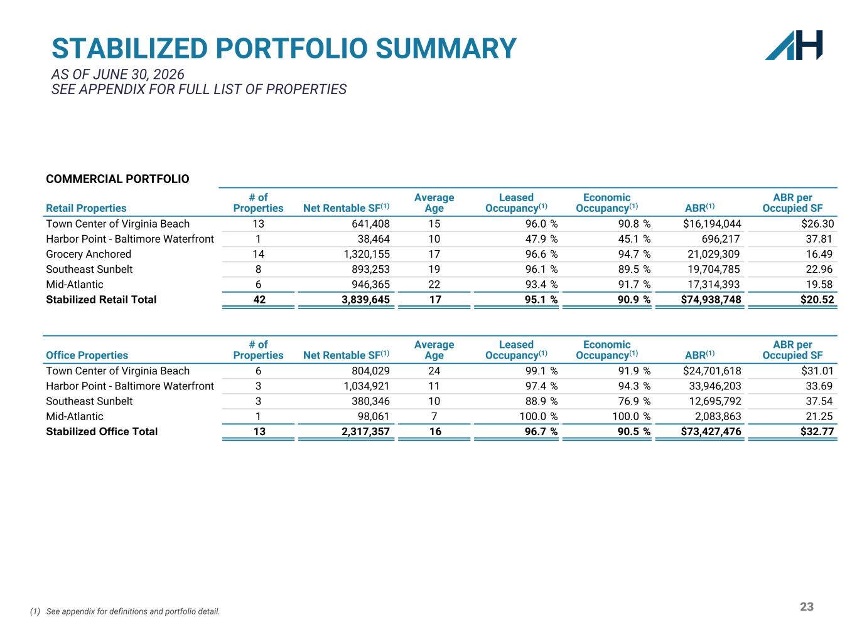
23 STABILIZED PORTFOLIO SUMMARY AS OF JUNE 30, 2026 SEE APPENDIX FOR FULL LIST OF PROPERTIES (1) See appendix for definitions and portfolio detail. COMMERCIAL PORTFOLIO Retail Properties # of Properties Net Rentable SF(1) Average Age Leased Occupancy(1) Economic Occupancy(1) ABR(1) ABR per Occupied SF Town Center of Virginia Beach 13 641,408 15 96.0 % 90.8 % $16,194,044 $26.30 Harbor Point - Baltimore Waterfront 1 38,464 10 47.9 % 45.1 % 696,217 37.81 Grocery Anchored 14 1,320,155 17 96.6 % 94.7 % 21,029,309 16.49 Southeast Sunbelt 8 893,253 19 96.1 % 89.5 % 19,704,785 22.96 Mid-Atlantic 6 946,365 22 93.4 % 91.7 % 17,314,393 19.58 Stabilized Retail Total 42 3,839,645 17 95.1 % 90.9 % $74,938,748 $20.52 Office Properties # of Properties Net Rentable SF(1) Average Age Leased Occupancy(1) Economic Occupancy(1) ABR(1) ABR per Occupied SF Town Center of Virginia Beach 6 804,029 24 99.1 % 91.9 % $24,701,618 $31.01 Harbor Point - Baltimore Waterfront 3 1,034,921 11 97.4 % 94.3 % 33,946,203 33.69 Southeast Sunbelt 3 380,346 10 88.9 % 76.9 % 12,695,792 37.54 Mid-Atlantic 1 98,061 7 100.0 % 100.0 % 2,083,863 21.25 Stabilized Office Total 13 2,317,357 16 96.7 % 90.5 % $73,427,476 $32.77

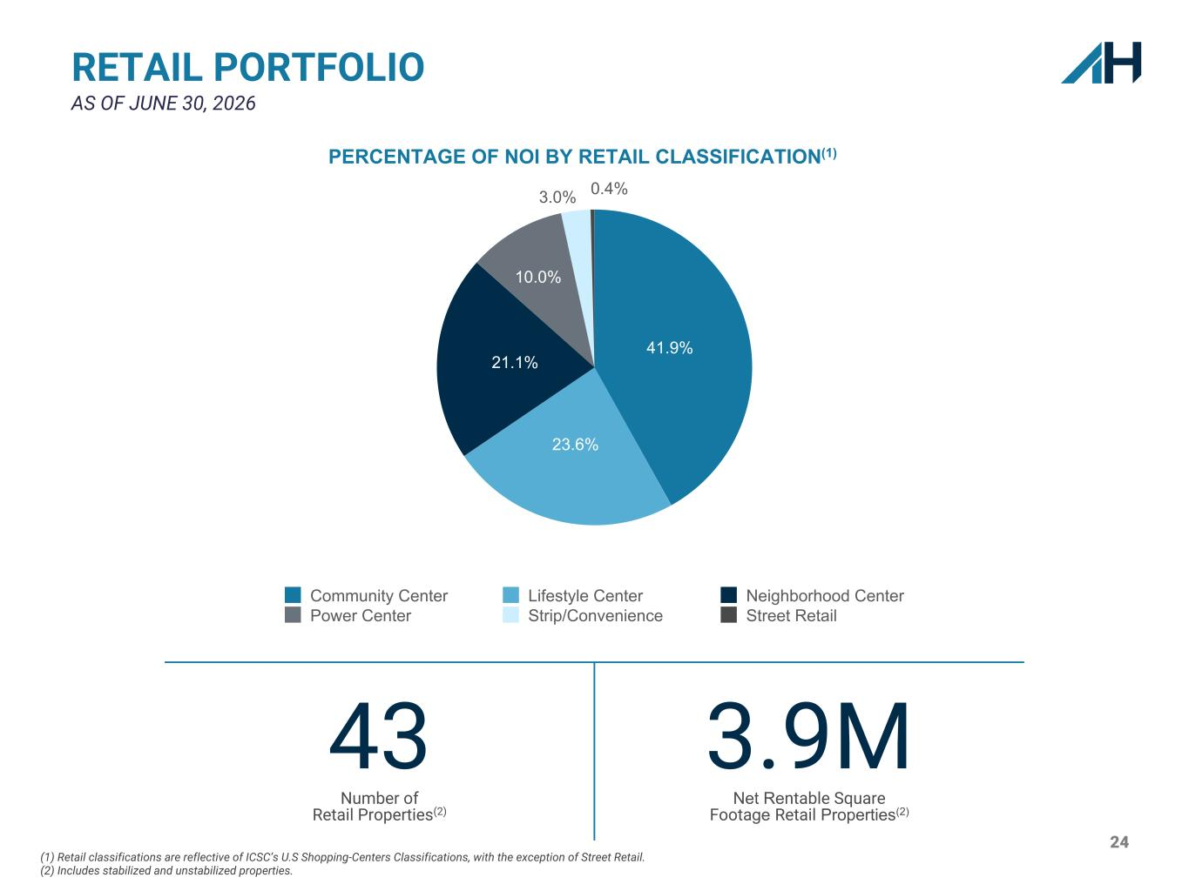
24 RETAIL PORTFOLIO AS OF JUNE 30, 2026 41.9% 23.6% 21.1% 10.0% 3.0% 0.4% Community Center Lifestyle Center Neighborhood Center Power Center Strip/Convenience Street Retail 43 Number of Retail Properties(2) 3.9M Net Rentable Square Footage Retail Properties(2) (1) Retail classifications are reflective of ICSC’s U.S Shopping-Centers Classifications, with the exception of Street Retail. (2) Includes stabilized and unstabilized properties. PERCENTAGE OF NOI BY RETAIL CLASSIFICATION(1)

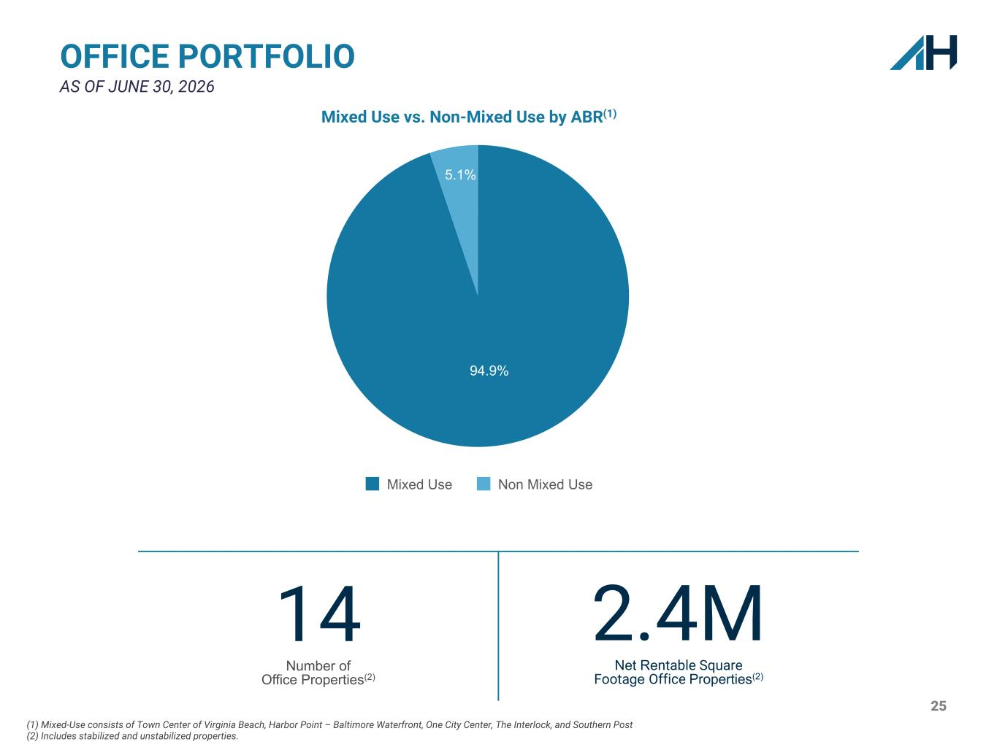
25 (1) Mixed-Use consists of Town Center of Virginia Beach, Harbor Point – Baltimore Waterfront, One City Center, The Interlock, and Southern Post (2) Includes stabilized and unstabilized properties. OFFICE PORTFOLIO AS OF JUNE 30, 2026 94.9% 5.1% Mixed Use Non Mixed Use 14 Number of Office Properties(2) 2.4M Net Rentable Square Footage Office Properties(2) Mixed Use vs. Non-Mixed Use by ABR(1)

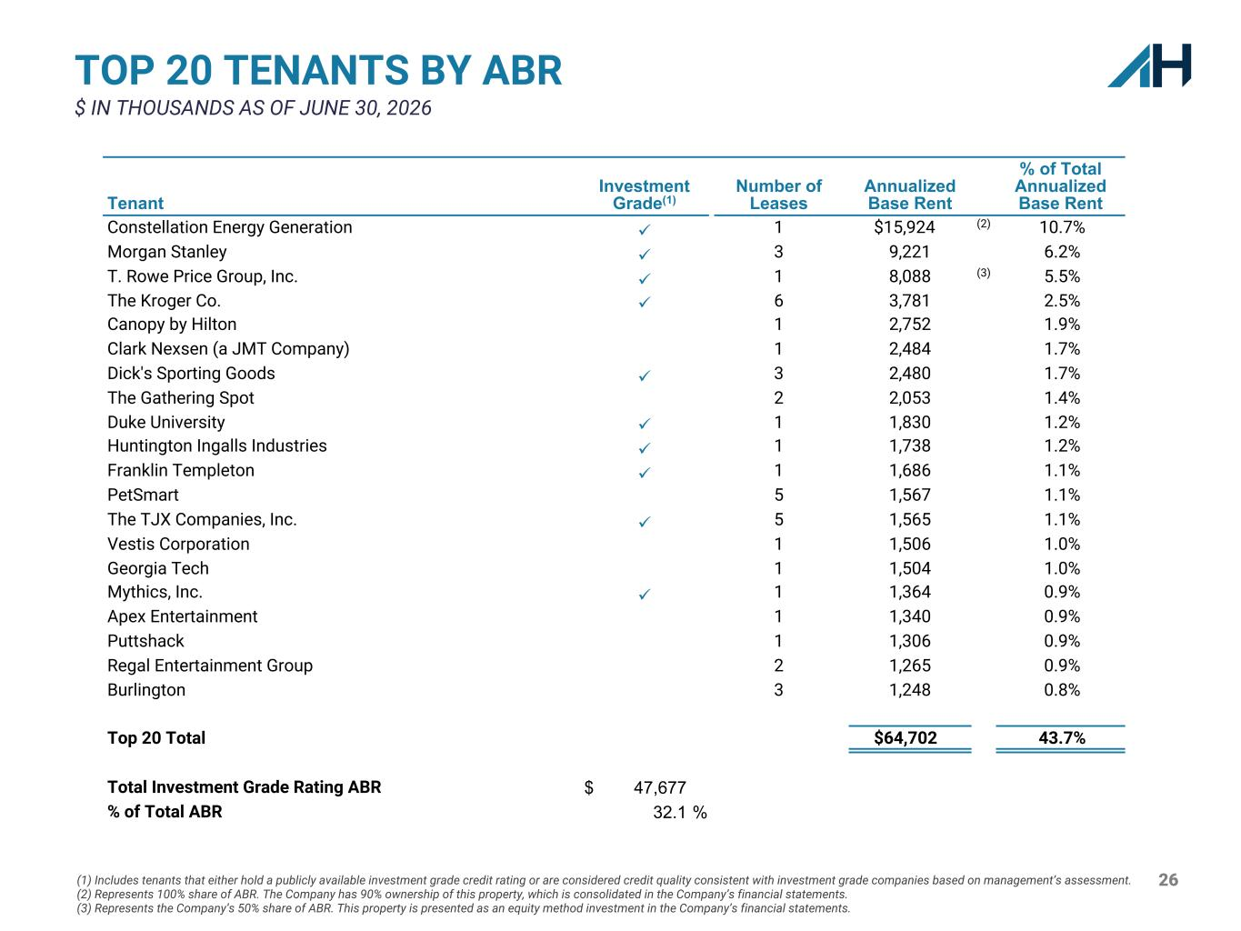
26 TOP 20 TENANTS BY ABR $ IN THOUSANDS AS OF JUNE 30, 2026 Tenant Investment Grade(1) Number of Leases Annualized Base Rent % of Total Annualized Base Rent Constellation Energy Generation ü 1 $15,924 (2) 10.7% Morgan Stanley ü 3 9,221 6.2% T. Rowe Price Group, Inc. ü 1 8,088 (3) 5.5% The Kroger Co. ü 6 3,781 2.5% Canopy by Hilton 1 2,752 1.9% Clark Nexsen (a JMT Company) 1 2,484 1.7% Dick's Sporting Goods ü 3 2,480 1.7% The Gathering Spot 2 2,053 1.4% Duke University ü 1 1,830 1.2% Huntington Ingalls Industries ü 1 1,738 1.2% Franklin Templeton ü 1 1,686 1.1% PetSmart 5 1,567 1.1% The TJX Companies, Inc. ü 5 1,565 1.1% Vestis Corporation 1 1,506 1.0% Georgia Tech 1 1,504 1.0% Mythics, Inc. ü 1 1,364 0.9% Apex Entertainment 1 1,340 0.9% Puttshack 1 1,306 0.9% Regal Entertainment Group 2 1,265 0.9% Burlington 3 1,248 0.8% Top 20 Total $64,702 43.7% Total Investment Grade Rating ABR $ 47,677 % of Total ABR 32.1 % (1) Includes tenants that either hold a publicly available investment grade credit rating or are considered credit quality consistent with investment grade companies based on management’s assessment. (2) Represents 100% share of ABR. The Company has 90% ownership of this property, which is consolidated in the Company’s financial statements. (3) Represents the Company’s 50% share of ABR. This property is presented as an equity method investment in the Company’s financial statements.

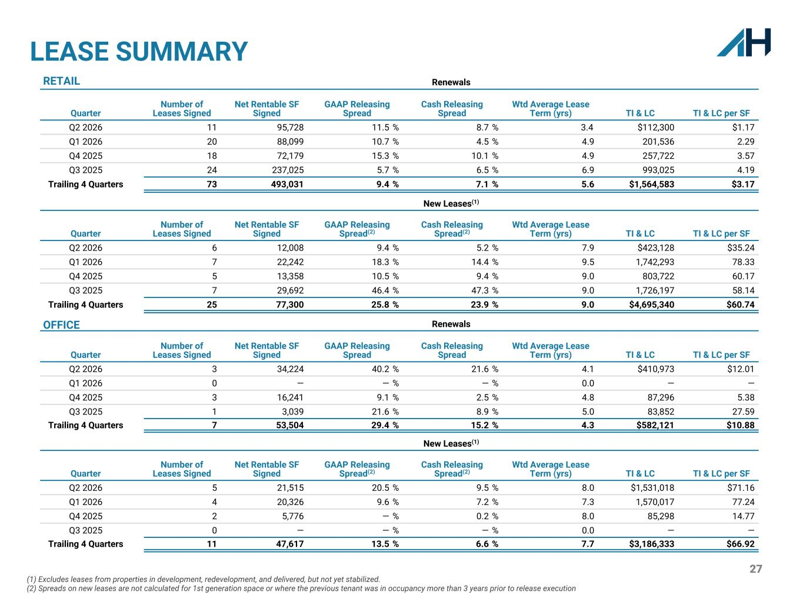
27 LEASE SUMMARY (1) Excludes leases from properties in development, redevelopment, and delivered, but not yet stabilized. (2) Spreads on new leases are not calculated for 1st generation space or where the previous tenant was in occupancy more than 3 years prior to release execution RETAIL Renewals Quarter Number of Leases Signed Net Rentable SF Signed GAAP Releasing Spread Cash Releasing Spread Wtd Average Lease Term (yrs) TI & LC TI & LC per SF Q2 2026 11 95,728 11.5 % 8.7 % 3.4 $112,300 $1.17 Q1 2026 20 88,099 10.7 % 4.5 % 4.9 201,536 2.29 Q4 2025 18 72,179 15.3 % 10.1 % 4.9 257,722 3.57 Q3 2025 24 237,025 5.7 % 6.5 % 6.9 993,025 4.19 Trailing 4 Quarters 73 493,031 9.4 % 7.1 % 5.6 $1,564,583 $3.17 New Leases(1) Quarter Number of Leases Signed Net Rentable SF Signed GAAP Releasing Spread(2) Cash Releasing Spread(2) Wtd Average Lease Term (yrs) TI & LC TI & LC per SF Q2 2026 6 12,008 9.4 % 5.2 % 7.9 $423,128 $35.24 Q1 2026 7 22,242 18.3 % 14.4 % 9.5 1,742,293 78.33 Q4 2025 5 13,358 10.5 % 9.4 % 9.0 803,722 60.17 Q3 2025 7 29,692 46.4 % 47.3 % 9.0 1,726,197 58.14 Trailing 4 Quarters 25 77,300 25.8 % 23.9 % 9.0 $4,695,340 $60.74 OFFICE Renewals Quarter Number of Leases Signed Net Rentable SF Signed GAAP Releasing Spread Cash Releasing Spread Wtd Average Lease Term (yrs) TI & LC TI & LC per SF Q2 2026 3 34,224 40.2 % 21.6 % 4.1 $410,973 $12.01 Q1 2026 0 — — % — % 0.0 — — Q4 2025 3 16,241 9.1 % 2.5 % 4.8 87,296 5.38 Q3 2025 1 3,039 21.6 % 8.9 % 5.0 83,852 27.59 Trailing 4 Quarters 7 53,504 29.4 % 15.2 % 4.3 $582,121 $10.88 New Leases(1) Quarter Number of Leases Signed Net Rentable SF Signed GAAP Releasing Spread(2) Cash Releasing Spread(2) Wtd Average Lease Term (yrs) TI & LC TI & LC per SF Q2 2026 5 21,515 20.5 % 9.5 % 8.0 $1,531,018 $71.16 Q1 2026 4 20,326 9.6 % 7.2 % 7.3 1,570,017 77.24 Q4 2025 2 5,776 — % 0.2 % 8.0 85,298 14.77 Q3 2025 0 — — % — % 0.0 — — Trailing 4 Quarters 11 47,617 13.5 % 6.6 % 7.7 $3,186,333 $66.92

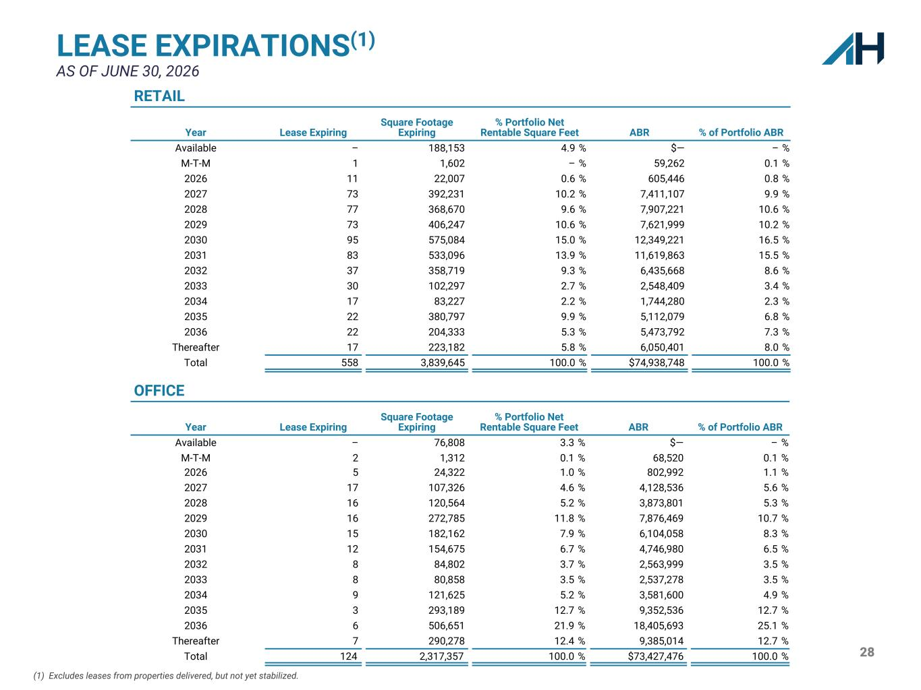
28 LEASE EXPIRATIONS(1) AS OF JUNE 30, 2026 (1) Excludes leases from properties delivered, but not yet stabilized. OFFICE Year Lease Expiring Square Footage Expiring % Portfolio Net Rentable Square Feet ABR % of Portfolio ABR Available – 76,808 3.3 % $— – % M-T-M 2 1,312 0.1 % 68,520 0.1 % 2026 5 24,322 1.0 % 802,992 1.1 % 2027 17 107,326 4.6 % 4,128,536 5.6 % 2028 16 120,564 5.2 % 3,873,801 5.3 % 2029 16 272,785 11.8 % 7,876,469 10.7 % 2030 15 182,162 7.9 % 6,104,058 8.3 % 2031 12 154,675 6.7 % 4,746,980 6.5 % 2032 8 84,802 3.7 % 2,563,999 3.5 % 2033 8 80,858 3.5 % 2,537,278 3.5 % 2034 9 121,625 5.2 % 3,581,600 4.9 % 2035 3 293,189 12.7 % 9,352,536 12.7 % 2036 6 506,651 21.9 % 18,405,693 25.1 % Thereafter 7 290,278 12.4 % 9,385,014 12.7 % Total 124 2,317,357 100.0 % $73,427,476 100.0 % RETAIL Year Lease Expiring Square Footage Expiring % Portfolio Net Rentable Square Feet ABR % of Portfolio ABR Available – 188,153 4.9 % $— – % M-T-M 1 1,602 – % 59,262 0.1 % 2026 11 22,007 0.6 % 605,446 0.8 % 2027 73 392,231 10.2 % 7,411,107 9.9 % 2028 77 368,670 9.6 % 7,907,221 10.6 % 2029 73 406,247 10.6 % 7,621,999 10.2 % 2030 95 575,084 15.0 % 12,349,221 16.5 % 2031 83 533,096 13.9 % 11,619,863 15.5 % 2032 37 358,719 9.3 % 6,435,668 8.6 % 2033 30 102,297 2.7 % 2,548,409 3.4 % 2034 17 83,227 2.2 % 1,744,280 2.3 % 2035 22 380,797 9.9 % 5,112,079 6.8 % 2036 22 204,333 5.3 % 5,473,792 7.3 % Thereafter 17 223,182 5.8 % 6,050,401 8.0 % Total 558 3,839,645 100.0 % $74,938,748 100.0 %

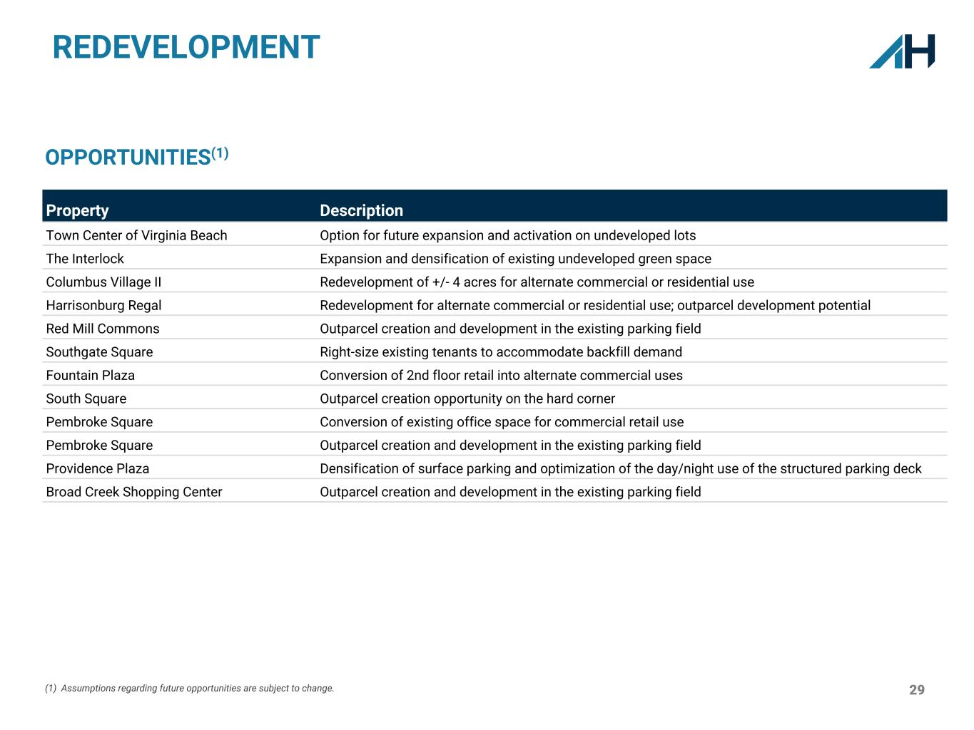
29 REDEVELOPMENT Property Description Town Center of Virginia Beach Option for future expansion and activation on undeveloped lots The Interlock Expansion and densification of existing undeveloped green space Columbus Village II Redevelopment of +/- 4 acres for alternate commercial or residential use Harrisonburg Regal Redevelopment for alternate commercial or residential use; outparcel development potential Red Mill Commons Outparcel creation and development in the existing parking field Southgate Square Right-size existing tenants to accommodate backfill demand Fountain Plaza Conversion of 2nd floor retail into alternate commercial uses South Square Outparcel creation opportunity on the hard corner Pembroke Square Conversion of existing office space for commercial retail use Pembroke Square Outparcel creation and development in the existing parking field Providence Plaza Densification of surface parking and optimization of the day/night use of the structured parking deck Broad Creek Shopping Center Outparcel creation and development in the existing parking field OPPORTUNITIES(1) (1) Assumptions regarding future opportunities are subject to change.

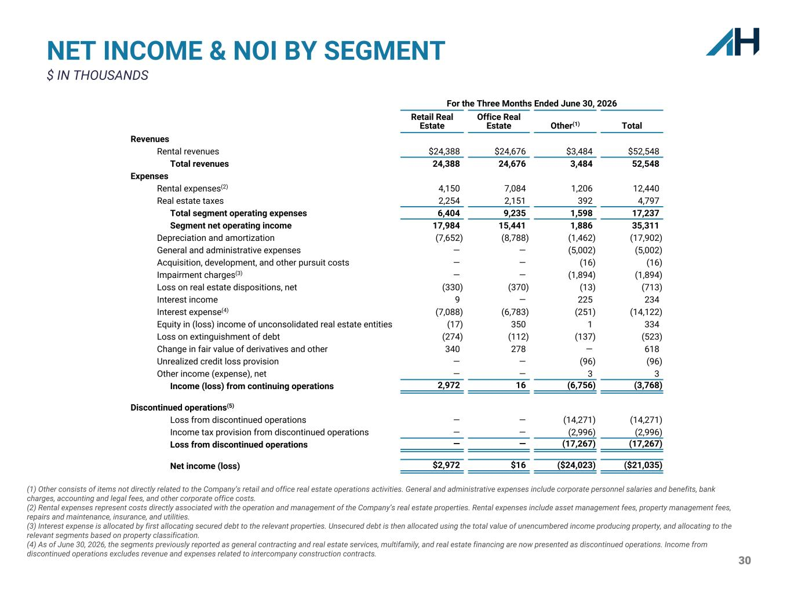
30 NET INCOME & NOI BY SEGMENT $ IN THOUSANDS For the Three Months Ended June 30, 2026 Retail Real Estate Office Real Estate Other(1) Total Revenues Rental revenues $24,388 $24,676 $3,484 $52,548 Total revenues 24,388 24,676 3,484 52,548 Expenses Rental expenses(2) 4,150 7,084 1,206 12,440 Real estate taxes 2,254 2,151 392 4,797 Total segment operating expenses 6,404 9,235 1,598 17,237 Segment net operating income 17,984 15,441 1,886 35,311 Depreciation and amortization (7,652) (8,788) (1,462) (17,902) General and administrative expenses — — (5,002) (5,002) Acquisition, development, and other pursuit costs — — (16) (16) Impairment charges(3) — — (1,894) (1,894) Loss on real estate dispositions, net (330) (370) (13) (713) Interest income 9 — 225 234 Interest expense(4) (7,088) (6,783) (251) (14,122) Equity in (loss) income of unconsolidated real estate entities (17) 350 1 334 Loss on extinguishment of debt (274) (112) (137) (523) Change in fair value of derivatives and other 340 278 — 618 Unrealized credit loss provision — — (96) (96) Other income (expense), net — — 3 3 Income (loss) from continuing operations 2,972 16 (6,756) (3,768) Discontinued operations(5) Loss from discontinued operations — — (14,271) (14,271) Income tax provision from discontinued operations — — (2,996) (2,996) Loss from discontinued operations — — (17,267) (17,267) Net income (loss) $2,972 $16 ($24,023) ($21,035) (1) Other consists of items not directly related to the Company’s retail and office real estate operations activities. General and administrative expenses include corporate personnel salaries and benefits, bank charges, accounting and legal fees, and other corporate office costs. (2) Rental expenses represent costs directly associated with the operation and management of the Company’s real estate properties. Rental expenses include asset management fees, property management fees, repairs and maintenance, insurance, and utilities. (3) Interest expense is allocated by first allocating secured debt to the relevant properties. Unsecured debt is then allocated using the total value of unencumbered income producing property, and allocating to the relevant segments based on property classification. (4) As of June 30, 2026, the segments previously reported as general contracting and real estate services, multifamily, and real estate financing are now presented as discontinued operations. Income from discontinued operations excludes revenue and expenses related to intercompany construction contracts.

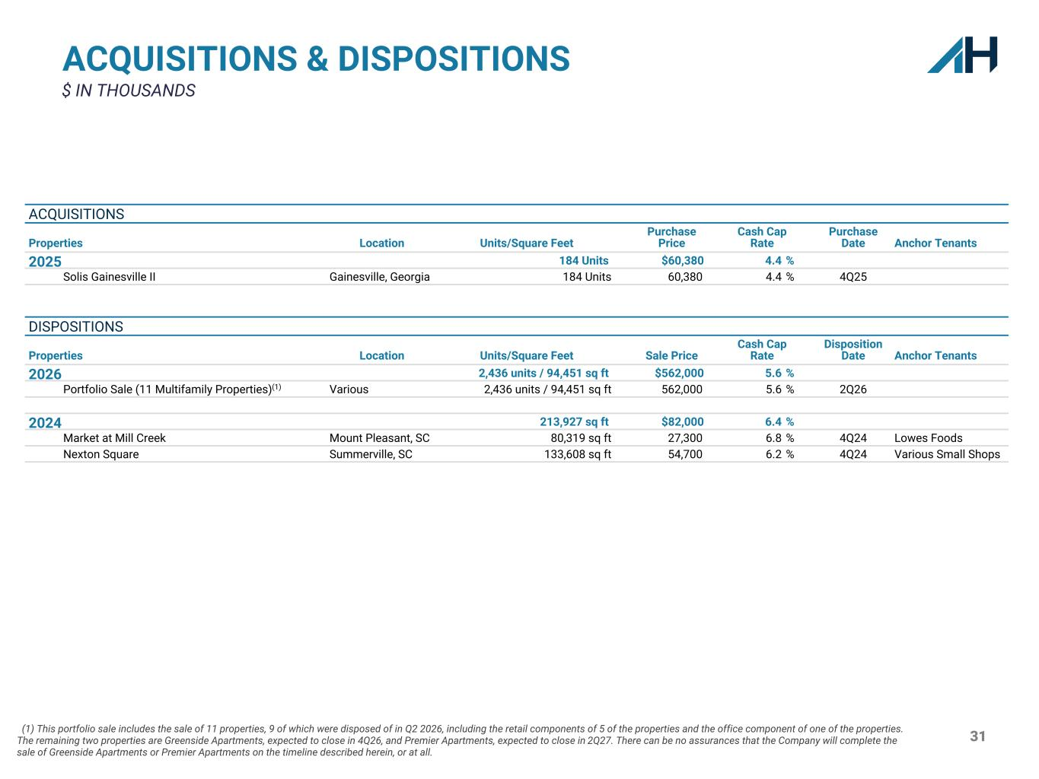
31 ACQUISITIONS & DISPOSITIONS $ IN THOUSANDS ACQUISITIONS Properties Location Units/Square Feet Purchase Price Cash Cap Rate Purchase Date Anchor Tenants 2025 184 Units $60,380 4.4 % Solis Gainesville II Gainesville, Georgia 184 Units 60,380 4.4 % 4Q25 DISPOSITIONS Properties Location Units/Square Feet Sale Price Cash Cap Rate Disposition Date Anchor Tenants 2026 2,436 units / 94,451 sq ft $562,000 5.6 % Portfolio Sale (11 Multifamily Properties)(1) Various 2,436 units / 94,451 sq ft 562,000 5.6 % 2Q26 2024 213,927 sq ft $82,000 6.4 % Market at Mill Creek Mount Pleasant, SC 80,319 sq ft 27,300 6.8 % 4Q24 Lowes Foods Nexton Square Summerville, SC 133,608 sq ft 54,700 6.2 % 4Q24 Various Small Shops (1) This portfolio sale includes the sale of 11 properties, 9 of which were disposed of in Q2 2026, including the retail components of 5 of the properties and the office component of one of the properties. The remaining two properties are Greenside Apartments, expected to close in 4Q26, and Premier Apartments, expected to close in 2Q27. There can be no assurances that the Company will complete the sale of Greenside Apartments or Premier Apartments on the timeline described herein, or at all.

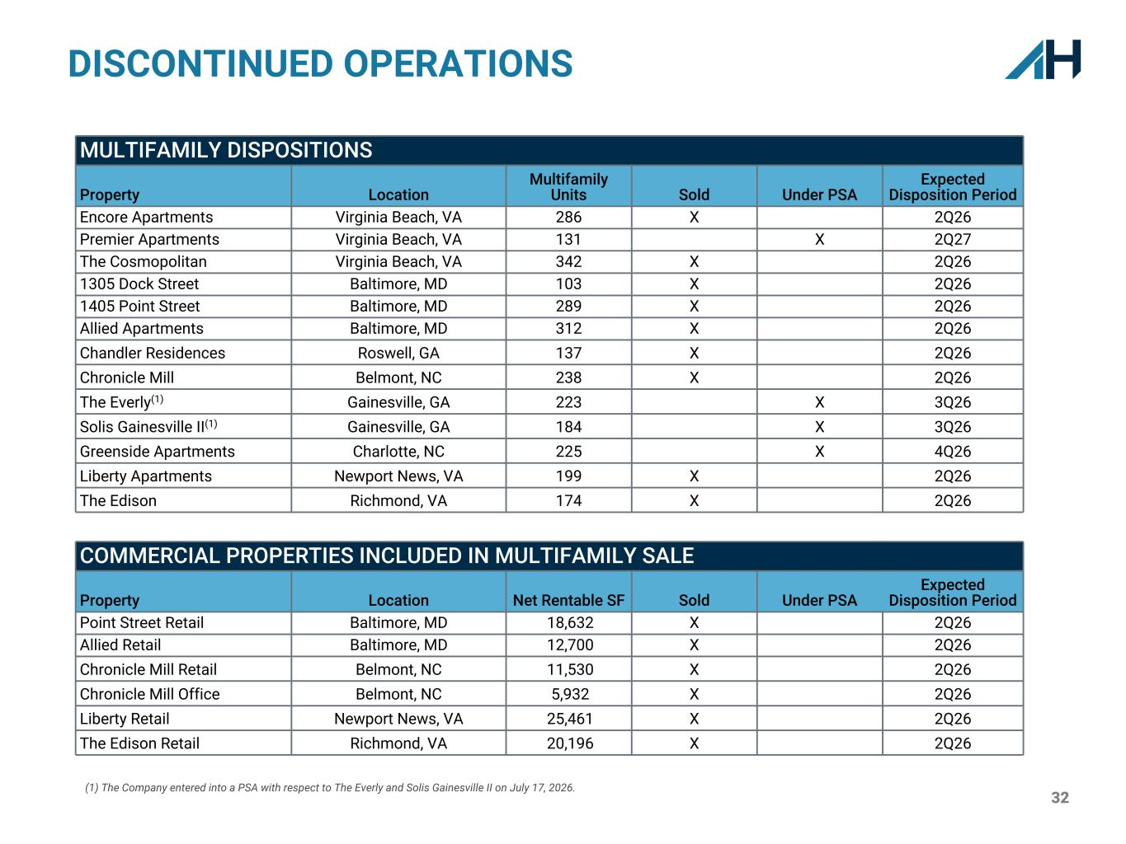
32 DISCONTINUED OPERATIONS MULTIFAMILY DISPOSITIONS Property Location Multifamily Units Sold Under PSA Expected Disposition Period Encore Apartments Virginia Beach, VA 286 X 2Q26 Premier Apartments Virginia Beach, VA 131 X 2Q27 The Cosmopolitan Virginia Beach, VA 342 X 2Q26 1305 Dock Street Baltimore, MD 103 X 2Q26 1405 Point Street Baltimore, MD 289 X 2Q26 Allied Apartments Baltimore, MD 312 X 2Q26 Chandler Residences Roswell, GA 137 X 2Q26 Chronicle Mill Belmont, NC 238 X 2Q26 The Everly(1) Gainesville, GA 223 X 3Q26 Solis Gainesville II(1) Gainesville, GA 184 X 3Q26 Greenside Apartments Charlotte, NC 225 X 4Q26 Liberty Apartments Newport News, VA 199 X 2Q26 The Edison Richmond, VA 174 X 2Q26 COMMERCIAL PROPERTIES INCLUDED IN MULTIFAMILY SALE Property Location Net Rentable SF Sold Under PSA Expected Disposition Period Point Street Retail Baltimore, MD 18,632 X 2Q26 Allied Retail Baltimore, MD 12,700 X 2Q26 Chronicle Mill Retail Belmont, NC 11,530 X 2Q26 Chronicle Mill Office Belmont, NC 5,932 X 2Q26 Liberty Retail Newport News, VA 25,461 X 2Q26 The Edison Retail Richmond, VA 20,196 X 2Q26 (1) The Company entered into a PSA with respect to The Everly and Solis Gainesville II on July 17, 2026.

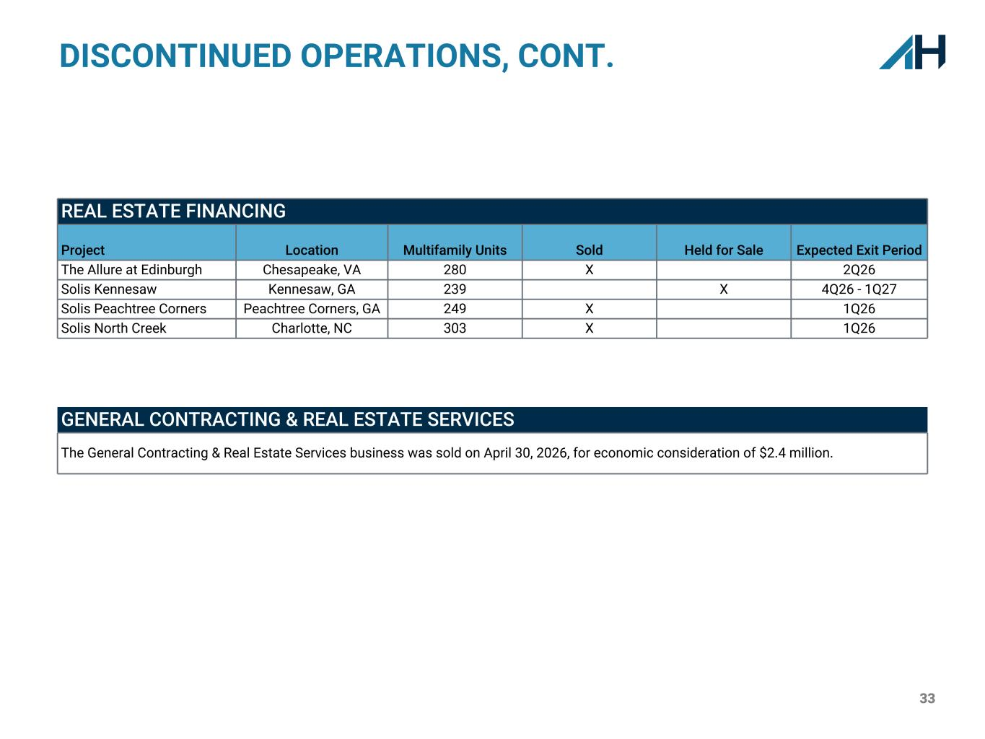
33 DISCONTINUED OPERATIONS, CONT. REAL ESTATE FINANCING Project Location Multifamily Units Sold Held for Sale Expected Exit Period The Allure at Edinburgh Chesapeake, VA 280 X 2Q26 Solis Kennesaw Kennesaw, GA 239 X 4Q26 - 1Q27 Solis Peachtree Corners Peachtree Corners, GA 249 X 1Q26 Solis North Creek Charlotte, NC 303 X 1Q26 GENERAL CONTRACTING & REAL ESTATE SERVICES The General Contracting & Real Estate Services business was sold on April 30, 2026, for economic consideration of $2.4 million.

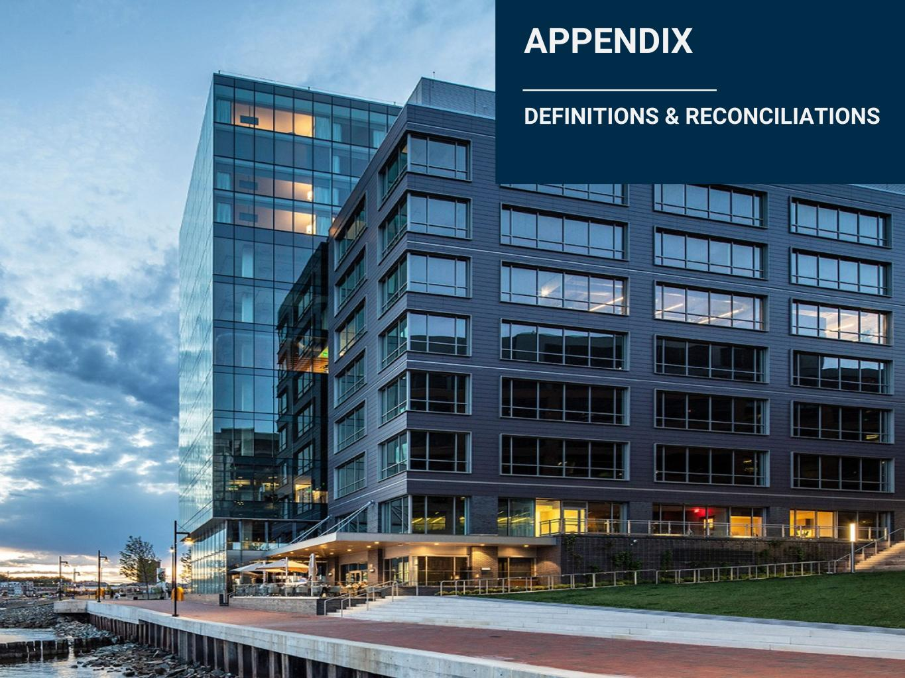
34 APPENDIX DEFINITIONS & RECONCILIATIONS

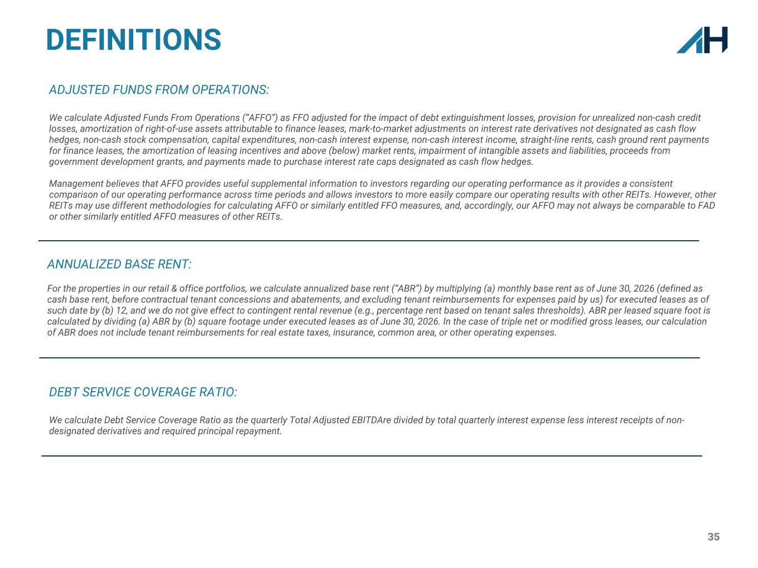
35 ANNUALIZED BASE RENT: For the properties in our retail & office portfolios, we calculate annualized base rent (“ABR”) by multiplying (a) monthly base rent as of June 30, 2026 (defined as cash base rent, before contractual tenant concessions and abatements, and excluding tenant reimbursements for expenses paid by us) for executed leases as of such date by (b) 12, and we do not give effect to contingent rental revenue (e.g., percentage rent based on tenant sales thresholds). ABR per leased square foot is calculated by dividing (a) ABR by (b) square footage under executed leases as of June 30, 2026. In the case of triple net or modified gross leases, our calculation of ABR does not include tenant reimbursements for real estate taxes, insurance, common area, or other operating expenses. DEFINITIONS ADJUSTED FUNDS FROM OPERATIONS: We calculate Adjusted Funds From Operations (“AFFO”) as FFO adjusted for the impact of debt extinguishment losses, provision for unrealized non-cash credit losses, amortization of right-of-use assets attributable to finance leases, mark-to-market adjustments on interest rate derivatives not designated as cash flow hedges, non-cash stock compensation, capital expenditures, non-cash interest expense, non-cash interest income, straight-line rents, cash ground rent payments for finance leases, the amortization of leasing incentives and above (below) market rents, impairment of intangible assets and liabilities, proceeds from government development grants, and payments made to purchase interest rate caps designated as cash flow hedges. Management believes that AFFO provides useful supplemental information to investors regarding our operating performance as it provides a consistent comparison of our operating performance across time periods and allows investors to more easily compare our operating results with other REITs. However, other REITs may use different methodologies for calculating AFFO or similarly entitled FFO measures, and, accordingly, our AFFO may not always be comparable to FAD or other similarly entitled AFFO measures of other REITs. DEBT SERVICE COVERAGE RATIO: We calculate Debt Service Coverage Ratio as the quarterly Total Adjusted EBITDAre divided by total quarterly interest expense less interest receipts of non- designated derivatives and required principal repayment.

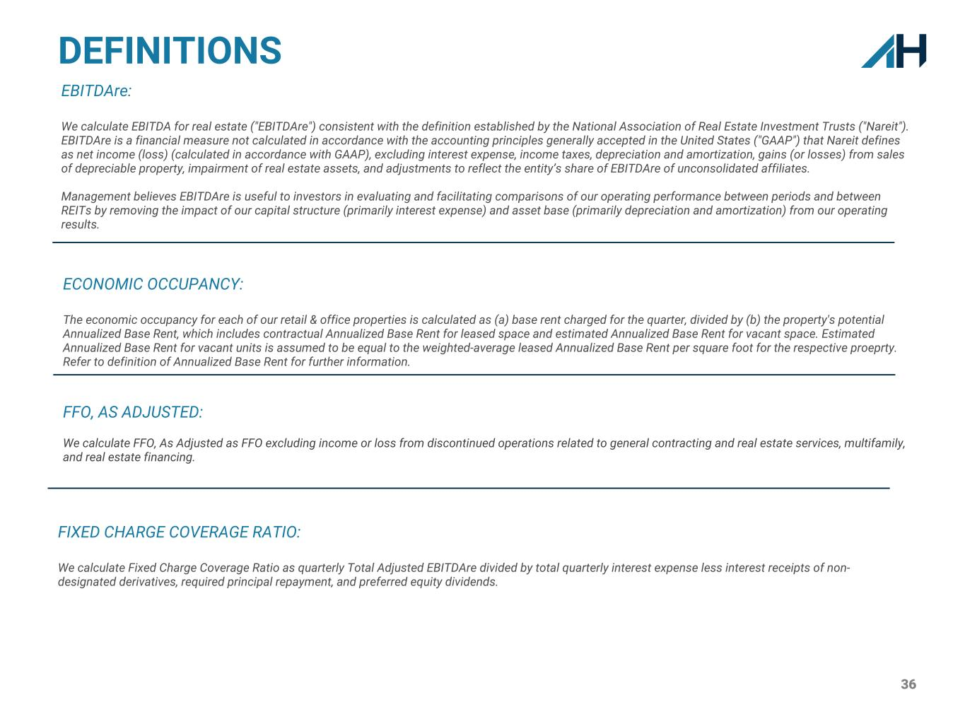
36 DEFINITIONS EBITDAre: We calculate EBITDA for real estate ("EBITDAre") consistent with the definition established by the National Association of Real Estate Investment Trusts ("Nareit"). EBITDAre is a financial measure not calculated in accordance with the accounting principles generally accepted in the United States ("GAAP") that Nareit defines as net income (loss) (calculated in accordance with GAAP), excluding interest expense, income taxes, depreciation and amortization, gains (or losses) from sales of depreciable property, impairment of real estate assets, and adjustments to reflect the entity’s share of EBITDAre of unconsolidated affiliates. Management believes EBITDAre is useful to investors in evaluating and facilitating comparisons of our operating performance between periods and between REITs by removing the impact of our capital structure (primarily interest expense) and asset base (primarily depreciation and amortization) from our operating results. FIXED CHARGE COVERAGE RATIO: We calculate Fixed Charge Coverage Ratio as quarterly Total Adjusted EBITDAre divided by total quarterly interest expense less interest receipts of non- designated derivatives, required principal repayment, and preferred equity dividends. ECONOMIC OCCUPANCY: The economic occupancy for each of our retail & office properties is calculated as (a) base rent charged for the quarter, divided by (b) the property's potential Annualized Base Rent, which includes contractual Annualized Base Rent for leased space and estimated Annualized Base Rent for vacant space. Estimated Annualized Base Rent for vacant units is assumed to be equal to the weighted-average leased Annualized Base Rent per square foot for the respective proeprty. Refer to definition of Annualized Base Rent for further information. FFO, AS ADJUSTED: We calculate FFO, As Adjusted as FFO excluding income or loss from discontinued operations related to general contracting and real estate services, multifamily, and real estate financing.

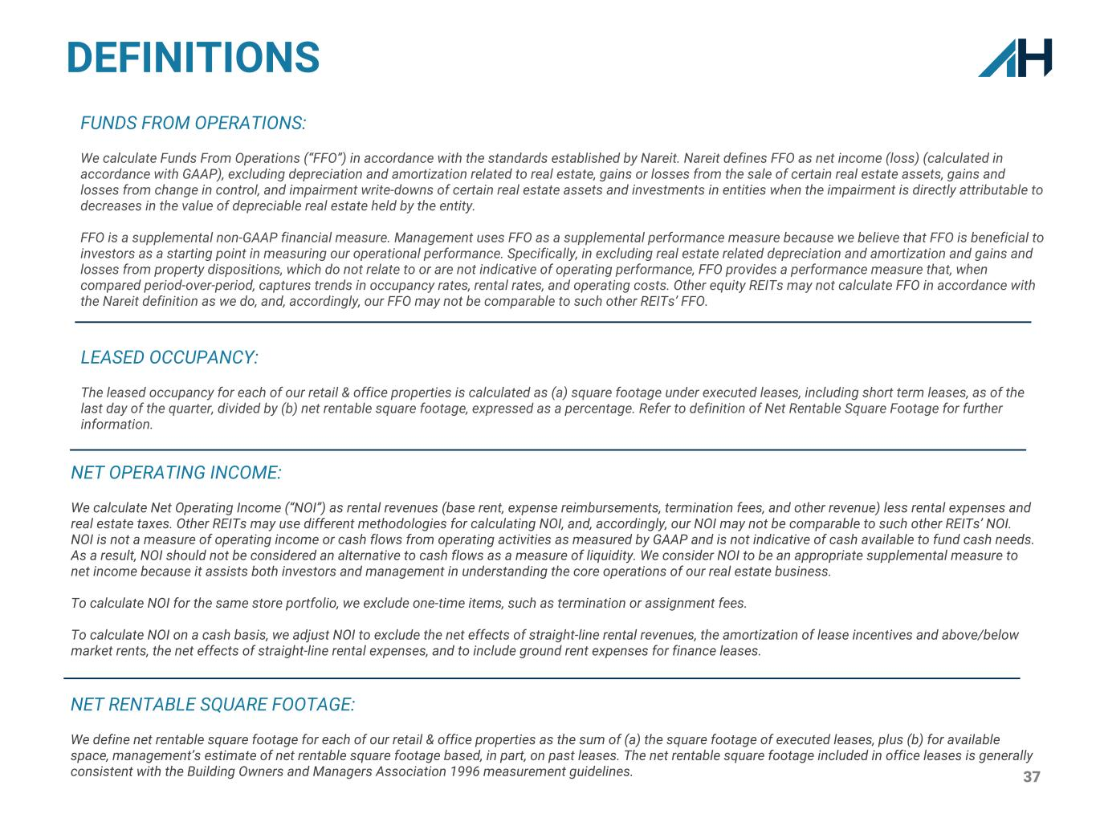
37 NET OPERATING INCOME: We calculate Net Operating Income (“NOI”) as rental revenues (base rent, expense reimbursements, termination fees, and other revenue) less rental expenses and real estate taxes. Other REITs may use different methodologies for calculating NOI, and, accordingly, our NOI may not be comparable to such other REITs’ NOI. NOI is not a measure of operating income or cash flows from operating activities as measured by GAAP and is not indicative of cash available to fund cash needs. As a result, NOI should not be considered an alternative to cash flows as a measure of liquidity. We consider NOI to be an appropriate supplemental measure to net income because it assists both investors and management in understanding the core operations of our real estate business. To calculate NOI for the same store portfolio, we exclude one-time items, such as termination or assignment fees. To calculate NOI on a cash basis, we adjust NOI to exclude the net effects of straight-line rental revenues, the amortization of lease incentives and above/below market rents, the net effects of straight-line rental expenses, and to include ground rent expenses for finance leases. NET RENTABLE SQUARE FOOTAGE: We define net rentable square footage for each of our retail & office properties as the sum of (a) the square footage of executed leases, plus (b) for available space, management’s estimate of net rentable square footage based, in part, on past leases. The net rentable square footage included in office leases is generally consistent with the Building Owners and Managers Association 1996 measurement guidelines. DEFINITIONS LEASED OCCUPANCY: The leased occupancy for each of our retail & office properties is calculated as (a) square footage under executed leases, including short term leases, as of the last day of the quarter, divided by (b) net rentable square footage, expressed as a percentage. Refer to definition of Net Rentable Square Footage for further information. FUNDS FROM OPERATIONS: We calculate Funds From Operations (“FFO”) in accordance with the standards established by Nareit. Nareit defines FFO as net income (loss) (calculated in accordance with GAAP), excluding depreciation and amortization related to real estate, gains or losses from the sale of certain real estate assets, gains and losses from change in control, and impairment write-downs of certain real estate assets and investments in entities when the impairment is directly attributable to decreases in the value of depreciable real estate held by the entity. FFO is a supplemental non-GAAP financial measure. Management uses FFO as a supplemental performance measure because we believe that FFO is beneficial to investors as a starting point in measuring our operational performance. Specifically, in excluding real estate related depreciation and amortization and gains and losses from property dispositions, which do not relate to or are not indicative of operating performance, FFO provides a performance measure that, when compared period-over-period, captures trends in occupancy rates, rental rates, and operating costs. Other equity REITs may not calculate FFO in accordance with the Nareit definition as we do, and, accordingly, our FFO may not be comparable to such other REITs’ FFO.

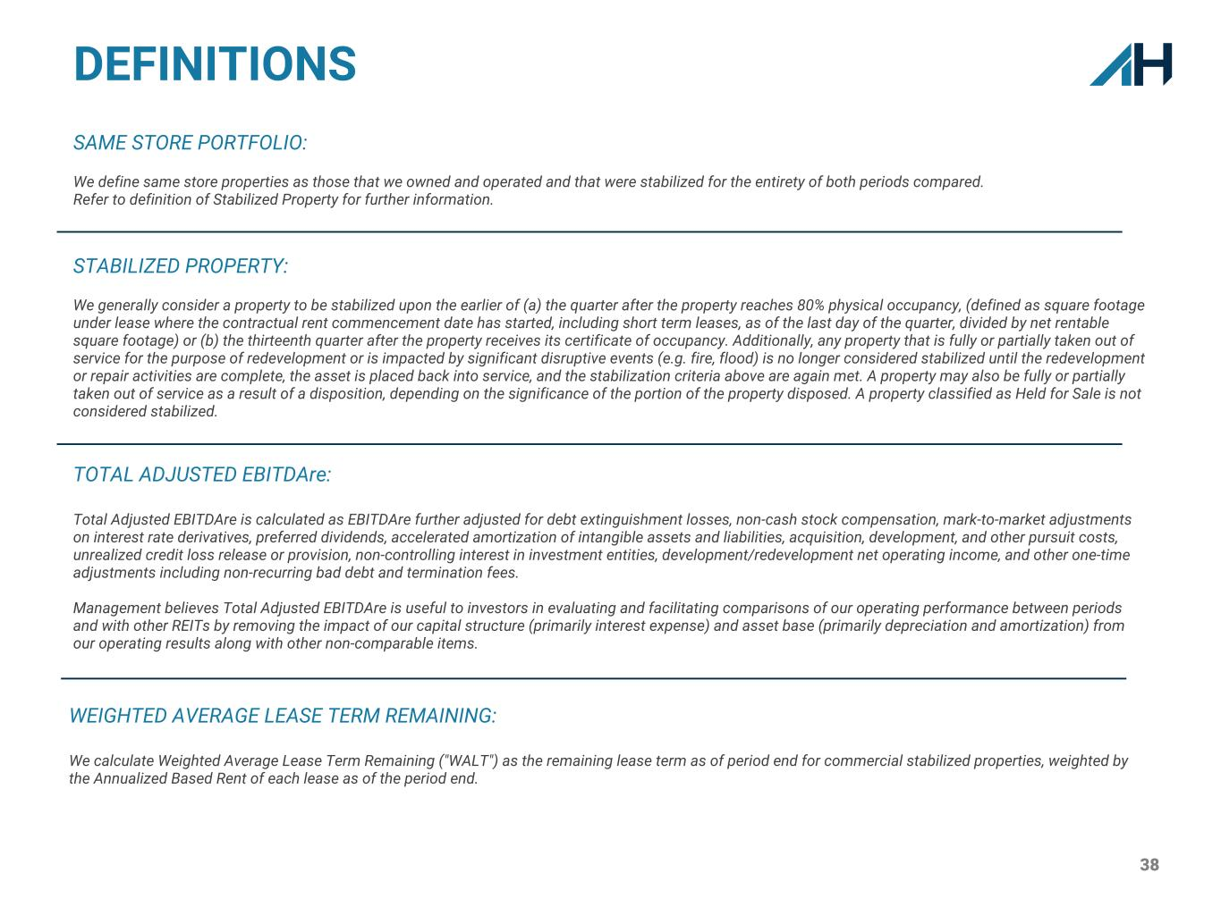
38 DEFINITIONS STABILIZED PROPERTY: We generally consider a property to be stabilized upon the earlier of (a) the quarter after the property reaches 80% physical occupancy, (defined as square footage under lease where the contractual rent commencement date has started, including short term leases, as of the last day of the quarter, divided by net rentable square footage) or (b) the thirteenth quarter after the property receives its certificate of occupancy. Additionally, any property that is fully or partially taken out of service for the purpose of redevelopment or is impacted by significant disruptive events (e.g. fire, flood) is no longer considered stabilized until the redevelopment or repair activities are complete, the asset is placed back into service, and the stabilization criteria above are again met. A property may also be fully or partially taken out of service as a result of a disposition, depending on the significance of the portion of the property disposed. A property classified as Held for Sale is not considered stabilized. SAME STORE PORTFOLIO: We define same store properties as those that we owned and operated and that were stabilized for the entirety of both periods compared. Refer to definition of Stabilized Property for further information. TOTAL ADJUSTED EBITDAre: Total Adjusted EBITDAre is calculated as EBITDAre further adjusted for debt extinguishment losses, non-cash stock compensation, mark-to-market adjustments on interest rate derivatives, preferred dividends, accelerated amortization of intangible assets and liabilities, acquisition, development, and other pursuit costs, unrealized credit loss release or provision, non-controlling interest in investment entities, development/redevelopment net operating income, and other one-time adjustments including non-recurring bad debt and termination fees. Management believes Total Adjusted EBITDAre is useful to investors in evaluating and facilitating comparisons of our operating performance between periods and with other REITs by removing the impact of our capital structure (primarily interest expense) and asset base (primarily depreciation and amortization) from our operating results along with other non-comparable items. WEIGHTED AVERAGE LEASE TERM REMAINING: We calculate Weighted Average Lease Term Remaining ("WALT") as the remaining lease term as of period end for commercial stabilized properties, weighted by the Annualized Based Rent of each lease as of the period end.

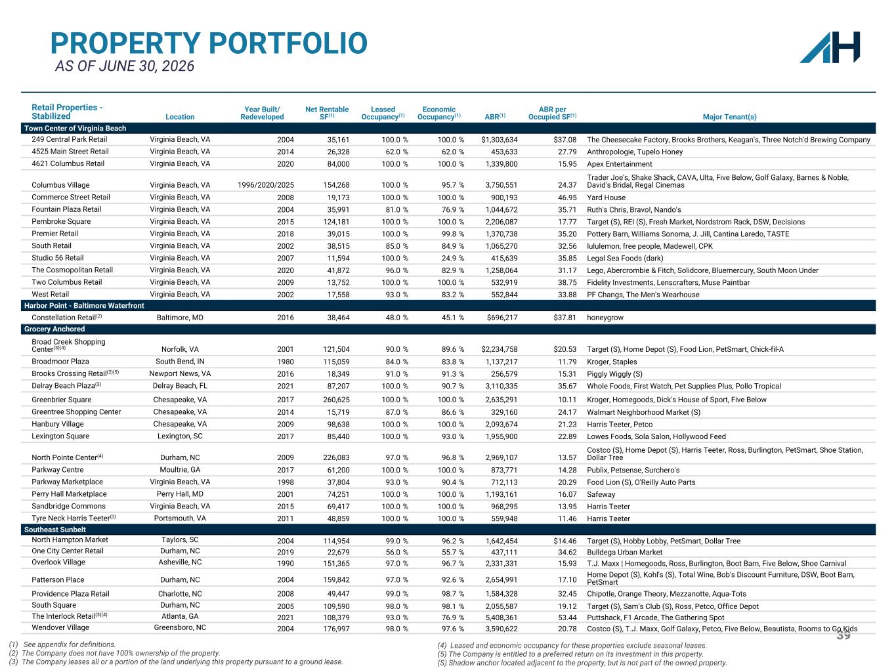
39 PROPERTY PORTFOLIO AS OF JUNE 30, 2026 Retail Properties - Stabilized Location Year Built/ Redeveloped Net Rentable SF(1) Leased Occupancy(1) Economic Occupancy(1) ABR(1) ABR per Occupied SF(1) Major Tenant(s) Town Center of Virginia Beach 249 Central Park Retail Virginia Beach, VA 2004 35,161 100.0 % 100.0 % $1,303,634 $37.08 The Cheesecake Factory, Brooks Brothers, Keagan's, Three Notch'd Brewing Company 4525 Main Street Retail Virginia Beach, VA 2014 26,328 62.0 % 62.0 % 453,633 27.79 Anthropologie, Tupelo Honey 4621 Columbus Retail Virginia Beach, VA 2020 84,000 100.0 % 100.0 % 1,339,800 15.95 Apex Entertainment Columbus Village Virginia Beach, VA 1996/2020/2025 154,268 100.0 % 95.7 % 3,750,551 24.37 Trader Joe's, Shake Shack, CAVA, Ulta, Five Below, Golf Galaxy, Barnes & Noble, David's Bridal, Regal Cinemas Commerce Street Retail Virginia Beach, VA 2008 19,173 100.0 % 100.0 % 900,193 46.95 Yard House Fountain Plaza Retail Virginia Beach, VA 2004 35,991 81.0 % 76.9 % 1,044,672 35.71 Ruth's Chris, Bravo!, Nando's Pembroke Square Virginia Beach, VA 2015 124,181 100.0 % 100.0 % 2,206,087 17.77 Target (S), REI (S), Fresh Market, Nordstrom Rack, DSW, Decisions Premier Retail Virginia Beach, VA 2018 39,015 100.0 % 99.8 % 1,370,738 35.20 Pottery Barn, Williams Sonoma, J. Jill, Cantina Laredo, TASTE South Retail Virginia Beach, VA 2002 38,515 85.0 % 84.9 % 1,065,270 32.56 lululemon, free people, Madewell, CPK Studio 56 Retail Virginia Beach, VA 2007 11,594 100.0 % 24.9 % 415,639 35.85 Legal Sea Foods (dark) The Cosmopolitan Retail Virginia Beach, VA 2020 41,872 96.0 % 82.9 % 1,258,064 31.17 Lego, Abercrombie & Fitch, Solidcore, Bluemercury, South Moon Under Two Columbus Retail Virginia Beach, VA 2009 13,752 100.0 % 100.0 % 532,919 38.75 Fidelity Investments, Lenscrafters, Muse Paintbar West Retail Virginia Beach, VA 2002 17,558 93.0 % 83.2 % 552,844 33.88 PF Changs, The Men's Wearhouse Harbor Point - Baltimore Waterfront Constellation Retail(2) Baltimore, MD 2016 38,464 48.0 % 45.1 % $696,217 $37.81 honeygrow Grocery Anchored Broad Creek Shopping Center(3)(4) Norfolk, VA 2001 121,504 90.0 % 89.6 % $2,234,758 $20.53 Target (S), Home Depot (S), Food Lion, PetSmart, Chick-fil-A Broadmoor Plaza South Bend, IN 1980 115,059 84.0 % 83.8 % 1,137,217 11.79 Kroger, Staples Brooks Crossing Retail(2)(5) Newport News, VA 2016 18,349 91.0 % 91.3 % 256,579 15.31 Piggly Wiggly (S) Delray Beach Plaza(3) Delray Beach, FL 2021 87,207 100.0 % 90.7 % 3,110,335 35.67 Whole Foods, First Watch, Pet Supplies Plus, Pollo Tropical Greenbrier Square Chesapeake, VA 2017 260,625 100.0 % 100.0 % 2,635,291 10.11 Kroger, Homegoods, Dick's House of Sport, Five Below Greentree Shopping Center Chesapeake, VA 2014 15,719 87.0 % 86.6 % 329,160 24.17 Walmart Neighborhood Market (S) Hanbury Village Chesapeake, VA 2009 98,638 100.0 % 100.0 % 2,093,674 21.23 Harris Teeter, Petco Lexington Square Lexington, SC 2017 85,440 100.0 % 93.0 % 1,955,900 22.89 Lowes Foods, Sola Salon, Hollywood Feed North Pointe Center(4) Durham, NC 2009 226,083 97.0 % 96.8 % 2,969,107 13.57 Costco (S), Home Depot (S), Harris Teeter, Ross, Burlington, PetSmart, Shoe Station, Dollar Tree Parkway Centre Moultrie, GA 2017 61,200 100.0 % 100.0 % 873,771 14.28 Publix, Petsense, Surchero's Parkway Marketplace Virginia Beach, VA 1998 37,804 93.0 % 90.4 % 712,113 20.29 Food Lion (S), O'Reilly Auto Parts Perry Hall Marketplace Perry Hall, MD 2001 74,251 100.0 % 100.0 % 1,193,161 16.07 Safeway Sandbridge Commons Virginia Beach, VA 2015 69,417 100.0 % 100.0 % 968,295 13.95 Harris Teeter Tyre Neck Harris Teeter(3) Portsmouth, VA 2011 48,859 100.0 % 100.0 % 559,948 11.46 Harris Teeter Southeast Sunbelt North Hampton Market Taylors, SC 2004 114,954 99.0 % 96.2 % 1,642,454 $14.46 Target (S), Hobby Lobby, PetSmart, Dollar Tree One City Center Retail Durham, NC 2019 22,679 56.0 % 55.7 % 437,111 34.62 Bulldega Urban Market Overlook Village Asheville, NC 1990 151,365 97.0 % 96.7 % 2,331,331 15.93 T.J. Maxx | Homegoods, Ross, Burlington, Boot Barn, Five Below, Shoe Carnival Patterson Place Durham, NC 2004 159,842 97.0 % 92.6 % 2,654,991 17.10 Home Depot (S), Kohl's (S), Total Wine, Bob's Discount Furniture, DSW, Boot Barn, PetSmart Providence Plaza Retail Charlotte, NC 2008 49,447 99.0 % 98.7 % 1,584,328 32.45 Chipotle, Orange Theory, Mezzanotte, Aqua-Tots South Square Durham, NC 2005 109,590 98.0 % 98.1 % 2,055,587 19.12 Target (S), Sam's Club (S), Ross, Petco, Office Depot The Interlock Retail(3)(4) Atlanta, GA 2021 108,379 93.0 % 76.9 % 5,408,361 53.44 Puttshack, F1 Arcade, The Gathering Spot Wendover Village Greensboro, NC 2004 176,997 98.0 % 97.6 % 3,590,622 20.78 Costco (S), T.J. Maxx, Golf Galaxy, Petco, Five Below, Beautista, Rooms to Go Kids (1) See appendix for definitions. (2) The Company does not have 100% ownership of the property. (3) The Company leases all or a portion of the land underlying this property pursuant to a ground lease. (4) Leased and economic occupancy for these properties exclude seasonal leases. (5) The Company is entitled to a preferred return on its investment in this property. (S) Shadow anchor located adjacent to the property, but is not part of the owned property.

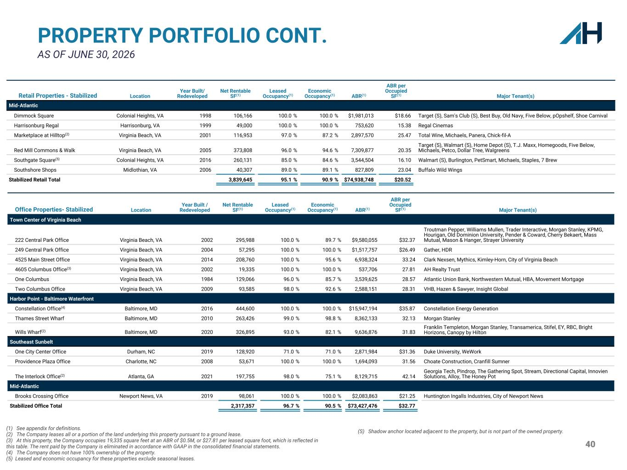
40 PROPERTY PORTFOLIO CONT. AS OF JUNE 30, 2026 Retail Properties - Stabilized Location Year Built/ Redeveloped Net Rentable SF(1) Leased Occupancy(1) Economic Occupancy(1) ABR(1) ABR per Occupied SF(1) Major Tenant(s) Mid-Atlantic Dimmock Square Colonial Heights, VA 1998 106,166 100.0 % 100.0 % $1,981,013 $18.66 Target (S), Sam's Club (S), Best Buy, Old Navy, Five Below, pOpshelf, Shoe Carnival Harrisonburg Regal Harrisonburg, VA 1999 49,000 100.0 % 100.0 % 753,620 15.38 Regal Cinemas Marketplace at Hilltop(2) Virginia Beach, VA 2001 116,953 97.0 % 87.2 % 2,897,570 25.47 Total Wine, Michaels, Panera, Chick-fil-A Red Mill Commons & Walk Virginia Beach, VA 2005 373,808 96.0 % 94.6 % 7,309,877 20.35 Target (S), Walmart (S), Home Depot (S), T.J. Maxx, Homegoods, Five Below, Michaels, Petco, Dollar Tree, Walgreens Southgate Square(5) Colonial Heights, VA 2016 260,131 85.0 % 84.6 % 3,544,504 16.10 Walmart (S), Burlington, PetSmart, Michaels, Staples, 7 Brew Southshore Shops Midlothian, VA 2006 40,307 89.0 % 89.1 % 827,809 23.04 Buffalo Wild Wings Stabilized Retail Total 3,839,645 95.1 % 90.9 % $74,938,748 $20.52 (1) See appendix for definitions. (2) The Company leases all or a portion of the land underlying this property pursuant to a ground lease. (3) At this property, the Company occupies 19,335 square feet at an ABR of $0.5M, or $27.81 per leased square foot, which is reflected in this table. The rent paid by the Company is eliminated in accordance with GAAP in the consolidated financial statements. (4) The Company does not have 100% ownership of the property. (5) Leased and economic occupancy for these properties exclude seasonal leases. Office Properties- Stabilized Location Year Built / Redeveloped Net Rentable SF(1) Leased Occupancy(1) Economic Occupancy(1) ABR(1) ABR per Occupied SF(1) Major Tenant(s) Town Center of Virginia Beach 222 Central Park Office Virginia Beach, VA 2002 295,988 100.0 % 89.7 % $9,580,055 $32.37 Troutman Pepper, Williams Mullen, Trader Interactive, Morgan Stanley, KPMG, Hourigan, Old Dominion University, Pender & Coward, Cherry Bekaert, Mass Mutual, Mason & Hanger, Strayer University 249 Central Park Office Virginia Beach, VA 2004 57,295 100.0 % 100.0 % $1,517,757 $26.49 Gather, HDR 4525 Main Street Office Virginia Beach, VA 2014 208,760 100.0 % 95.6 % 6,938,324 33.24 Clark Nexsen, Mythics, Kimley-Horn, City of Virginia Beach 4605 Columbus Office(3) Virginia Beach, VA 2002 19,335 100.0 % 100.0 % 537,706 27.81 AH Realty Trust One Columbus Virginia Beach, VA 1984 129,066 96.0 % 85.7 % 3,539,625 28.57 Atlantic Union Bank, Northwestern Mutual, HBA, Movement Mortgage Two Columbus Office Virginia Beach, VA 2009 93,585 98.0 % 92.6 % 2,588,151 28.31 VHB, Hazen & Sawyer, Insight Global Harbor Point - Baltimore Waterfront Constellation Office(4) Baltimore, MD 2016 444,600 100.0 % 100.0 % $15,947,194 $35.87 Constellation Energy Generation Thames Street Wharf Baltimore, MD 2010 263,426 99.0 % 98.8 % 8,362,133 32.13 Morgan Stanley Wills Wharf(2) Baltimore, MD 2020 326,895 93.0 % 82.1 % 9,636,876 31.83 Franklin Templeton, Morgan Stanley, Transamerica, Stifel, EY, RBC, Bright Horizons, Canopy by Hilton Southeast Sunbelt One City Center Office Durham, NC 2019 128,920 71.0 % 71.0 % 2,871,984 $31.36 Duke University, WeWork Providence Plaza Office Charlotte, NC 2008 53,671 100.0 % 100.0 % 1,694,093 31.56 Choate Construction, Cranfill Sumner The Interlock Office(2) Atlanta, GA 2021 197,755 98.0 % 75.1 % 8,129,715 42.14 Georgia Tech, Pindrop, The Gathering Spot, Stream, Directional Capital, Innovien Solutions, Alloy, The Honey Pot Mid-Atlantic Brooks Crossing Office Newport News, VA 2019 98,061 100.0 % 100.0 % $2,083,863 $21.25 Huntington Ingalls Industries, City of Newport News Stabilized Office Total 2,317,357 96.7 % 90.5 % $73,427,476 $32.77 (S) Shadow anchor located adjacent to the property, but is not part of the owned property.

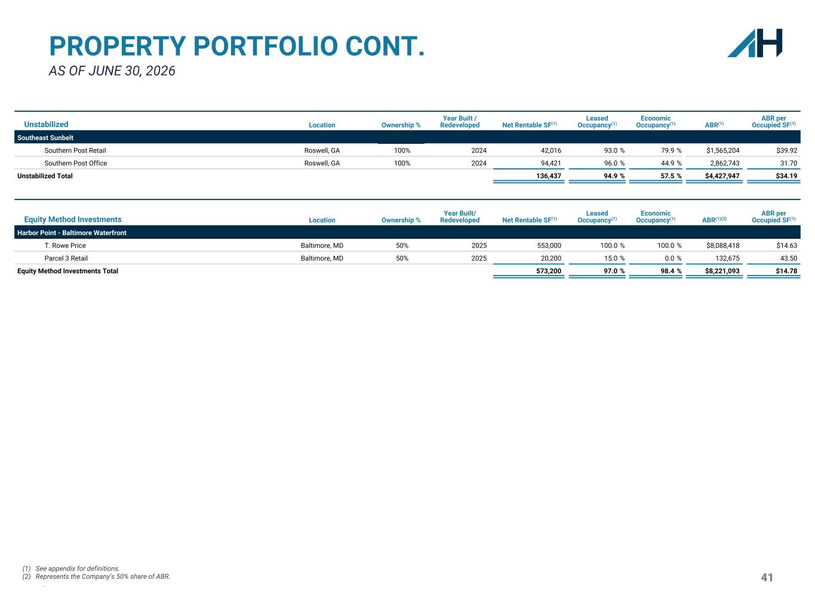
41 PROPERTY PORTFOLIO CONT. AS OF JUNE 30, 2026 Unstabilized Location Ownership % Year Built / Redeveloped Net Rentable SF(1) Leased Occupancy(1) Economic Occupancy(1) ABR(1) ABR per Occupied SF(1) Southeast Sunbelt Southern Post Retail Roswell, GA 100% 2024 42,016 93.0 % 79.9 % $1,565,204 $39.92 Southern Post Office Roswell, GA 100% 2024 94,421 96.0 % 44.9 % 2,862,743 31.70 Unstabilized Total 136,437 94.9 % 57.5 % $4,427,947 $34.19 Equity Method Investments Location Ownership % Year Built/ Redeveloped Net Rentable SF(1) Leased Occupancy(1) Economic Occupancy(1) ABR(1)(2) ABR per Occupied SF(1) Harbor Point - Baltimore Waterfront T. Rowe Price Baltimore, MD 50% 2025 553,000 100.0 % 100.0 % $8,088,418 $14.63 Parcel 3 Retail Baltimore, MD 50% 2025 20,200 15.0 % 0.0 % 132,675 43.50 Equity Method Investments Total 573,200 97.0 % 98.4 % $8,221,093 $14.78 (1) See appendix for definitions. (2) Represents the Company’s 50% share of ABR. .

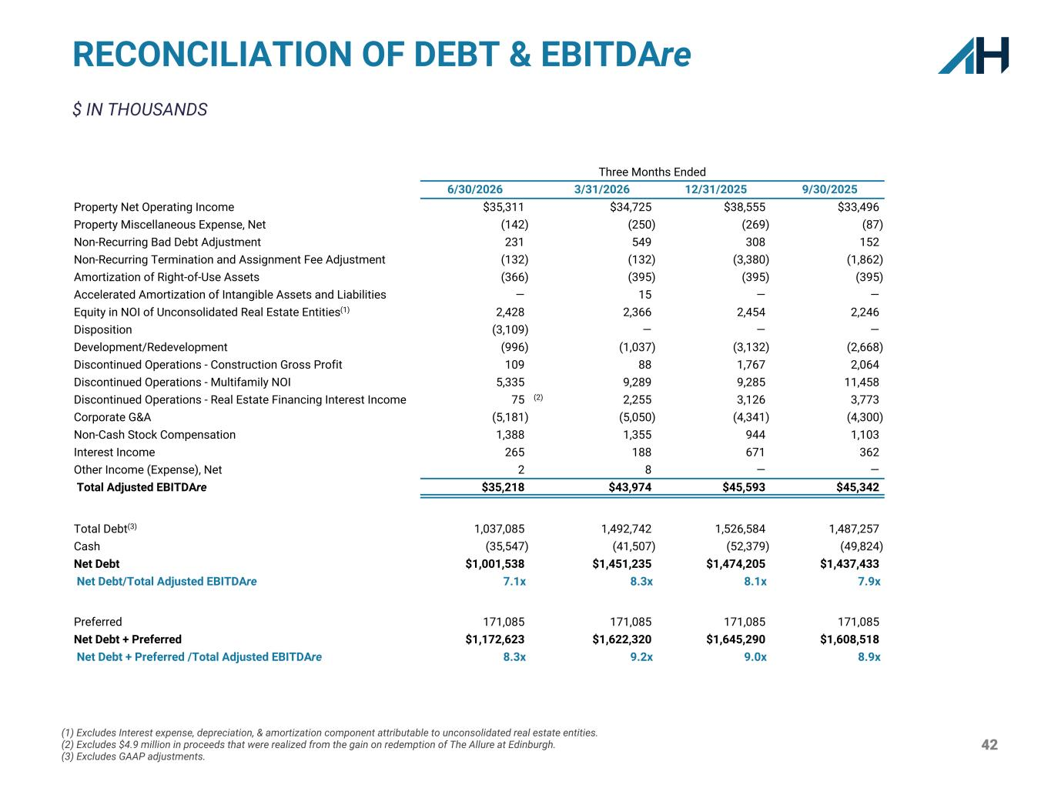
42 $ IN THOUSANDS RECONCILIATION OF DEBT & EBITDAre (1) Excludes Interest expense, depreciation, & amortization component attributable to unconsolidated real estate entities. (2) Excludes $4.9 million in proceeds that were realized from the gain on redemption of The Allure at Edinburgh. (3) Excludes GAAP adjustments. Three Months Ended 6/30/2026 3/31/2026 12/31/2025 9/30/2025 Property Net Operating Income $35,311 $34,725 $38,555 $33,496 Property Miscellaneous Expense, Net (142) (250) (269) (87) Non-Recurring Bad Debt Adjustment 231 549 308 152 Non-Recurring Termination and Assignment Fee Adjustment (132) (132) (3,380) (1,862) Amortization of Right-of-Use Assets (366) (395) (395) (395) Accelerated Amortization of Intangible Assets and Liabilities — 15 — — Equity in NOI of Unconsolidated Real Estate Entities(1) 2,428 2,366 2,454 2,246 Disposition (3,109) — — — Development/Redevelopment (996) (1,037) (3,132) (2,668) Discontinued Operations - Construction Gross Profit 109 88 1,767 2,064 Discontinued Operations - Multifamily NOI 5,335 9,289 9,285 11,458 Discontinued Operations - Real Estate Financing Interest Income 75 (2) 2,255 3,126 3,773 Corporate G&A (5,181) (5,050) (4,341) (4,300) Non-Cash Stock Compensation 1,388 1,355 944 1,103 Interest Income 265 188 671 362 Other Income (Expense), Net 2 8 — — Total Adjusted EBITDAre $35,218 $43,974 $45,593 $45,342 Total Debt(3) 1,037,085 1,492,742 1,526,584 1,487,257 Cash (35,547) (41,507) (52,379) (49,824) Net Debt $1,001,538 $1,451,235 $1,474,205 $1,437,433 Net Debt/Total Adjusted EBITDAre 7.1x 8.3x 8.1x 7.9x Preferred 171,085 171,085 171,085 171,085 Net Debt + Preferred $1,172,623 $1,622,320 $1,645,290 $1,608,518 Net Debt + Preferred /Total Adjusted EBITDAre 8.3x 9.2x 9.0x 8.9x

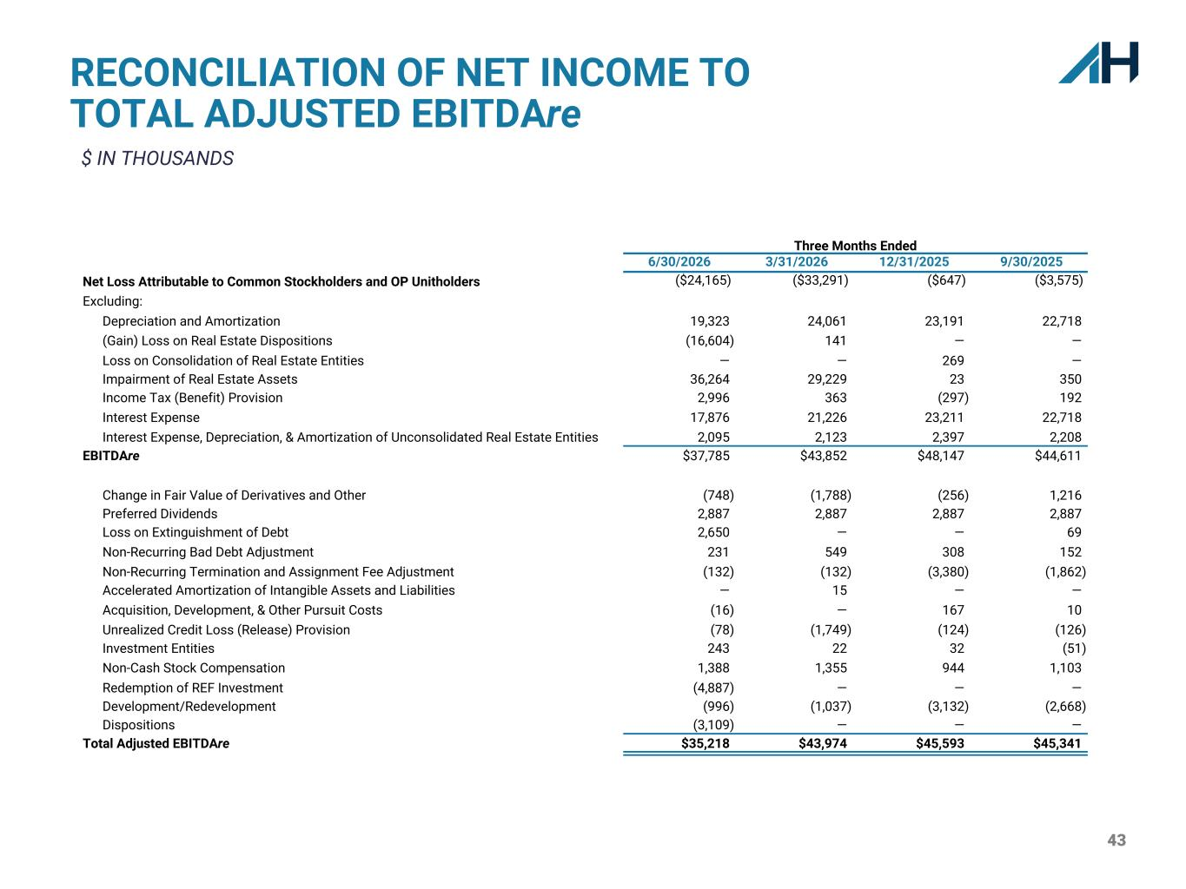
43 Three Months Ended 6/30/2026 3/31/2026 12/31/2025 9/30/2025 Net Loss Attributable to Common Stockholders and OP Unitholders ($24,165) ($33,291) ($647) ($3,575) Excluding: Depreciation and Amortization 19,323 24,061 23,191 22,718 (Gain) Loss on Real Estate Dispositions (16,604) 141 — — Loss on Consolidation of Real Estate Entities — — 269 — Impairment of Real Estate Assets 36,264 29,229 23 350 Income Tax (Benefit) Provision 2,996 363 (297) 192 Interest Expense 17,876 21,226 23,211 22,718 Interest Expense, Depreciation, & Amortization of Unconsolidated Real Estate Entities 2,095 2,123 2,397 2,208 EBITDAre $37,785 $43,852 $48,147 $44,611 Change in Fair Value of Derivatives and Other (748) (1,788) (256) 1,216 Preferred Dividends 2,887 2,887 2,887 2,887 Loss on Extinguishment of Debt 2,650 — — 69 Non-Recurring Bad Debt Adjustment 231 549 308 152 Non-Recurring Termination and Assignment Fee Adjustment (132) (132) (3,380) (1,862) Accelerated Amortization of Intangible Assets and Liabilities — 15 — — Acquisition, Development, & Other Pursuit Costs (16) — 167 10 Unrealized Credit Loss (Release) Provision (78) (1,749) (124) (126) Investment Entities 243 22 32 (51) Non-Cash Stock Compensation 1,388 1,355 944 1,103 Redemption of REF Investment (4,887) — — — Development/Redevelopment (996) (1,037) (3,132) (2,668) Dispositions (3,109) — — — Total Adjusted EBITDAre $35,218 $43,974 $45,593 $45,341 RECONCILIATION OF NET INCOME TO TOTAL ADJUSTED EBITDAre $ IN THOUSANDS

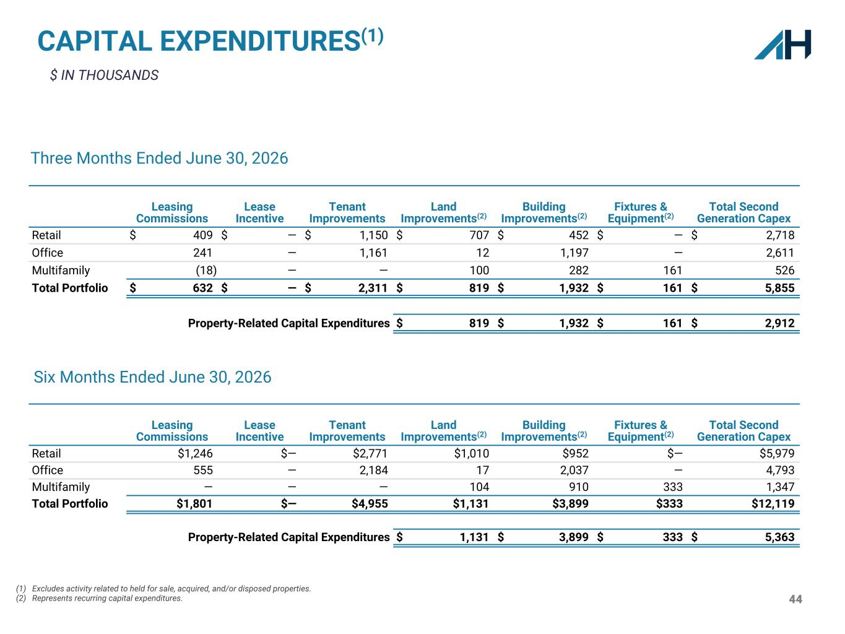
44 $ IN THOUSANDS CAPITAL EXPENDITURES(1) (1) Excludes activity related to held for sale, acquired, and/or disposed properties. (2) Represents recurring capital expenditures. Leasing Commissions Lease Incentive Tenant Improvements Land Improvements(2) Building Improvements(2) Fixtures & Equipment(2) Total Second Generation Capex Retail $ 409 $ — $ 1,150 $ 707 $ 452 $ — $ 2,718 Office 241 — 1,161 12 1,197 — 2,611 Multifamily (18) — — 100 282 161 526 Total Portfolio $ 632 $ — $ 2,311 $ 819 $ 1,932 $ 161 $ 5,855 Property-Related Capital Expenditures $ 819 $ 1,932 $ 161 $ 2,912 Three Months Ended June 30, 2026 Leasing Commissions Lease Incentive Tenant Improvements Land Improvements(2) Building Improvements(2) Fixtures & Equipment(2) Total Second Generation Capex Retail $1,246 $— $2,771 $1,010 $952 $— $5,979 Office 555 — 2,184 17 2,037 — 4,793 Multifamily — — — 104 910 333 1,347 Total Portfolio $1,801 $— $4,955 $1,131 $3,899 $333 $12,119 Property-Related Capital Expenditures $ 1,131 $ 3,899 $ 333 $ 5,363 Six Months Ended June 30, 2026

